FOR IMMEDIATE RELEASE
MARCH 3, 2023

INGRID ANDRESS RELEASES GOOD PERSON (DELUXE) TODAY
LISTEN HERE

THREE BRAND-NEW TRACKS INCLUDE COLLABORATION WITH
JP SAXE ON “RUNNIN”

THE GOOD PERSON TOUR PRESENTED BY 21SEEDS CONTINUES WITH
SOLD-OUT NYC SHOW ON 3/15

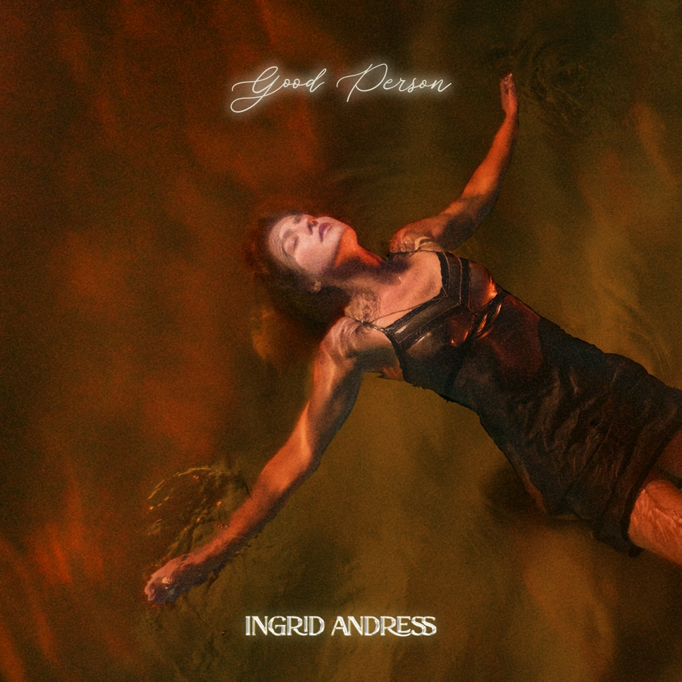
DOWNLOAD ARTWORK HERE

4x GRAMMY-nominee Ingrid Andress has released the deluxe version of her acclaimed sophomore album, Good Person, today (LISTEN HERE). Good Person (Deluxe) features three brand-new original tracks, including “Runnin (with JP Saxe).”

Andress kicked off her 20+ date trek on The Good Person Tour Presented by 21Seeds earlier this month with a sold-out performance in Salt Lake City and Denver. The Colorado-native will play to sold-out crowds in NYC, Boston, Minneapolis and more before wrapping up in Norway May 24th (see full list of dates below).

Additional Good Person standout track, “Blue,” was also recently chosen by Kelly Clarkson to perform during the fan-favorite ‘Kellyoke’ segment on her Emmy-winning daytime talk show The Kelly Clarkson Show (WATCH HERE). The song is featured on alongside her current single, “Feel Like This” (LISTEN HERE). As seen on The Late Show with Stephen Colbert and Jimmy Kimmel Live! and co-written by Andress, Ellis and Julia Michaels, the track “puts an informed, mature spin on love [with its] adult approach to the mysteries of relationships” (Billboard). The lauded singer/songwriter also recently earned her second career No. 1 with the GRAMMY-nominated, Platinum-certified hit “Wishful Drinking (with Sam Hunt).”

Hailed by The New York Times as “a Nashville outsider who paved her own way in” (READ HERE), Andress returns to the reflection and confession at the core of her acclaimed debut, Lady Like, and plumbs even deeper on Good Person. In addition to co-writing every track, Andress found herself in the co-producer’s chair once again alongside Sam Ellis, who played the same role on Lady Like. She pushed for bold, experimental sounds that blended banjos with vocoders; swung from sweeping orchestration to spare, acoustic-based arrangements; and showcased previously unexplored parts of her vocal range.

Good Person sees Andress entering the next chapter of her career following her record-breaking debut, Lady Like, named “one of the year’s strongest albums” by Associated Press and one of Billboard’s Top 10 Best Country Albums of 2020. The celebrated LP scored Andress three GRAMMY nominations including Best New Artist, Best Country Album and Best Country Song for the multi-platinum No. 1 radio single “More Hearts Than Mine.” She is also a 4x ACM Award, 3x CMA Award and 2x CMT Music Award nominee.

With over one billion global streams and fans spanning the globe, Andress spent last year out on the road with Keith Urban for his North American “The Speed of Now World Tour” and will head out in support of Walker Hayes beginning in April.

THE GOOD PERSON TOUR PRESENTED BY 21SEEDS DATES
^ with special guest Madeline Edwards
• with special guest Carter Faith
+ with special guest Nick Wilson
* with special guest Blü Eyes

Feb 24 – Salt Lake City, UT – Commonwealth ^ **SOLD OUT**
Feb 25 – Denver, CO – Bluebird ^ **SOLD OUT**
March 2 – Los Angeles, CA – El Rey ^*
March 15 – New York City, NY – Gramercy • **SOLD OUT**
March 16 – Boston, MA – Sinclair • **SOLD OUT**
March 23 – Grand Rapids, MI – Elevation ^
March 25 – Minneapolis, MN – Fine Line ^ **SOLD OUT**
May 4 – Dublin, IRL – Whelans +
May 5 – Belfast, UK – Limelight 2 +
May 7 – Glasgow, UK – St. Luke's + **SOLD OUT**
May 9 – Manchester, UK – Gorilla +
May 10 – Birmingham, UK – O2 Institute 3 +
May 11 – London, UK – Scala +
May 15 – Paris, France – Le Pop Up du Label +
May 16 – Amsterdam, NL – Melkweg OZ +
May 17 – Cologne, DE – Blue Shell +
May 19 – Berlin, DE – Frannz Club +
May 20 – Hamburg, DE – Nochtwache +
May 21 – Copenhagen, DK – Lille Vega +
May 23 – Stockholm, SE – Nalen Club +
May 24 – Oslo, NO – John Dee +
Aug 23 – San Francisco, CA – Great American Music Hall ^

Good Person (Deluxe) Track List:
1. Treated Me Good
Written by: Ingrid Andress, Sam Ellis, Derrick Southerland
Produced by: Ingrid Andress & Sam Ellis

2. Wish You Would
Written by: Ingrid Andress, Paul DiGiovanni, Dave Barnes
Produced by: Ingrid Andress & Sam Ellis

3. Runnin (with JP Saxe)
Written by: Ingrid Andress, JP Saxe, Ryan Marrone
Produced by: Ingrid Andress & Sam Ellis

4. Good Person
Written by: Ingrid Andress, Steph Jones, Sam Ellis
Produced by: Ingrid Andress & Sam Ellis

5. Yearbook
Written by: Ingrid Andress, Pete Good, Shane McAnally, Derrick Southerland
Produced by: Ingrid Andress & Sam Ellis

6. Seeing Someone Else
Written by: Ingrid Andress, Derrick Southerland, Jesse Frasure
Produced by: Ingrid Andress & Sam Ellis

7. Talk
Written by: Ingrid Andress, Alex Stacey, Tommy Gee, David Fremberg, Mich Hansen
Produced by: Ingrid Andress & Sam Ellis

8. How Honest Do You Want Me to Be?
Written by: Ingrid Andress, Sam Ellis, Derrick Southerland
Produced by: Ingrid Andress & Sam Ellis

9. No Choice
Written by: Ingrid Andress, AJ Pruis, Derrick Southerland
Produced by: Ingrid Andress & AJ Pruis

10. Pain
Written by: Ingrid Andress, Laura Veltz, Sam Ellis
Produced by: Ingrid Andress & Sam Ellis

11. Feel Like This
Written by: Ingrid Andress, Julia Michaels, Sam Ellis
Produced by: Ingrid Andress & Sam Ellis

12. Blue
Written by: Ingrid Andress, Sam Ellis, Derrick Southerland, Shane McAnally
Produced by: Ingrid Andress & Sam Ellis

13. Falling For You
Written by: Ingrid Andress, Derrick Southerland, Sam Ellis
Produced by: Ingrid Andress & Sam Ellis

14. All the Love
Written by: Ingrid Andress, Derrick Southerland, Sam Ellis
Produced by: Ingrid Andress & Sam Ellis

15. Things That Haven't Happened Yet
Written by: Ingrid Andress, Derrick Southerland, Sam Ellis
Produced by: Ingrid Andress & Sam Ellis

16. Wishful Drinking
Written by: Ingrid Andress, Jonny Price, JP Saxe, Lucky Daye, Rykeyz
Produced by: Ingrid Andress & Jordan M. Schmidt

###

CONNECT WITH INGRID ANDRESS:
FACEBOOK | TWITTER | INSTAGRAM | YOUTUBE

PRESS CONTACTS
Andrew George | Atlantic Records
Andrew.George@atlanticrecords.com

Mary Catherine Rebrovick | Warner Music Nashville
MaryCatherine@wmg.com

