NEON GOLD/ATLANTIC RECORDS ARTIST JOE P TEAMS UP WITH K. FLAY ON NEW VERSION OF #1 TRIPLE A RADIO SINGLE “OFF MY MIND”
JOE P ANNOUNCES DEBUT HEADLINE TOUR KICKING OFF THIS APRIL
STREAM/DOWNLOAD “OFF MY MIND” FEATURING K.FLAY HERE
STREAM/DOWNLOAD “OFF MY MIND” HERE
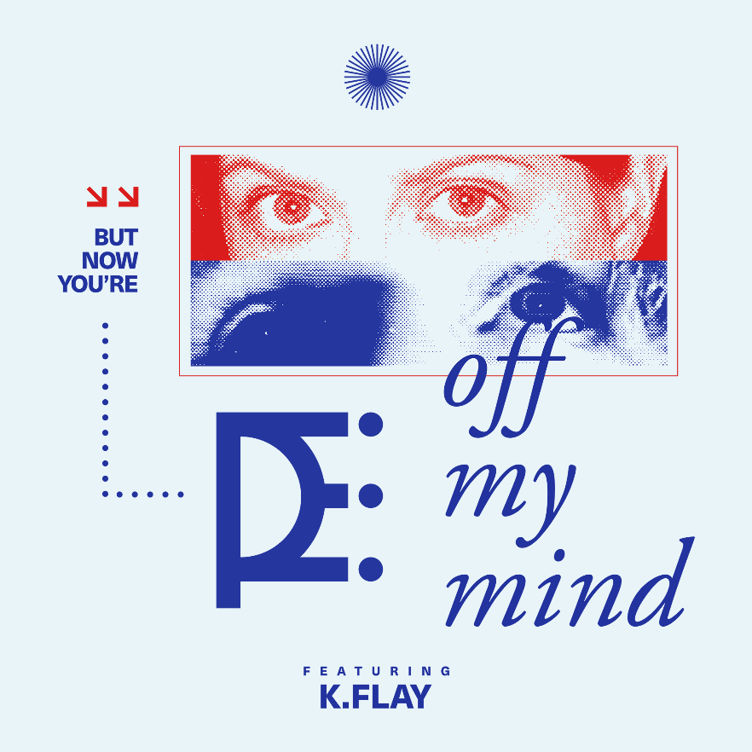
DOWNLOAD HI-RES ARTWORK
Alternative singer-songwriter Joe P has teamed up with GRAMMY-nominated artist K.Flay on a new version of his breakout hit, “Off My Mind.” Listen HERE. “Off My Mind,” became Joe P’s debut #1 on Triple A radio last week and has amassed over 20 million streams. Listen HERE.
Joe P says, “This version of the song brings out an entirely different emotion that I didn’t know existed within the song until I heard K. Flay singing on it. I really wanted to avoid it feeling like it was a cliche “guy and girl singing to each other duet” so I tried aiming for more of the same message that the song holds but from two different perspectives. I don’t even see the two characters/singers in the song knowing each other exist, but rather just living in their own personal scenarios that just so happen to be the same.”
Alongside the new version of “Off My Mind,” Joe P announces his debut headline tour kicking off this April in Washington DC and making stops in New York, Chicago and more. Joe P’s debut headline tour follows his tour treks supporting Spacey Jane, Middle Kids and Joywave. General Onsale is February 17th. For more information visit https://www.joepthehyena.com/.
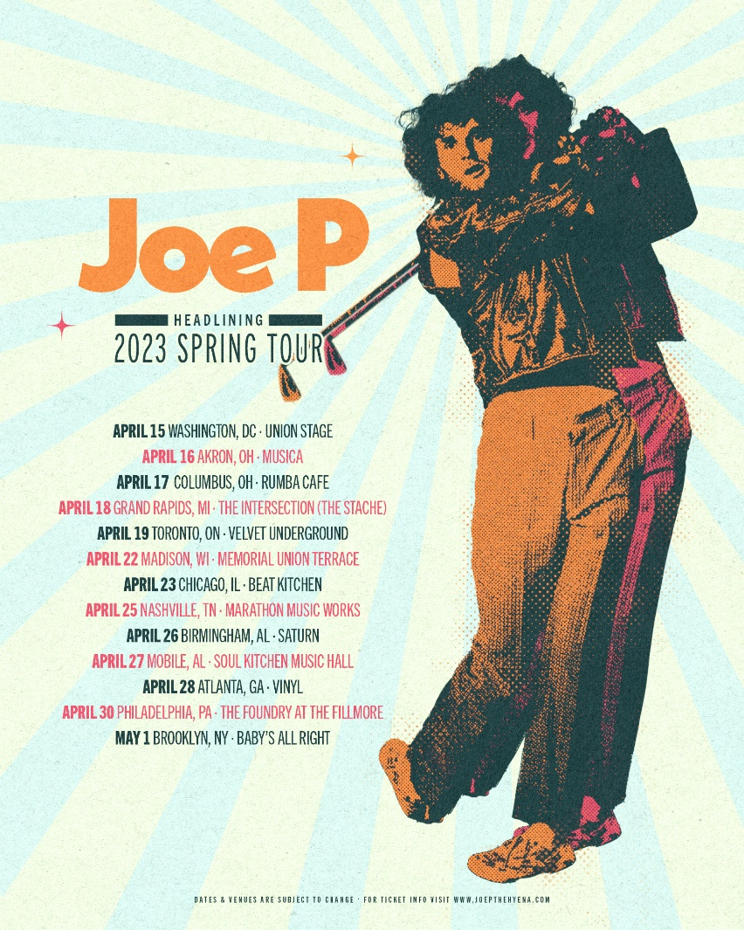
JOE P HEADLINING SPRING TOUR
4/15 – Washington, DC @ Union Stage
4/16 – Akron, OH @ Musica
4/17 – Columbus, OH @ Rumba Café
4/18 – Grand Rapids, MI @ The Stache
4/19 – Toronto, ON @ Velvet Underground
4/22 – Madison, WI @ The Sett
4/23 – Chicago, IL @ Beat Kitchen
4/25 – Nashville, TN @ Marathon Music Works – *opening for beabadoobee*
4/26 – Birmingham, AL @ Saturn
4/27 – Mobile, AL @ Soul Kitchen Music Hall
4/28 – Atlanta, GA @ Aisle 5
4/30 – Philadelphia, PA @ The Foundry
5/1 – Brooklyn, NY –@Baby’s All Right

Joe P’s recently released seven-song project, French Blonde features the anthemic “Happy People” and the pulse-pounding title track, “French Blonde.” The official live performance video for “French Blonde” also served as the opening scene of Joe P’s short horror film, “If We Run,” starring Michael Gandolfini (The Many Saints of Newark), Kevin Interdonato (The Sopranos), and Joe P as himself. “Off My Mind,” was also featured in the film – watch HERE.
When the onset of the pandemic brought about the dissolution of the band he’d fronted since eighth grade, Joe P found himself in isolation with time to step out and experiment on his own. From the refuge of his New Jersey basement studio, he threw himself into writing, recording and producing his most personal material to date. Posting homegrown ideas to TikTok, joe p watched as his raw acoustic videos drew millions of views and over 300K followers in just a few months. Among those new fans was Apple Music’s Zane Lowe, who kicked joe’s career into hyperdrive by duetting alongside his self-made “Fighting In The Car” video (streaming HERE). A deal with Neon Gold/Atlantic was quickly followed by the acclaimed release of joe p’s acclaimed debut EP, Emily Can’t Sing, highlighted by the viral hit single, “All Day I Dream About. ” First introduced as “Adidases” in a hugely popular TikTok teaser (watch HERE), the song proved Joe’s biggest first week success to date upon its August premiere, earning over 233K streams in the US alone along with 13K pre-saves – a staggering number for a new alternative artist still in his initial ascent.

# # #

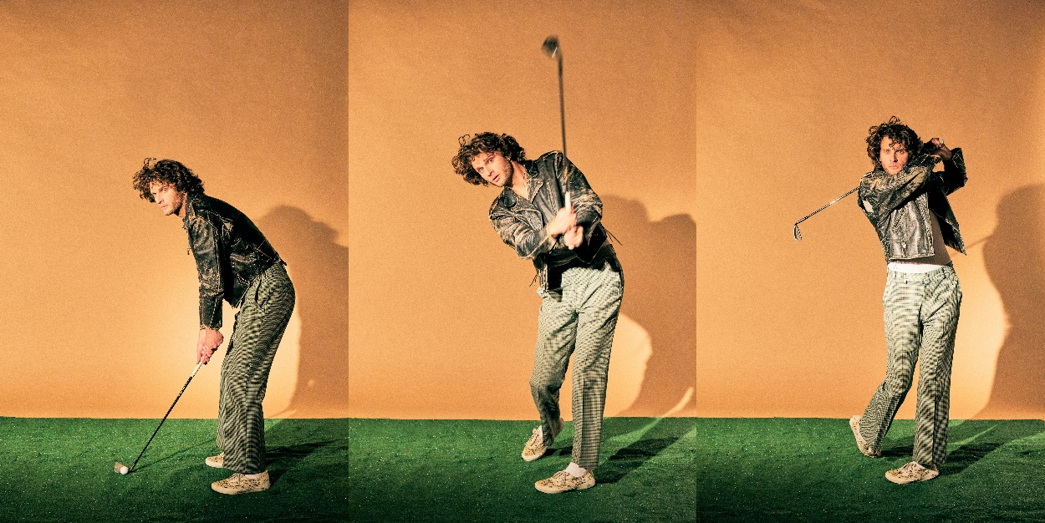
DOWNLOAD HI-RES IMAGE // PHOTO CREDIT: JIMMY FONTAINE

# # #

CONNECT WITH JOE P
WEBSITE | FACEBOOK | INSTAGRAM | SOUNDCLOUD | SPOTIFY | TIKTOK | TWITTER | YOUTUBE

PRESS CONTACTS
corey.brewer@atlanticrecords.com
gabrielle.reese@atlanticrecords.com

