KELLY CLARKSON ANNOUNCES EXCLUSIVE LAS VEGAS ENGAGEMENT AT BAKKT THEATER AT PLANET HOLLYWOOD RESORT & CASINO

chemistry…an intimate night with Kelly Clarkson
Launches Friday, July 28, 2023

Presales begin Tuesday, March 28;
Public on sale begins Friday, March 31

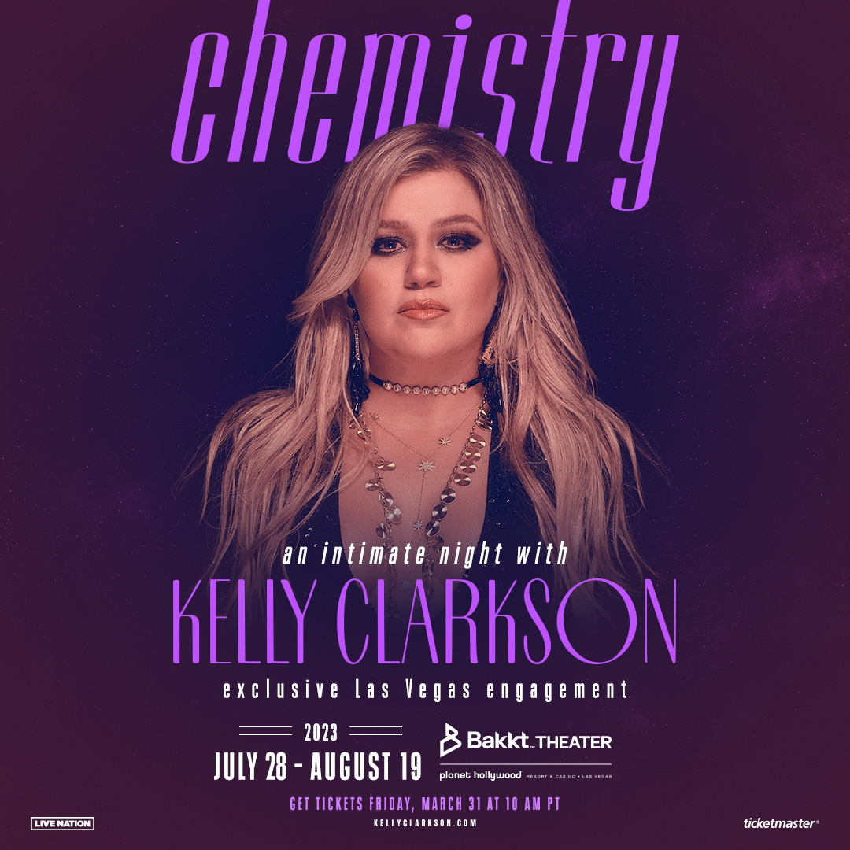

Please click here to download admat, video and photo
LAS VEGAS (March 27, 2023) – GRAMMY Award-winning global superstar Kelly Clarkson has announced that she will headline an exclusive Las Vegas engagement chemistry…an intimate night with Kelly Clarkson, opening Friday, July 28, 2023 at Bakkt Theater at Planet Hollywood Resort & Casino.
Designed exclusively for the Bakkt Theater (formerly Zappos Theater) stage, Kelly and her longtime band will immerse fans in an intimate music experience that spans her two-decade long catalog of award-winning hits.

“I am so excited for these shows and couldn’t think of a better place to get back on stage than Las Vegas! The crowds in Vegas are such an amazing collection of people that simply want to have a great time and that’s what we’re going to do!” said Kelly Clarkson. “So many of my musical idols have had, and still have, incredible residencies on The Strip, and I’m so excited to create my own!”

Tickets go on sale starting Friday, March 31 at 10 a.m. PT at ticketmaster.com/KellyVegas. Artist fans will have access to a presale beginning Tuesday, March 28 at 12 p.m. PT. Citi is the official presale card of Kelly’s exclusive Las Vegas engagement at Bakkt Theater at Planet Hollywood. Citi cardmembers will have access to presale tickets beginning Tuesday, March 28 at 10 a.m. PT until Thursday, March 30 at 10 p.m. PT through the Citi Entertainment program. For complete presale details visit www.citientertainment.com.

Caesars Rewards members, Caesars Entertainment’s loyalty program, and Live Nation and Ticketmaster customers will have access to a presale from Wednesday, March 29 at 10 a.m. PT until Thursday, March 30 at 10 p.m. PT.

The 10 performances going on sale are:

July 2023: 28, 29
August 2023: 2, 4, 5, 9, 11, 12, 18, 19

Shows begin at 8 p.m. For more information and to purchase tickets, please visit
ticketmaster.com/KellyVegas.

About Kelly Clarkson
Kelly Clarkson is one of the most popular artists of this era with total worldwide sales of more than 25 million albums and 40 million singles. Her multi-Emmy Award-winning daytime talk show, “The Kelly Clarkson Show,” is currently filming its 4th season and has already been picked up for its 5th and 6th seasons. Additionally, she was the winning coach on seasons 14, 15, 17, and 21 of “The Voice” and will return as a coach for Season 23.

She recently released her EP “Kellyoke” which features six studio versions of popular covers from the Kellyoke segment on “The Kelly Clarkson Show.”

In 2021 she released her GRAMMY-nominated ninth studio album “When Christmas Comes Around…,” her latest since 2017’s critically acclaimed GRAMMY-nominated album “Meaning of Life” and second holiday offering following 2013’s “Wrapped In Red.” The 15-track collection, featuring a mix of new original songs and Christmas classics, sees Clarkson explore a wide range of holiday emotions and experiences anchored by her incomparable vocal prowess.
The Texas-born singer-songwriter first came to fame in 2002 as the winner of the inaugural season of “American Idol.” Clarkson’s debut single, “A Moment Like This,” followed and quickly went to #1 on Billboard’s Hot 100, ultimately ranking as the year’s best-selling single in the U.S. Further, Clarkson is one of pop’s top singles artists, with 17 singles boasting multi-platinum, platinum and gold certifications around the world, including such global favorites as “Miss Independent” and “Because of You.”
Clarkson has released nine studio albums (“Thankful,” “Breakaway,” “My December,” “All I Ever Wanted,” “Stronger,” “Wrapped in Red,” “Piece By Piece,” “Meaning of Life,” “When Christmas Comes Around…”), one EP, “Kellyoke,” one greatest hits album and two children’s books (New York Times Top 10 bestseller “River Rose and the Magical Lullaby” and “River Rose and the Magical Christmas”).
Clarkson was most recently honored with the 2,733rd star on the Hollywood Walk of Fame and is the recipient of an array of awards, including three consecutive Daytime Emmy Awards for “Outstanding Entertainment Talk Show Host” for “The Kelly Clarkson Show,” three GRAMMY Awards, four American Music Awards, three MTV Video Music Awards, one MTV Movie & TV Award, two Academy of Country Music Awards, two American Country Awards and one Country Music Assn. Award. She is also the first artist to top each of Billboard’s pop, adult contemporary, country and dance charts.

About Live Nation Las Vegas
Live Nation Entertainment (NYSE: LYV) is the world’s leading live entertainment company comprised of global market leaders: Ticketmaster, Live Nation Concerts, and Live Nation Sponsorship. Live Nation Las Vegas produces residency shows from Garth Brooks, Sting and Rod Stewart at The Colosseum at Caesars Palace; Maroon 5, Usher, Lady Gaga, Aerosmith and Bruno Mars at Dolby Live at Park MGM; The B-52s, FOREIGNER, Styx, ZZ TOP, Earth, Wind & Fire and Chicago at The Venetian Theatre at The Venetian Resort Las Vegas; Kelly Clarkson, The Chicks, Keith Urban and Miranda Lambert at Bakkt Theater at Planet Hollywood Resort & Casino; and Santana at House of Blues. Live Nation Las Vegas also brings other world-famous artists to many of the city’s other premier concert venues including Allegiant Stadium, T-Mobile Arena, MGM Grand Garden Arena, Michelob ULTRA Arena, the Pearl at Palms Casino Resort, Downtown Las Vegas Events Center and more. For additional information, visit www.livenationentertainment.com. Find Live Nation Las Vegas on Facebook, Instagram and follow us on Twitter.

About Planet Hollywood Resort & Casino
Planet Hollywood Resort & Casino is the centerpiece of the famed Las Vegas Strip, with 2,500 beautifully redesigned guest rooms and suites showcasing some of the best views in town, along with endless options of unparalleled shopping, distinguished dining, popular entertainment and a bustling nightlife. A bright, bold addition to the resort’s portfolio, the Ultra Hip Rooms feature contemporary elegance and luxury bedding. Known as the place to play for its roster of A-list celebrity guests, Planet Hollywood’s 231 restyled suites feature stunning views of the glittering skyline and daring décor elements such as suspended sofas, lounge-style living spaces and oversized modern artwork. The resort encompasses more than 100,000 square feet of gaming, Caesars Sportsbook at Planet Hollywood, The Scene Pool Deck, several lounges, an intimate wedding chapel, and a relaxing spa and salon. Impressive restaurants include Gordon Ramsay Burger, KOI, Strip House and more. Home to the first pop music residency in Las Vegas, Bakkt Theater is one of the largest theaters on the Vegas Strip and showcases a variety of resident headliners including superstars like Kelly Clarkson, The Chicks, Jeff Dunham, Keith Urban and Miranda Lambert. Magician Criss Angel performs an over-the-top visual spectacular of “Criss Angel MINDFREAK®” in the Criss Angel Theater. The property is encircled by Miracle Mile Shops with more than 170 specialty stores and restaurants. Planet Hollywood Resort & Casino is operated by a subsidiary of Caesars Entertainment, Inc. (NASDAQ: CZR). For more information, please visit planethollywoodresort.com or the Caesars Entertainment Las Vegas media room. Find Planet Hollywood Resort & Casino on Facebook and follow on Twitter and Instagram. Must be 21 or older to gamble. Know When To Stop Before You Start.® If you or someone you know has a gambling problem, crisis counseling and referral services can be accessed by calling or texting 1-800-GAMBLER ©2021, Caesars License Company, LLC.
MEDIA CONTACTS:
For Live Nation Las Vegas:
Kelly Frey
Kelly@KFPublicity.com

For Caesars Entertainment:
Robert Jarrett
RJarrett@caesars.com

For Kelly Clarkson:
Melissa Kates
melissa.kates@viewpointla.com

Haley Hileman
haley@viewpointla.com

Sheila Richman
sheila.richman@atlanticrecords.com

Ted Sullivan
ted.sullivan@atlanticrecords.com

