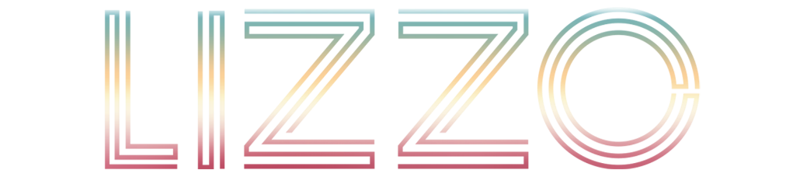

Every once in a while, an artist changes not only music, but culture as well. Lizzo has done both. The four-time GRAMMY® Award-winning, Emmy-Award-winning superstar singer, songwriter, rapper, and actress has shifted the sound, soul, and spirit of popular music and culture with a series of definitive history-making smashes. Along the way, she has collected numerous awards, toppled the Billboard Hot 100 at #1 twice, picked up over a dozen gold and platinum certifications, sold out tours, and appeared in blockbuster films. However, she’s launched her biggest, boldest, and brightest revolution yet with SPECIAL, her second full-length offering for Nice Life Recording Company/Atlantic Records, and more to come.

Lizzo turned the page on her next chapter with her second monumental and culturally-defining #1 single, “About Damn Time,” heralding her latest album SPECIAL (July 15, 2022). Now boasting a GRAMMY® win for “Record of the Year” after Lizzo also performed at the 65th Annual GRAMMY® Awards, “About Damn Time” proved a Billboard Hot 100 #1, Top 40 & Hot AC Radio #1, worldwide smash. With the win, Lizzo becomes the first black woman to be awarded “Record of the Year” since Whitney Houston’s win for "I Will Always Love You" in 1994. Hailed by Rolling Stone as “the most unabashedly joyous, sonically diverse, and emotionally profound album put out by a major label since Beyonce’s Lemonade,” Lizzo’s SPECIAL debuted at #2 on the Billboard 200 album chart, and #1 on the Pop Albums chart.

A number of high-profile media appearances helped launch the SPECIAL era, including hosting and performing on SNL with a coveted double duty appearance that included the debut of title track “Special.” Now decked out with a fan-favorite feature, “Special (Feat. SZA)” received its live debut during Lizzo’s sold-out LA Kia Forum show - currently available for streaming on HBO’s Lizzo: Live In Concert. SPECIAL was further introduced with Lizzo’s celebratory live performance for NBC’s 2022 “Citi Concert Series on TODAY,” a heartwarming comedy bit on ABC’s Jimmy Kimmel Live!, and a hilarious guest spot on Watch What Happens Live With Andy Cohen.

Lizzo first took over with her 2019 debut album, CUZ I LOVE YOU. It bowed at #4 on the Billboard Top 200, reached platinum status, graced countless critical year-end lists, and spawned “Tempo” [feat. Missy Elliott] (platinum), “Juice” (2x-platinum), “Good As Hell” (4x-platinum), and “Truth Hurts” (9x-platinum). The latter vaulted to #1 on the Hot 100, cementing her as “the third female rapper to top the Hot 100 without a featured artist” and “the first black solo female R&B singer to claim the top spot since 2012.” It also dominated the chart for seven weeks, making history as “the longest running #1 by a solo female rap artist ever.” Speaking to its impact, Rolling Stone even touted it among its coveted “500 Greatest Songs Of All Time.”

At the GRAMMY® Awards, “Truth Hurts” took home “Best Pop Solo Performance,” CUZ I LOVE (Deluxe) scored “Best Urban Contemporary Album,” and “Jerome” walked away with “Best Traditional R&B Performance.” TIME Magazine and Entertainment Weekly crowned her “Entertainer of the Year” in 2019, and she adorned the covers of Rolling Stone, Billboard, Elle, British Vogue, and more as well as gracing Barack Obama’s Playlist. CBS Sunday Morning chronicled her career in a special. Turning heads, she notably lit up the American Music Awards, MTV VMA, BET Awards, and SNL with unforgettable performances. She only maintained this momentum on 2021’s gold-certified “Rumors” [feat. Cardi B].

Expanding her imprint and influence across media, she lent her voice to the animated UglyDolls and accompanied Jennifer Lopez on the big screen in Hustlers. She joined forces with Amazon Prime to launch #1 Prime Reality TV show Watch Out For the Big Grrrls. Championing diversity, the show follows her search for new backup dancers, inviting 10 plus-sized talents to compete for a place on her world tour. Not to mention, she linked up with Fabletics for her own activewear line, Yitty, inclusive of plus-sized body types.

It’s her time.

CONNECT WITH LIZZO
OFFICIAL | TIKTOK | INSTAGRAM | YOUTUBE | FACEBOOK

