**LUH TYLER UNLEASHES DEBUT MIXTAPE *MY VISION***

[**DOWNLOAD/STREAM *MY VISION***](https://luhtyler.lnk.to/MyVision)

**RISING RAPPER’S NEW PROJECT ARRIVES ALONGSIDE OFFICIAL VIDEO FOR “YOU WAS LAUGHING”**

[**WATCH HERE**](https://LuhTyler.lnk.to/YouWasLaughingVideo)

***“****Coolest 16-year-old in America”* – **PITCHFORK**

*“Rapper to watch in 2023”* – **COMPLEX**

*“An actual overnight sensation”* **– XXL**

*“Already one of (if not the) hottest young rappers coming up”* **– HIPHOPDX**

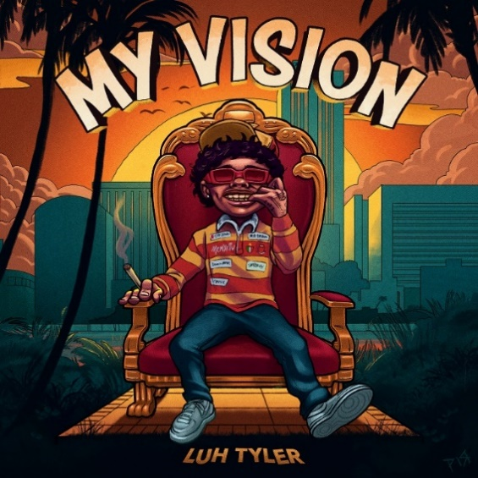

[DOWNLOAD HI-RES ARTWORK](https://press.atlanticrecords.com/luh-tyler)

(New York, NY - March 31, 2023) Rising 17-year-old rapper **Luh Tyler**’s debut mixtape, ***My Vision,*** is out todayvia **Motion Music/Atlantic Records** [Download/Stream]. The Tallahassee native’s 12-track project arrives alongside the official video for **“You Was Laughing,”** directed by **Cotto0verDidIt** – Watch [here.](https://LuhTyler.lnk.to/YouWasLaughingVideo)

***My Vision*** includes features from **NoCap, Anti Da Menace, Loe Shimmy** and production from **ForeveRolling** (Gucci Mane, BigWalkDog, Lil Durk), **Al Geno** (Quavo, Lil Baby) and **LuciG** (PopSmoke, Rod Wave).

*“This project represents my vision of me seeing myself at the top”*

**-LUH TYLER**

***My Vision*** was announced earlier this month after the release of both **“Back Flippin,”** and **“Fat Racks Pt.2”** with **BabyTron**.  In less than a year of releasing music, Tyler has amassed more than 43 million streams, received cosigns from hip-hop heavyweights **Drake**, **Lil Uzi Vert,** **Chris Brown, Coi Leray, Kehlani, Trippie Redd, Rubi Rose** and more with critical praise from [Complex](https://www.complex.com/music/rappers-to-watch-2023), [Pitchfork](https://pitchfork.com/thepitch/luh-tyler-is-the-coolest-16-year-old-rapper-in-america/), [XXL](https://www.xxlmag.com/the-break-interview-luh-tyler/) and [HipHopDX](https://hiphopdx.com/editorials/hiphopdx-rising-stars-2023).

In 2022, Luh Tyler caught the world’s attention with [**“Law and Order”**](https://www.youtube.com/watch?v=X9X_qq35OZg)and fan favorite, **“Jayda Wayda.”**

***MY VISION* TRACKLIST**

1. My Vision
2. Stand On Biz
3. Poppin’ Shit Feat.Anti Da Menace
4. Fat Racks Pt. 2 Feat. BabyTron
5. Hit the Top
6. Santa Feat. Loe Shimmy
7. Back Flippin’
8. Can’t Move Wrong Feat. Trapland Pat
9. Moncler On My Coat
10. Gettin’ Fishy Feat. SCY JIMM & Wizz Havinn
11. Weeks Feat. NoCap
12. You Was Laughing

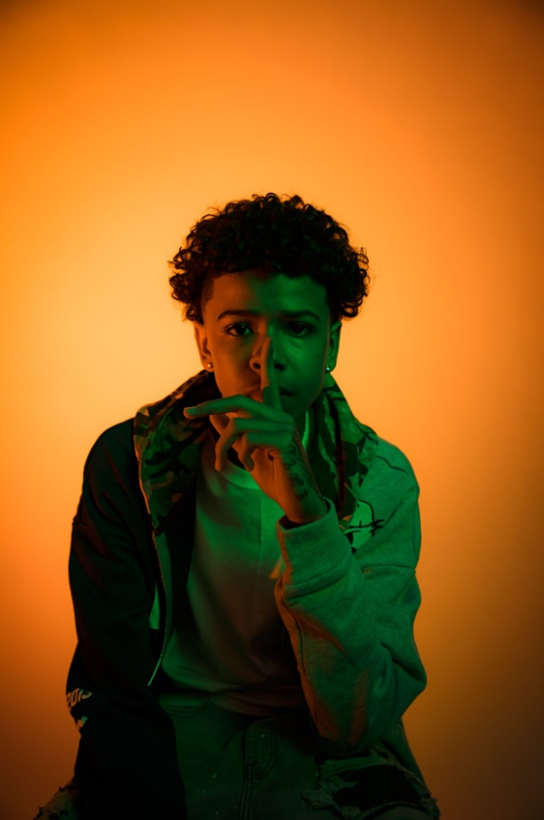

[DOWNLOAD PRESS PHOTO](https://press.atlanticrecords.com/luh-tyler) (Credit: dill35mm)

**For all Luh Tyler press inquiries, please contact:**

Jason Davis | [Jason.Davis@atlanticrecords.com](mailto:Jason.Davis@atlanticrecords.com)

**ABOUT LUH TYLER**

Wielding a wavy flow, irresistible melodies, and inventive dynamics, Luh Tyler animates bouncy anthems with undeniable unpredictability. He switches lanes seamlessly between his signature laidback cadence and airy high register, touting a style all his own. It’s why he’s quietly emerged as a vibrant voice out of his native Tallahassee, FL all before the age of 16. Growing up the youngest of three kids in “a good family,” he initially excelled on the basketball court as a point guard before picking up a mic in high school. Inspired by local favorites Wizz Havin, Trapland Pat, L.O.E. Shimmy, and more, he started to upload music of his own. Following “5 On It Freestyle,” he gained traction on Spotify and YouTube with “Jayda Wayda.” Meanwhile, YouTube views on “Law & Order” soared. DJ Booth touted him as one of “10 Rappers You Should Know Right Now,” and Stereogum christened him, “Best new rapper.” During late 2022, Tyler released “Back Flippin,” the in demand song he teased weeks prior on Tik Tok, which immediately bolstered with support from the likes of Jordan Ross, Chris Brown and Kehlani while Pitchfork declared “…Luh Tyler’s music makes you long for the days when chilling was your only responsibility…his punchlines are boosted by his icy delivery.” Now, he continues to surprise on a series of 2023 singles and his forthcoming debut project.