FOR IMMEDIATE RELEASE
MARCH 23, 2023

INGRID ANDRESS PERFORMS ON NPR’S ICONIC “TINY DESK” TODAY
WATCH HERE

JUST ANNOUNCED AS PART OF LOLLAPALOOZA 2023

THE GOOD PERSON TOUR PRESENTED BY 21SEEDS CONTINUES
FOLLOWING SOLD-OUT SHOW AT NEW YORK’S GRAMERCY THEATRE

GOOD PERSON (DELUXE) OUT NOW
FEATURING THREE BRAND-NEW TRACKS INCLUDING “RUNNIN (WITH JP SAXE)”
LISTEN HERE

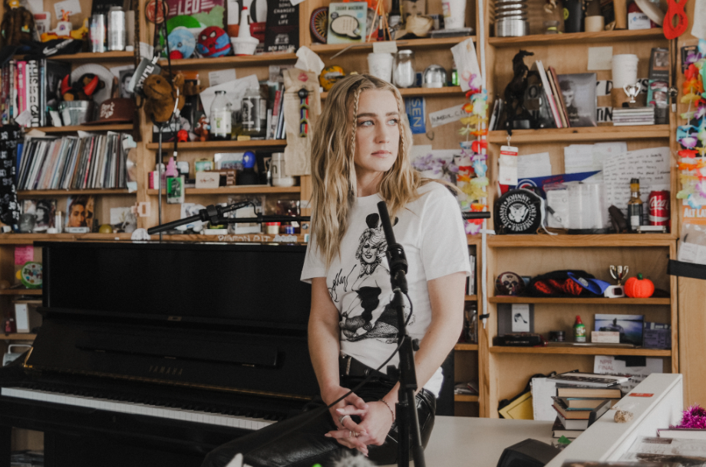
DOWNLOAD PHOTO HERE // CREDIT: ACACIA EVANS

4x GRAMMY-nominee Ingrid Andress is the latest featured artist on NPR’s iconic “Tiny Desk” concert series, sharing beautiful, stripped-down, live versions of “Feel Like This,” “Yearbook” and her acclaimed No. 1 debut single, “More Hearts Than Mine”– Watch HERE.

Announced yesterday, Andress is also set to perform at Lollapalooza in Chicago, IL this August. She is currently on the road for her headlining The Good Person Tour Presented by 21Seeds, with recent sold-out shows at New York’s Gramercy Theatre and Boston’s Sinclair. She’s set to continue the global trek tomorrow night in Grand Rapids, MI before heading overseas in May and wrapping up in Norway on May 24th (see full list of dates below).

Andress recently released the deluxe version of her celebrated sophomore album – Good Person (Deluxe) features three brand-new original tracks, including “Runnin (with JP Saxe).” Earlier this month, additional Good Person standout track, “Blue,” was chosen by Kelly Clarkson to perform during the fan-favorite ‘Kellyoke’ segment on her Emmy-winning daytime talk show The Kelly Clarkson Show (WATCH HERE). The album’s track listing also includes current single, “Feel Like This” (LISTEN HERE). As seen on The Late Show with Stephen Colbert and Jimmy Kimmel Live! and co-written by Andress, Ellis and Julia Michaels, the track “puts an informed, mature spin on love [with its] adult approach to the mysteries of relationships” (Billboard). The lauded singer/songwriter also recently earned her second career No. 1 with the GRAMMY-nominated, Platinum-certified hit “Wishful Drinking (with Sam Hunt).”

Good Person sees Andress entering the next chapter of her career following her record-breaking debut, Lady Like, named “one of the year’s strongest albums” by Associated Press and one of Billboard’s Top 10 Best Country Albums of 2020. The celebrated LP scored Andress three GRAMMY nominations including Best New Artist, Best Country Album and Best Country Song for the multi-platinum No. 1 radio single “More Hearts Than Mine.” She is also a 4x ACM Award, 3x CMA Award and 4x CMT Music Award nominee.

THE GOOD PERSON TOUR PRESENTED BY 21SEEDS DATES
^ with special guest Madeline Edwards
• with special guest Carter Faith
+ with special guest Nick Wilson
* with special guest Blü Eyes

Feb 24 – Salt Lake City, UT – Commonwealth ^ **SOLD OUT**
Feb 25 – Denver, CO – Bluebird ^ **SOLD OUT**
March 2 – Los Angeles, CA – El Rey ^*
March 15 – New York City, NY – Gramercy • **SOLD OUT**
March 16 – Boston, MA – Sinclair • **SOLD OUT**
March 23 – Grand Rapids, MI – Elevation ^
March 25 – Minneapolis, MN – Fine Line ^ **SOLD OUT**
May 4 – Dublin, IRL – Whelans +
May 5 – Belfast, UK – Limelight 2 +
May 7 – Glasgow, UK – St. Luke's + **SOLD OUT**
May 9 – Manchester, UK – Gorilla + **SOLD OUT**
May 10 – Birmingham, UK – O2 Institute2 + **UPGRADED**
May 11 – London, UK – Scala + **SOLD OUT**
May 15 – Paris, France – Le Pop Up du Label +
May 16 – Amsterdam, NL – Melkweg OZ +
May 17 – Cologne, DE – Blue Shell +
May 19 – Berlin, DE – Frannz Club +
May 20 – Hamburg, DE – Nochtwache +
May 21 – Copenhagen, DK – Lille Vega +
May 23 – Stockholm, SE – Nalen Club +
May 24 – Oslo, NO – John Dee +
Aug 23 – San Francisco, CA – Great American Music Hall ^

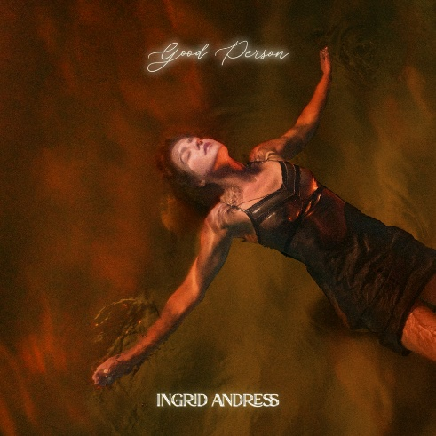
DOWNLOAD ARTWORK HERE

CONNECT WITH INGRID ANDRESS:
FACEBOOK | TWITTER | INSTAGRAM | YOUTUBE

PRESS CONTACTS
Andrew George | Atlantic Records
Andrew.George@atlanticrecords.com

Mary Catherine Rebrovick | Warner Music Nashville
MaryCatherine@wmg.com

