FOR IMMEDIATE RELEASE
MARCH 31, 2023

SARA KAYS RETURNS WITH “BORED”

PLATINUM-CERTIFIED SINGER-SONGWRITER SHARES NEW SINGLE AND VIDEO

LISTEN TO “BORED” | WATCH OFFICIAL MUSIC VIDEO

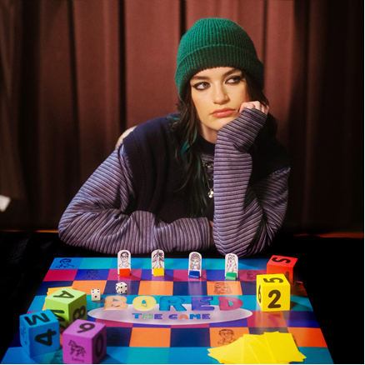
DOWNLOAD ARTWORK HERE

RIAA platinum-certified singer-songwriter Sara Kays returns with her new single, “Bored,” arriving alongside an official music video, which premiered earlier today at Rolling Stone – watch HERE.

“‘Bored’ is such a personal song for me,” shares Sara. “I’ve always been a soft-spoken person and tend to keep my thoughts inside because the feeling that what I’m saying isn’t interesting immediately enters my mind whenever I speak. These feelings have lead me to be pretty closed off in relationships because I’m worried that fully opening up to someone will make them realize how boring I am. After experiencing these feelings heavily in a relationship, I was in last year, I was inspired to write ‘Bored’ which is mostly about trying to keep the focus on the other person as much as possible in a conversation to avoid them getting bored of me. Writing this song was a fun and emotional process and I’m so excited for it to be released!”

“Bored” follows last year’s singles including “Math,” “When You Look At Me,” “Watching TV,” and her recently released cover of Owl City’s “Fireflies,“ the latter of which quickly became a fan favorite last year as she performed on tour across North America opening for Alec Benjamin and MAX.

With over 620M worldwide streams and an intensely engaged and supportive audience on TikTok nearing 2M followers, Kays is disarmingly raw about everything from body image to mental health, her authenticity shining through in her powerful lyricism and expressive voice. The Nashville-based musician saw her profile grow with 2021’s breakthrough EP, Struck By Lightning, highlighted by the RIAA Platinum-certified, viral breakup anthem, “Remember That Night?“. Kays quickly garnered critical acclaim spanning Billboard‘s “Emerging Artists Spotlight” and PEOPLE‘s “Talented Emerging Artists” lists, as well as making her national late night TV debut performing “Remember That Night?” on CBS’ The Late Show with Stephen Colbert. With more new music on the horizon, Sara is poised to stake a claim as one of today’s most powerful and poignant singer-songwriters.

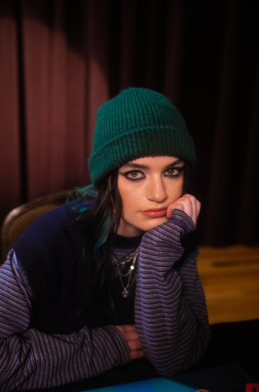
DOWNLOAD PRESS PHOTOS HERE
CREDIT: CHASE DENTON

WHAT CRITICS ARE SAYING:

“Sara Kays’ music has something to offer for everyone.” – PEOPLE

“Sara Kays knows what it takes to craft heartfelt lyrics spun with velvet, tight-knit arrangements that simply elevate the already high-flying material.” – AMERICAN SONGWRITER

“Normalizing life’s struggles that often seem easier to avoid, Sara has carved out a unique space…quickly creating a community through her message.” – FLAUNT

“Sara Kays has cultivated a devoted following by wearing her heart on her sleeve. The rapidly rising artist’s growing fanbase is a testament to her understated gift for empathetic songwriting.” – ONES TO WATCH

“One Of Pop Music’s Breakout Stars” – HUFFPOST

CONNECT WITH SARA KAYS:
SARAKAYS.COM | TIKTOK | TWITTER | INSTAGRAM | facebook | YOUTUBE | PRESS ASSETS

PRESS CONTACT:
ANDREW.GEORGE@ATLANTICRECORDS.COM

