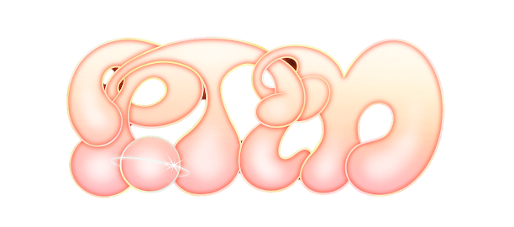

**PORTUGAL. THE MAN IS BACK WITH NEW SINGLE “DUMMY”**

[**DOWNLOAD/STREAM**](https://ptm.lnk.to/Dummy)

**LONG-AWAITED, JEFF BHASKER-PRODUCED NEW ALBUM**

***CHRIS BLACK CHANGED MY LIFE* OUT EVERYWHERE JUNE 23**

**“DUMMY” ARRIVES ALONGSIDE OFFICIAL MUSIC VIDEO**

**DIRECTED BY NOEL PAUL, STARRING TANK DOG**

[**WATCH “DUMMY” MUSIC VIDEO**](https://ptm.lnk.to/DummyVideoPR)

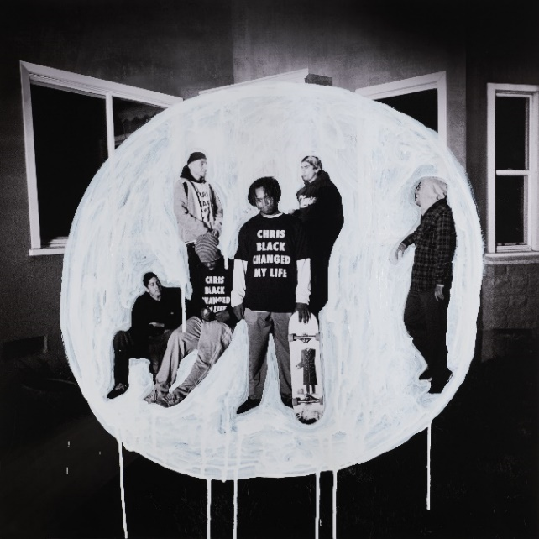

*Photo by Maclay Heriot*

*Design by John Gourley, Wes Hubbard, Maclay Heriot, Cleon Peterson, Em Steele & Austin Sellers*

**RECENTLY ANNOUNCED LIMITED HEADLINE SHOWS AT ICONIC VENUES:**

**LOS ANGELES’ HOLLYWOOD BOWL, NEW YORK CITY’S RADIO CITY MUSIC HALL, DENVER’S RED ROCKS AMPHITHEATRE & PORTLAND’S EDGEFIELD**

**GRAMMY WINNERS CELEBRATE NEW RIAA CERTIFICATIONS:  
“FEEL IT STILL” – 7X PLATINUM  
*WOODSTOCK* – PLATINUM ALBUM**

[**DOWNLOAD ALL PRESS ASSETS**](https://warnermusicgroup.box.com/s/90f3lk5ogl477r1rr5qct6aikbedwa1p)

*(album art, press photos, “Dummy” single art + lyrics)*

**(New York, NY – March 1, 2023)** Multi-platinum, GRAMMY Award-winning rock band **Portugal. The Man** make their triumphant return with new single, **“Dummy,”** available everywhere now via Atlantic Records. **Download/stream** [**HERE**](https://ptm.lnk.to/Dummy).

*“Worried about the impending nuclear war? “Dummy” is an ode to The Cure. For all those hopeless doomers out there waxing poetic on the end times while dancing to Boys Don’t Cry. All my troubles seem so far away. Thank you for waiting, it feels good to be back!”* – John Gourley, Portugal. The Man

**“Dummy”** is produced by **Asa Taccone** (**“Feel It Still”**) and marks the first official single from the band’s long-awaited new album, ***CHRIS BLACK CHANGED MY LIFE,*** produced by **Jeff Bhasker** (Beyonce, Harry Styles, SZA, Mark Ronson), due out **June 23**. The album is now available for pre-order HERE.

[**DOWNLOAD/STREAM “DUMMY”**](https://ptm.lnk.to/Dummy)[**PRE-ORDER *CHRIS BLACK CHANGED MY LIFE***](https://ptm.lnk.to/ChrisBlackChangedMyLife)

Accompanying the single is the official music video for **“Dummy”** directed by **Noel Paul** and stars the band’s new, honorary member, [**Tank Dog**](https://www.dropbox.com/scl/fo/tdrnwxzik49cowi436qvd/h?dl=0&rlkey=dsdn80v1j48z7o07szff9hpyx)**.** Created by **Wes Hubbard** ([Wooden Cyclops](https://www.instagram.com/woodencyclops/?hl=en&__coig_restricted=1)) and **John Gourley**, Tank Dog is PTM’s newest sidekick.

[**WATCH “DUMMY” MUSIC VIDEO**](https://ptm.lnk.to/DummyVideoPR)

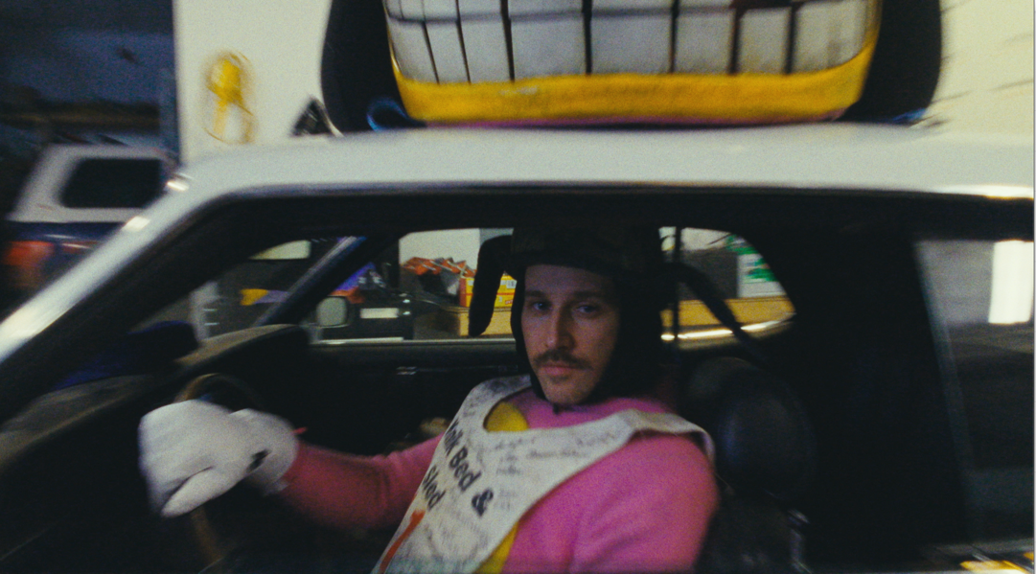

***CHRIS BLACK CHANGED MY LIFE*** is the band’s first full length album since the release of their now Platinum-certified, 2017 album, ***WOODSTOCK.*** The album’s opening song, **“Heavy Games II (feat. Jeff Bhasker),”** teased the forthcoming album with a companion visual featuring and produced by Jeff Bhasker – Watch [HERE.](https://www.youtube.com/watch?v=27k0KxyvRD4) The album is dedicated to the band’s late friend and honorary band member, Chris Black.

The Portland-based rockers will follow the release of ***CHRIS BLACK CHANGED MY LIFE*** with very few headline shows for 2023. Featuring a career spanning set, each show will take place at an iconic venue this summer, including Portland’s **Edgefield,** Colorado’s **Red Rocks Amphitheatre,** New York City’s **Radio City Music Hall** andLos Angeles’ **Hollywood Bowl.**

***CHRIS BLACK CHANGED MY LIFE* TRACKLIST:**

Heavy Games II (feat Jeff Bhasker)

Grim Generation

Thunderdome [W.T.A] (feat. ** & **)

Dummy

Summer of Luv (feat. **)

Ghost Town

Time’s a Fantasy (feat. ** & **)

Doubt

Plastic Island

Champ (feat. **)

Anxiety:Clarity (feat. **)

**UPCOMING LIVE SHOWS**

6/16 – Manchester, TN @ Bonnaroo

7/20 - Portland, OR @ Edgefield

7/23 - Morrison, CO @ Red Rocks Amphitheatre

7/27 - New York, NY @ Radio City Music Hall

8/6 - Los Angeles, CA @ Hollywood Bowl

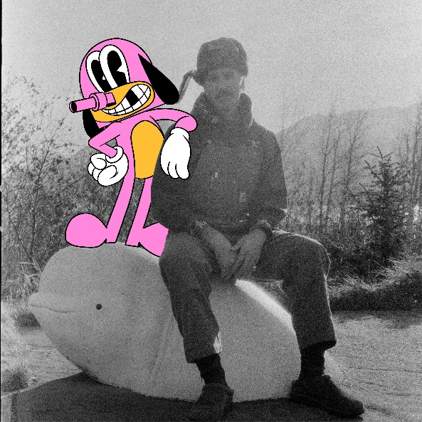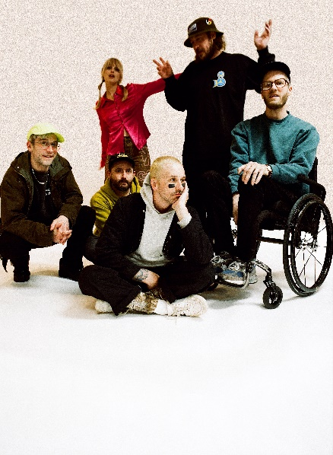

**PRESS CONTACTS:**

Jason Davis | [Jason.Davis@atlanticrecords.com](mailto:Jason.Davis@atlanticrecords.com)

Libby Kober | [Libby.Kober@atlanticrecords.com](mailto:Libby.Kober@atlanticrecords.com)

**ABOUT PORTUGAL THE MAN:**

Over the past decade, Portugal. The Man has established themselves as one of rock’s most prized possessions and a live phenomenon, with over 1,600 shows under their belts and a storied reputation as festival favorites.

Originally heralding from Alaska, the Portland-based band soared to new heights in 2017 with the release of their now RIAA certified-Platinum album, Woodstock. The album was marked by the astounding success of their infectious single, “Feel It Still,” which earned the group a plethora of new accolades – including a GRAMMY for “Best Pop Duo/Group Performance,” a 7x RIAA Platinum certification, a record setting 20-week residency at #1 on alternative radio, and an inescapable presence on the Top 40 airwaves.

Alongside the shine of their myriad of musical accomplishments lies the group’s long-standing passion for social justice. In fact, this is precisely the intersection in which Portugal. The Man thrives; throughout their career, the band has consistently exemplified how to deeply commit to both artistry and activism. This ultimately inspired them to officially launch PTM Foundation in 2020, focused on universal issues related to human rights, community health, and the environment, with an emphasis on causes directly impacting Indigenous Peoples, including Alaska Native Health (providing the highest quality of health services for Alaska Native people) and Seeding Sovereignty (radicalizing and disrupting colonized spaces through land, body, food sovereignty work and more).

Portugal. The Man have also partnered with an array of organizations such as National Coalition Against Censorship, The Skatepark Project (helping communities build public skate parks for youth in underserved communities), March for Our Lives (Gun Reform), Keep Oregon Well (Mental Health), and Protect Our Winters (Climate Change), to name just a few. In 2022, the band furthered their passion for activism when they launched PTM’s NIGHT OUT initiative – supporting disabled fans requiring ADA access.

**ABOUT *CHRIS BLACK CHANGED MY LIFE*:**

We lost a very dear friend of ours on May 19, 2019. It shook us to our core. Chris was one of those people who was like glue; he brought everyone together. His passing really messed with us. The band was in shambles and this record is the first time I feel I made a complete record; a complete thought about our world crumbling around us and the journey back. While it is a very personal journey, I feel like everyone has a Chris Black in their life; at least I hope that everyone has a Chris Black in their life. That one friend who has a way of making everything right and making everything fun. The one who keeps you in check when you go off course and is always there to celebrate the good times and to support you in the bad times. Chris Black Changed My Life.

# # #