

**PORTUGAL. THE MAN RELEASES “DUMMY (CHRIS LAKE REMIX)”**

[**DOWNLOAD/STREAM**](https://ptm.lnk.to/DummyChrisLakeRemix)

**ACCLAIMED PRODUCER + DJ DEBUTED REMIX DURING LIVE SETS AT MIAMI MUSIC WEEK – WATCH** [**HERE**](https://www.tiktok.com/@chrislake/video/7213097520463973674?lang=en)

**PORTUGAL. THE MAN’S HIGHLY-ANTICIPATED NEW ALBUM**

***CHRIS BLACK CHANGED MY LIFE* DUE JUNE 23 – PRODUCED BY JEFF BHASKER**

**“DUMMY” ALREADY TOP 15 AT ALTERNATIVE RADIO**

[**LISTEN TO “DUMMY”**](https://nam04.safelinks.protection.outlook.com/?url=https%3A%2F%2Fptm.lnk.to%2FDummy&data=05%7C01%7CKaty.Carmichael%40atlanticrecords.com%7C63e90f49085b4ab4c2c308db1a77cd1a%7C8367939002ec4ba1ad3d69da3fdd637e%7C0%7C0%7C638132874133693621%7CUnknown%7CTWFpbGZsb3d8eyJWIjoiMC4wLjAwMDAiLCJQIjoiV2luMzIiLCJBTiI6Ik1haWwiLCJXVCI6Mn0%3D%7C3000%7C%7C%7C&sdata=OBkumGFMOaHwIjDKwN4DxfUNvfSUYC2t1iPijFRWqGI%3D&reserved=0) **|** [**WATCH OFFICIAL MUSIC VIDEO**](https://nam04.safelinks.protection.outlook.com/?url=https%3A%2F%2Fptm.lnk.to%2FDummyVideoPR&data=05%7C01%7CKaty.Carmichael%40atlanticrecords.com%7C63e90f49085b4ab4c2c308db1a77cd1a%7C8367939002ec4ba1ad3d69da3fdd637e%7C0%7C0%7C638132874133693621%7CUnknown%7CTWFpbGZsb3d8eyJWIjoiMC4wLjAwMDAiLCJQIjoiV2luMzIiLCJBTiI6Ik1haWwiLCJXVCI6Mn0%3D%7C3000%7C%7C%7C&sdata=JpQUy1dm5oDqzskSjq9DeC6j6UY4FwiYwffcrUvxtVo%3D&reserved=0)

DOWNLOAD REMIX ARTWORK [HERE](https://warnermusicgroup.box.com/s/ey5ad33tt3l6tbrd3bps1f4o31h9t5p1)

[**DOWNLOAD ALL PRESS ASSETS**](https://nam04.safelinks.protection.outlook.com/?url=https%3A%2F%2Fwarnermusicgroup.box.com%2Fs%2F90f3lk5ogl477r1rr5qct6aikbedwa1p&data=05%7C01%7CKaty.Carmichael%40atlanticrecords.com%7C63e90f49085b4ab4c2c308db1a77cd1a%7C8367939002ec4ba1ad3d69da3fdd637e%7C0%7C0%7C638132874133693621%7CUnknown%7CTWFpbGZsb3d8eyJWIjoiMC4wLjAwMDAiLCJQIjoiV2luMzIiLCJBTiI6Ik1haWwiLCJXVCI6Mn0%3D%7C3000%7C%7C%7C&sdata=pRvN10%2FIv7ayL96SDBfowQFAxqF1NyRuRCZ5Yc0DT2s%3D&reserved=0)

*(album art, press photos, “Dummy” single art + lyrics)*

**PORTUGAL. THE MAN HEADLINING LIMITED SHOWS AT ICONIC VENUES THIS YEAR: LOS ANGELES’ HOLLYWOOD BOWL, NEW YORK CITY’S RADIO CITY MUSIC HALL, DENVER’S RED ROCKS AMPHITHEATRE & PORTLAND’S EDGEFIELD**

**GRAMMY WINNERS CELEBRATING NEW RIAA CERTIFICATIONS:  
“FEEL IT STILL” – 7X PLATINUM | *WOODSTOCK* – PLATINUM ALBUM**

*“Worried about the impending nuclear war? ‘Dummy’ is an ode to The Cure. For all those hopeless doomers out there waxing poetic on the end times while dancing to Boys Don’t Cry. All my troubles seem so far away. Thank you for waiting, it feels good to be back!”* – John Gourley, Portugal. The Man

***CHRIS BLACK CHANGED MY LIFE* TRACKLIST:**

Heavy Games II (feat Jeff Bhasker)

Grim Generation

Thunderdome [W.T.A] (feat. ** & **)

Dummy

Summer of Luv (feat. **)

Ghost Town

Time’s a Fantasy (feat. ** & **)

Doubt

Plastic Island

Champ (feat. **)

Anxiety:Clarity (feat. **)

**UPCOMING LIVE SHOWS**

6/16 – Manchester, TN @ Bonnaroo

7/20 - Portland, OR @ Edgefield

7/23 - Morrison, CO @ Red Rocks Amphitheatre

7/27 - New York, NY @ Radio City Music Hall

8/6 - Los Angeles, CA @ Hollywood Bowl

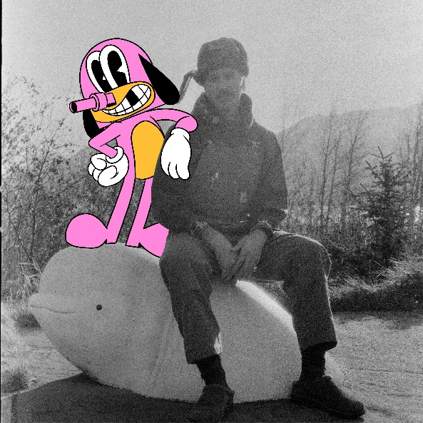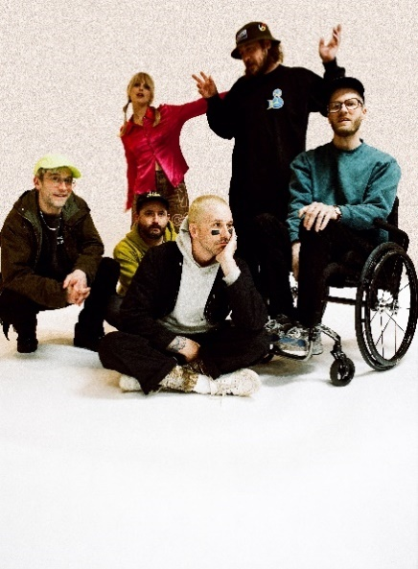

**PRESS CONTACTS:**

Jason Davis | [Jason.Davis@atlanticrecords.com](mailto:Jason.Davis@atlanticrecords.com)

Libby Kober | [Libby.Kober@atlanticrecords.com](mailto:Libby.Kober@atlanticrecords.com)

**ABOUT PORTUGAL THE MAN:**

Over the past decade, Portugal. The Man has established themselves as one of rock’s most prized possessions and a live phenomenon, with over 1,600 shows under their belts and a storied reputation as festival favorites.

Originally heralding from Alaska, the Portland-based band soared to new heights in 2017 with the release of their now RIAA certified-Platinum album, Woodstock. The album was marked by the astounding success of their infectious single, “Feel It Still,” which earned the group a plethora of new accolades – including a GRAMMY for “Best Pop Duo/Group Performance,” a 7x RIAA Platinum certification, a record setting 20-week residency at #1 on alternative radio, and an inescapable presence on the Top 40 airwaves.

Alongside the shine of their myriad of musical accomplishments lies the group’s long-standing passion for social justice. In fact, this is precisely the intersection in which Portugal. The Man thrives; throughout their career, the band has consistently exemplified how to deeply commit to both artistry and activism. This ultimately inspired them to officially launch PTM Foundation in 2020, focused on universal issues related to human rights, community health, and the environment, with an emphasis on causes directly impacting Indigenous Peoples, including Alaska Native Health (providing the highest quality of health services for Alaska Native people) and Seeding Sovereignty (radicalizing and disrupting colonized spaces through land, body, food sovereignty work and more).

Portugal. The Man have also partnered with an array of organizations such as National Coalition Against Censorship, The Skatepark Project (helping communities build public skate parks for youth in underserved communities), March for Our Lives (Gun Reform), Keep Oregon Well (Mental Health), and Protect Our Winters (Climate Change), to name just a few. In 2022, the band furthered their passion for activism when they launched PTM’s NIGHT OUT initiative – supporting disabled fans requiring ADA access.

**ABOUT *CHRIS BLACK CHANGED MY LIFE*:**

We lost a very dear friend of ours on May 19, 2019.  It shook us to our core.  Chris was one of those people who was like glue; he brought everyone together. His passing really messed with us. The band was in shambles and this record is the first time I feel I made a complete record; a complete thought about our world crumbling around us and the journey back. While it is a very personal journey, I feel like everyone has a Chris Black in their life; at least I hope that everyone has a Chris Black in their life. That one friend who has a way of making everything right and making everything fun. The one who keeps you in check when you go off course and is always there to celebrate the good times and to support you in the bad times. Chris Black Changed My Life.

**ABOUT CHRIS LAKE:**

As house music becomes ever more ubiquitous, beguiling listeners around the globe, British producer/DJ Chris Lake has cemented his status as one of the genre’s most compelling and massively successful artists, with combined global streams of his songs surpassing one billion. Since making his breakthrough with a string of #1 singles in the late 2000s, the GRAMMY®-nominated musician has toured the globe, bringing his explosive DJ set to virtually every major music festival. His relentless dedication to following his potent creative instincts has seen Lake return repeatedly to Billboard’s Hot Dance/Electronic Songs chart with recent hits like “A Drug From God” – his collaboration with Grimes’ new AI girl group, NPC – the long-awaited ID “In The Yuma” (Ft. Aatig) and the transcendent “I Remember.” He teamed up with legendary producer Armand Van Helden for the epic 2020 EP The Answer and his late 2022 remix of KH’s “Looking at Your Pager” quickly became a club staple, supported by the likes of Peggy Gou, Skrillex and Four Tet.  Founder of the pioneering record label Black Book Records, Lake has helped launch the careers of Cloonee, Miane, HoneyLuv, Mochakk and numerous other rising artists. Over the past two years, Lake has brought many of Black Book’s artists on his sold-out, outdoor summer block party tour, playing to over 50,000 fans.

# # #