FOR IMMEDIATE RELEASE
MARCH 10, 2023

QUANDO RONDO IS IN RECOVERY MODE AS HE LAUNCHES THE PRE-ORDER FOR HIS UPCOMING ALBUM RELEASING 3/24
PRE-ORDER IS ACCOMPANIED BY THE RELEASE OF “TEAR IT DOWN” SINGLE
SECOND SINGLE FROM THE UPCOMING ALBUM IS ACCOMPANIED BY OFFICIAL VISUAL
20-TRACK ALBUM INCLUDES A LONE FEATURE FROM YOUNGBOY NEVER BROKE AGAIN
SERVES AS THE FOLLOW-UP TO “ME FIRST” SINGLE NOW BOASTING 1M+ VIEWS
TRAILER FOR HIS UPCOMING ALBUM DOCUMENTARY CAN BE VIEWED HERE
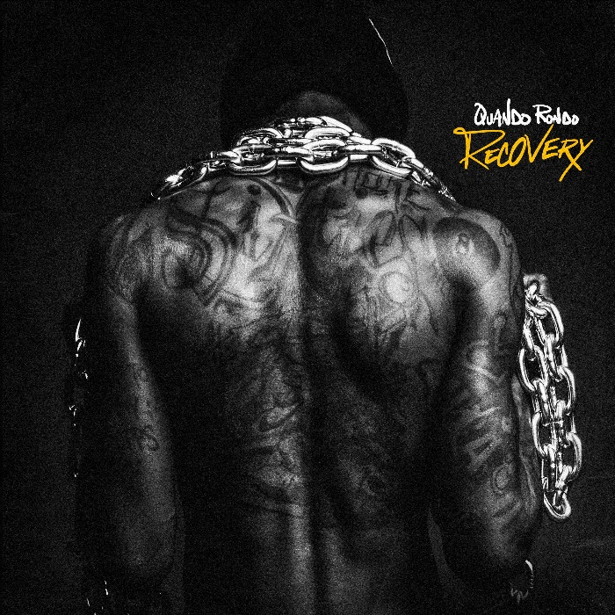
DOWNLOAD HI-RES ARTWORK
WATCH HERE
Quando Rondo continues his string of releases with the launch of the pre-order for his new album, Recovery, releasing on 3/24. The 20-track album includes a lone feature from YoungBoy Never Broke Again on their track “Give Me A Sign” which Quando released after the untimely passing of his cousin. The pre-order is accompanied by the latest single from his upcoming album, “Tear It Down.” Quando flows perfectly to compliment the beat on “Tear It Down” as he raps about his lifestyle. His vocals provide a more mature sound than his fans are used to – showing the world that he has evolved over the years. “Tear It Down” is accompanied by a companion visual available for streaming now. The single serves as a follow-up to the “Me First” with the visual now boasting 1M+ views. Quando also shared the trailer for his upcoming album documentary available to view HERE.
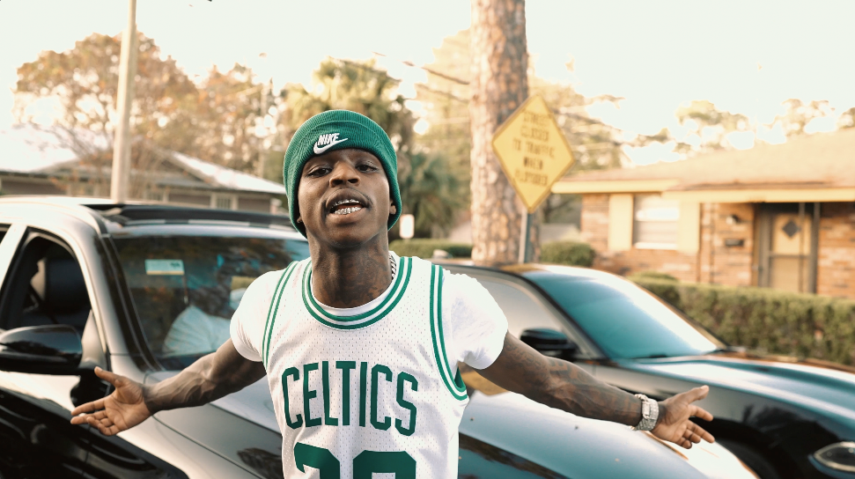
RECOVERY TRACKLIST

- 50
- Blame
- Lost Ones
- Me First
- Plenty Muscle
- Speeding
- Cut You Off
- Tear It Down
- Vision
- Where Would I Be
- Heartaches
- R.I.P. Phat Phat
- From The Bottom
- Counting Bands
- I Admit
- Long Live Pabb
- Nightmare
- No Scale
- Forever 16
- Give Me A Sign with YoungBoy Never Broke Again

# # #
QUANDO RONDO

Quando Rondo cements his legacy in ironclad bars and hazy hooks, building out a prolific body of work meant to last. The platinum Savannah, GA rapper spits with classic dexterity as he spouts off modern melodies with emotional precision and a head-nodding bounce. Since 2017, he has consistently amplified the spirit of the streets throughout the mainstream on his own terms, translating the struggles of Savannah (and hoods everywhere) into a dynamic documentary-style sound. Along the way, he logged a flurry of platinum singles including “ABG,” “I Remember” [feat. Lil Baby], “Imperfect Flower,” and YoungBoy Never Broke Again’s “I Am Who They Say I Am” with Kevin Gates. In between a string of critically acclaimed mixtapes and sold-out tour dates, he served up his 2020 full-length debut album, QPac, and bowed in the Top 25 of the Billboard Top 200.

Quando officially kicked off his busy 2022 with the previously released single, “Dead Wrong,” available for streaming and download HERE; an official music video is streaming HERE. “Give Me A Sign (Feat. YoungBoy Never Broke Again)” continued the rising star’s high-volume year, following such recently released tracks as “Cream Soda,” “It’s On,” “War Baby,” “24,” “10.27,” “Six-0 Business,” “Jakiyah” and his recent guest verse on YoungBoy Never Broke Again’s “Gangsta (Ft. Quando Rondo)” – the only feature on YoungBoy’s chart-topping 2022 mixtape, COLORS. After a flurry of single releases throughout the year, Quando ended his 2022 in a major way with the release of a collab mixtape with YoungBoy, entitled 3860. To kick off 2023, the rap phenom brought new energy to the first single from his upcoming album, “Me First,” taking fans back to the early days of his career.

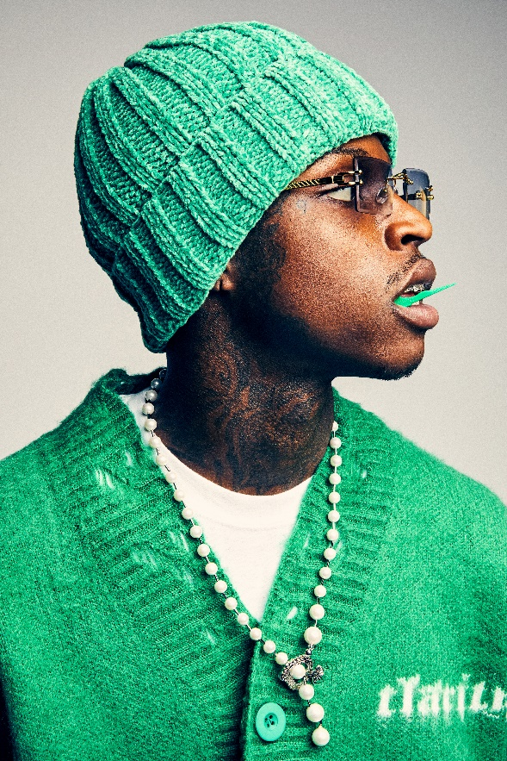
DOWNLOAD HI-RES PHOTOS
CREDIT: JIMMY FONTAINE

CONNECT WITH QUANDO RONDO
OFFICIAL | INSTAGRAM | TWITTER | FACEBOOK | YOUTUBE

FOR ALL PRESS INQUIRIES, PLEASE CONTACT:
ARIANA.WHITE@ATLANTICRECORDS.COM

