FOR IMMEDIATE RELEASE
MARCH 24, 2023

PUNK RAP QUEEN RICO NASTY REVITALIZES HER HIT CLASSIC “BEAT MY FACE” IN COLLAB WITH URBAN DECAY
WILL OFFICIALLY BE RELEASING ON DSPS FOR THE FIRST TIME SINCE 2017
CURRENTLY TRENDING ON TIKTOK WITH OVER 60K+ CREATES
CHECK OUT URBAN DECAY’S FUN TIKTOK TO CELEBRATE THE MOMENT
THE QUEEN OF SUGAR TRAP WILL ALSO BE KICKING OFF HER HEADLINING TOUR ON 4/16
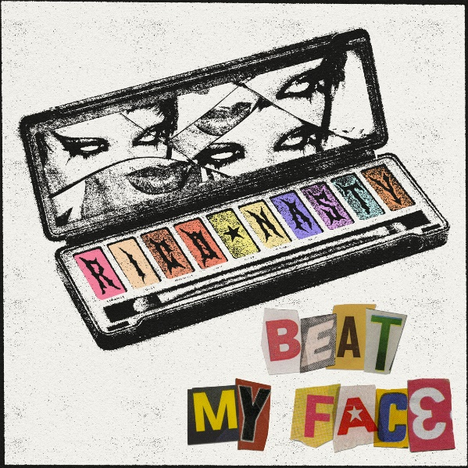
DOWNLOAD HI-RES ARTWORK
STREAM HERE

Today, certified rockstar, Rico Nasty, revitalized her previous Soundcloud and YouTube exclusive hit, “Beat My Face.” The track is now available on all DSPs after gaining traction on TikTok and now has over 60K+ fan creates on the platform. As the hit grew, it caught the ears of a few people at Urban Decay and has now become the official sound of their new campaigns. The brand has even made a fun TikTok to celebrate the momentous occasion.
Last month, Rico announced her 2023 headlining tour, Monster Energy Outbreak Tour Presents: Rico Nasty. The tour will kick off in Toronto, ON, on April 16 at Toybox Nightclub and stop in major cities, including Brooklyn, Washington D.C., and Los Angeles, and more, before wrapping in Detroit on May 26 at the El Club. Last year, Rico Nasty delivered Las Ruinas, a 17-track project that she labeled a mixtape featuring singer/songwriter Bibi Bourelly (Rihanna, Christina Aguilera, Usher), Electronic producer and DJ Marshmello and more. She also joined Kehlani last September on the domestic leg of her Blue Water Road Trip tour. That same year, her hit track "Smack a Bitch," produced by Kenny Beats, was RIAA-certified Platinum. Fans can access tickets at www.riconastymusic.com. See the full schedule below.
# # #
MONSTER ENERGY OUTBREAK TOUR PRESENTS: RICO NASTY
*Support from Omeretta The Great*

APRIL
16 – Toronto, ON – Toybox
18 – Boston, MA – The Sinclair
19 – Brooklyn, NY – Music Hall of Williamsburg
20 – Philadelphia, PA – Theatre of Living Arts
23 – Washington DC – The Fillmore
25 – Nashville, TN – Eastside Bowl
26 – Atlanta, GA – Center Stage
28 – New Orleans, GA – Republic NOLA
29 – Houston, TX – Bronze Peacock at House of Blues
30 – Dallas, TX – The Studio at the Factory
MAY
2 – Phoenix, AZ – Crescent Ballroom
3 – Las Vegas, NV – 24 Oxford
7 – San Diego, CA – SOMA
8 – Los Angeles, CA – El Rey Theatre
11 – Oakland, CA – The New Parish
12 – San Francisco, CA – Great American Music Hall
14 – Santa Cruz, CA – The Catalyst - Atrium
16 – Seattle, WA – Neumos
17 – Portland, OR – Hawthorne Theater
19 – Salt Lake City, UT – Soundwell
21 – Denver, CO – Bluebird Theater
23 – Saint Paul, MN – Amsterdam Bar & Hall
24 – Chicago, IL – Avondale Music Hall
26 – Detroit, MI – El Club
27 – Cincinnati, OH – Top Cats
# # #
RICO NASTY
Many artists change the game. However, Rico Nasty reinvents, recharges, and reimagines it with every move. Instead, the Washington, D.C.-born and Maryland-raised sonic sorceress shapeshifts at the speed of the culture, infusing airtight rap with uncontainable punk energy, hyperpop unpredictability, industrial intensity, and just the right amount of heavy metal attitude. Back in high school, she made waves with a series of independent projects before reaching critical mass with 2017’s Sugar Trap 2. On its heels, she maintained this momentum with the fan favorite Nasty in 2018. The collaborative mixtape Anger Management with Kenny Beats closed out 2019 on over a dozen year-end lists, including Complex, Dazed, Fact, The FADER, GQ, NME, Pitchfork, Rolling Stone, Stereogum, and Vice. During 2020, her full-length debut, Nightmare Vacation, boasted the gold-certified hit “Smack A Bitch.” Peers sought her out for high-profile collaborations, including the platinum “Tia Tamera” with Doja Cat, “#PROUDCATOWNERREMIX” with the late XXXTentacion, “¡aquí yo mando!” with Kali Uchis, and more. Rico’s’s the rare outlier who can grace the cover the XXL Freshman issue or light up Rihanna’s Savage X Fenty Show as an ambassador and ignite a mosh pit.
With an inimitable and influential signature style, she has reached multiplatinum status, posted up nearly 1 billion streams, and sold out countless shows. Last year she unleashed unfiltered truth with the force of a tornado through a tidal wave on Las Ruinas but from here on out Rico’s new mission is to take us back to the Sugar Trap – where it all began.
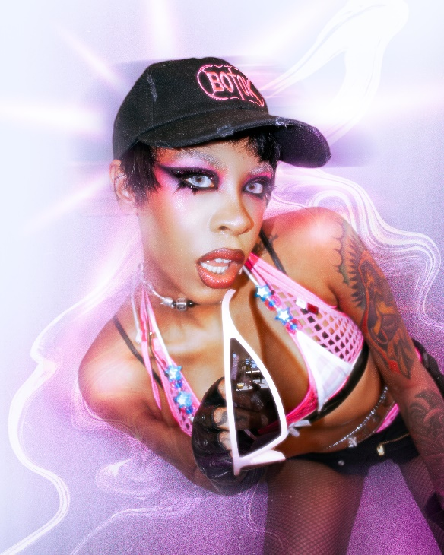
CONNECT WITH RICO NASTY:
WEBSITE | INSTAGRAM | TWITTER | FACEBOOK | YOUTUBE

FOR PRESS INQUIRIES, PLEASE CONTACT:
Ariana White | Ariana.White@atlanticrecords.com

