FOR IMMEDIATE RELEASE
MARCH 10, 2023

RITON DROPS OFFICIAL VIDEO TO
“SUGAR (FEAT. SOAKY SIREN)”

WATCH IT HERE

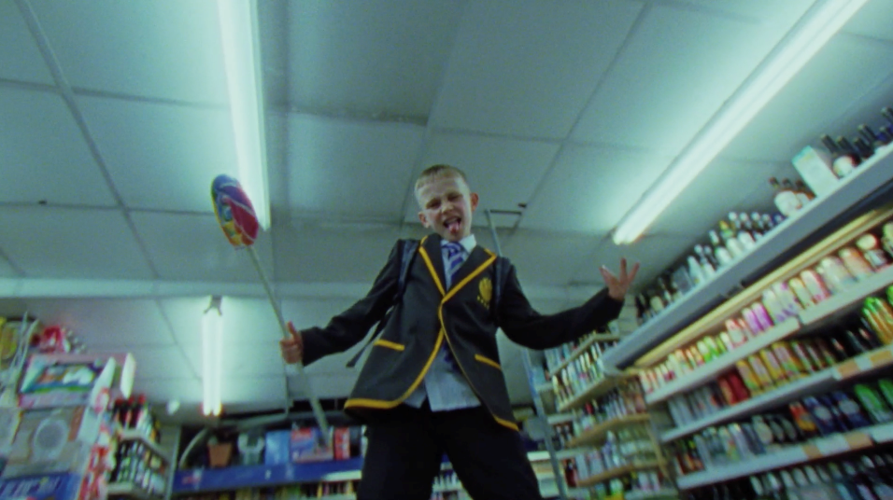

GRAMMY winning DJ/producer Riton has dropped the official video to new single, “Sugar (feat. Soaky Siren)” – watch it HERE.

Directed by So Me from Iconoclast, the official video trails a schoolboy on a fun, sweet-fuelled rampage across inner-city London; trading his uniform for a tie-dye hoodie, he dances on tables, raids off licenses, smashes glasses and causes maximum chaos on his quest for more sugar!

The pre-cursor to an incoming mixtape due later this year, ‘Sugar’ – which features the vocals of Latin GRAMMY-nominated rapper & singer-songwriter, Soaky Siren – is an explosive, peak-time dance anthem, niftily flipping a cut-and-paste sample from 50 Cent’s 2005 classic, ‘Candy Shop’. Bold, hyper-infectious and packing the sort of rowdy, carefree energy that feels woven into the fabric of all Riton’s forthcoming music, ‘Sugar’ marks an exciting introduction to Riton’s bright new technicolour world.

‘Sugar’ also dropped alongside a first-of-its-kind generative AI visualiser, developed by the WMG Global Data Science team. Created using a model that generates images based off of text descriptions, (known as Stable Diffusion), which was further trained on Riton’s face and moodboards, the team were also able to make the visuals react to the audio using AI, isolating audio individual elements and feeding them back into the animation. “It was a really exciting collaboration between data science and Atlantic’s creative team as we refined the aesthetic together”, explains Philip Watson, who headed up the visualiser’s creation. Watch the ‘Sugar’ visualiser HERE.

‘Sugar’ ft. Soaky Siren is out now on Atlantic Records: https://lnk.to/riton-sugar

About Riton
Riton has been at the vanguard of UK dance music for over 20 years. A legendary and vastly influential producer straddling both the underground (Ed Banger, Soul Wax, Ministry Of Sound) and the mainstream, he boasts collaborations with everyone from Fat Boy Slim, The Chemical Brothers and Diplo to Tame Impala and M.I.A., racking up over 2 billion global streams in the process. He also shared co-production on Silk City’s 2018 GRAMMY-winning smash ‘Electricity’ ft. Dua Lipa, as well as earning a 2017 GRAMMY nomination for ‘Rinse & Repeat’ ft. Kah-Lo and a BRIT nomination for 2021 UK #4 single ‘Friday’ ft. Mufasa and Hypeman – a record fast closing in on 1 billion streams of its own.

Connect With Riton:
Instagram | Twitter | Facebook | Tik Tok

Connect With Soaky Siren:
Instagram | Twitter | Facebook | Tik Tok

Contact:
Jessica Nall / Atlantic Records
Jessica.Nall@atlanticrecords.com

