FOR IMMEDIATE RELEASE
MARCH 7, 2023

GROUNDBREAKING ALTERNATIVE ARTIST SAM AUSTINS RELEASES NEW SINGLE “KEEP YOU COMPANY”

OFF FORTHCOMING EP DUE MAY 19 VIA ATLANTIC RECORDS

RECENTLY NAMED TO THE NME 100: ‘ESSENTIAL EMERGING ARTISTS FOR 2023’

LISTEN TO “KEEP YOU COMPANY” HERE
PRE-SAVE EP HERE

“riveting star quality… Sam Austins’ music has been described by Pusha T as ‘a mix between ‘My Beautiful Dark Twisted Fantasy’ and Prince,’ surely some of the highest praise you could get. Inspired by Motown and making music that incorporates indie, psych, R&B and beyond, Austins is a true Gen Z chameleon, but everything is imbued with a singular vision and unique voice.” – NME

“Sam Austins is a boundary-breaker, challenging long-held ideas of what it means to be an alternative artist.” – BILLBOARD

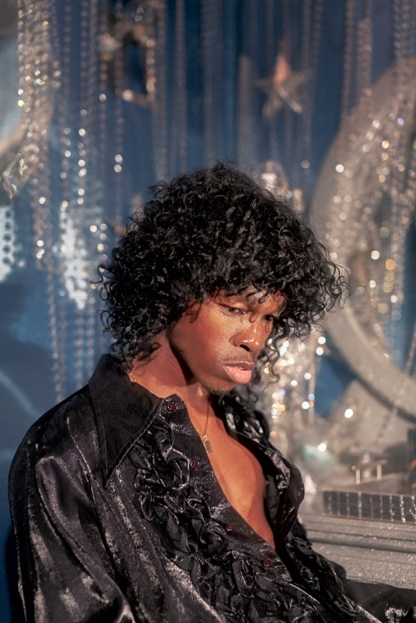
DOWNLOAD HI-RES PRESS PHOTO

Groundbreaking alternative singer-songwriter/model/artist Sam Austins returns with his first new music of 2023 – “Keep You Company” (listen HERE) – the magnetic lead single off his forthcoming EP, due May 19 via Atlantic Records (pre-save HERE). Opening with an addictively catchy guitar line, “Keep You Company” perfectly introduces us to the unforgettable, genre-bending world that Sam Austins continues to build with each project he unveils.

Recently named to the highly-regarded NME 100 (‘essential emerging artists for 2023’), the Detroit-born, LA-based musician has become known for effortlessly merging sounds and influences, “incorporat[ing] indie, psych, R&B and beyond,” and proving himself to be “a true Gen Z chameleon,” according to the UK publication.

“This song is inspired by the feeling of wanting acknowledgment from someone I deeply care for, and reaching out for their attention,” Austins shares of today’s release. “I’m letting that person know I need them and will cherish them, if they decide to step into my life. These thoughts became a loud, brash voice of edge and bravado, and manifested in a channeling of a forlorn rockstar, desperately crooning out into the world for this person they truly loved.”

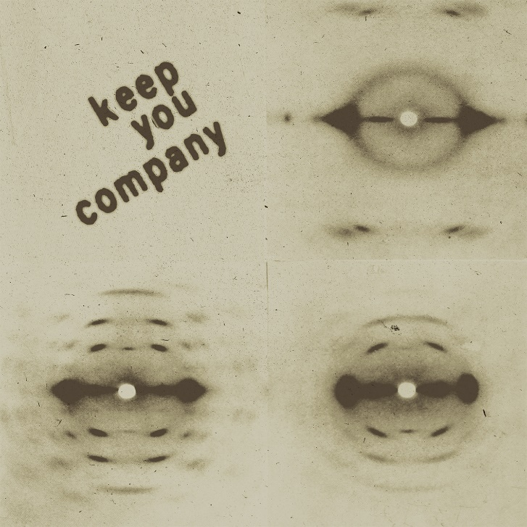
DOWNLOAD HI-RES SINGLE ARTWORK

“Keep You Company” follows “Dancing With The Devil” and “Matador” – two standout singles that Austins released in the fall of 2022, before embarking on his first-ever North American tour, supporting beloved indie artist Dora Jar. That tour saw Austins stop in cities from Boston to Chicago to San Francisco, and included sold-out shows at NYC’s iconic Bowery Ballroom, as well as LA’s storied Troubadour, where the run culminated.

Austins’ forthcoming May release marks the first EP that the artist has shared since his standout, debut mixtape, 2021’s HOMELESS STAR, which featured top single “JOY FOR YOUTH” with Atlantic labelmate Sir Chloe. Since he first arrived onto the scene, Sam Austins has become known for crafting music that’s simultaneously uplifting and melancholic, vulnerable and wildly inventive – an ability that’s been recognized with playlist adds from New Music Friday, Lorem, and Apple Music’s New Music Daily, sync placement on HBO’s Euphoria, and a slot at Lollapalooza last summer.

PRAISE FOR SAM AUSTINS

“Creating immersive and genre-fluid sonic worlds as conduits for his stories about growing up between the Michigan suburbs and the roaring city of Detroit, Austins’ music buzzes with a propulsive energy and has been described by Pusha T as a mix between My Beautiful Dark Twisted Fantasy and Prince.” – NME

“‘Matador‘ has everything you could want from a pop banger, a catchy chorus, exciting production and an inspiring popstar. Like the trumpets that usher the track in and dramatically see it out, Sam Austin doesn’t mess around. He enters, says what he needs to say and leaves, but not without a few dramatic flourishes to keep us coming back.” – CLUNK

“Love can and is all-consuming. On ‘Matador,’ that raw passion comes to life with unbound expression. Between his own feverish vocal performance, the driving guitars at his side, and the searing trumpet blaring its brassy, buoyant melody, Sam Austins ensures we hang on every moment of this dazzling, dramatic song.” – ATWOOD MAGAZINE

DOWNLOAD HI-RES PRESS PHOTO

# # #

ABOUT SAM AUSTINS:
Sam Austins is quickly rising to the forefront of contemporary art pop with his revolutionary fusion of energies, merging 90s alternative and R&B melodies with the aspirational aesthetics of high fashion and authentic tales of his Detroit youth. A series of increasingly acclaimed releases and performances saw the preternaturally gifted musician and in-demand model earning early acclaim and accolades from such outlets as VOGUE, HYPEBEAST, Pigeons & Planes, and many more.

Austins joined Atlantic Records’ legendary roster in 2021 and quickly unveiled his label debut mixtape, HOMELESS STAR, highlighted by such genre-defying singles as “KILOS,” “MIND ON DRUGS,” “DRIFTING AWAY,” and “JOY FOR YOUTH (with Sir Chloe),” all available now for streaming and download. The 10-track collection was greeted by critical acclaim from the likes of Billboard, which raved, “Austins carries his struggles proudly, channeling his experiences as inspiration for the creative direction and lyrical content of HOMELESS STAR…The avant-garde storyteller paints a picture of Detroit in the summer…he hones in on eclectic influences that manage to achieve synchronicity…part Blood Orange, part Tame Impala, yet entirely Austins.”

CONNECT WITH SAM AUSTINS
WEBSITE | FACEBOOK | INSTAGRAM | TWITTER | YOUTUBE

PRESS CONTACT
Fairley McCaskill | Fairley.McCaskill@atlanticrecords.com

