FOR IMMEDIATE RELEASE
MARCH 7, 2023

SIR CHLOE UNVEILS “HOOVES” VIDEO

DEBUT ALBUM I AM THE DOG OUT MAY 19 VIA ATLANTIC RECORDS

TO TOUR NORTH AMERICA AND EUROPE

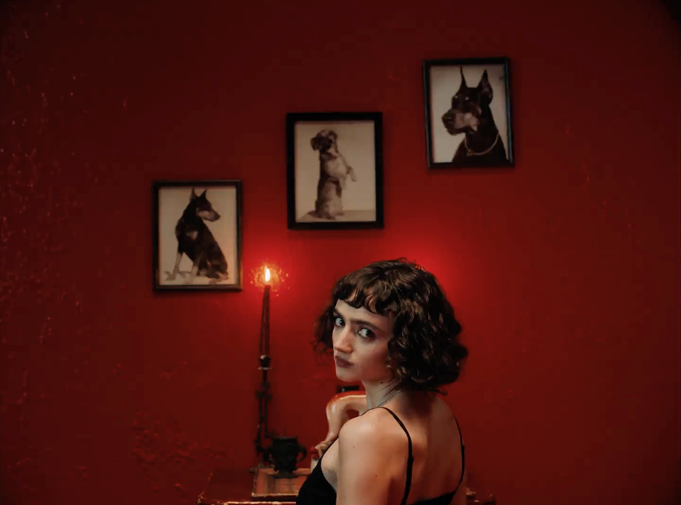
DOWNLOAD HI-RES THUMBNAIL

Today, Sir Chloe—the project of vocalist, songwriter and guitarist Dana Foote—unveils the video for, “Hooves,” directed by Molly Hawkins and Grant Spanier—watch here. The song is the lead single from Sir Chloe’s debut album, I Am the Dog, slated for release May 19 via Atlantic Records— pre-order/pre-save it here.

Additionally, Sir Chloe will embark on I Am The Tour later this year, a run of headline dates in North America and Europe, as well as previously confirmed support for a coheadline tour with Phoenix and Beck, which will also feature support from Japanese Breakfast, Weyes Blood and Jenny Lewis—see full routing below and get tickets here.

Made with Grammy-winning producer John Congleton (Lana Del Rey, St. Vincent, Angel Olsen) with songwriting contributions from Teddy Geiger (Caroline Polachek, Sylvan Esso, Lizzo) and Sarah Tudzin (Weyes Blood, Amen Dunes, Slowdive), I Am The Dog encapsulates the thrilling paradoxical nature of Sir Chloe. Thematically, the album grapples with finding control in the innate chaos of life, highlighting and interrogating this tension, only to destabilize it and opt for chaos once again. Anchored by Foote’s emotional and dynamic voice, the album toes the line between expression and concealment, making a fetish of the unsaid with lyrics that are simultaneously frank and ambiguous. With this constant push and pull propelling the album forward, Foote’s aim isn’t to be at rest but rather to ask why she cannot be.

Foote put Sir Chloe together in college to serve as her senior thesis, going on to write the band’s first major hits “Michelle”—which has accumulated more than 180 million streams on Spotify—and “Animal” on the floor of her dorm room. The rest of the songs on Sir Chloe’s 2020 EP Party Favors were recorded in a warehouse that the band transformed into a recording space with just $100 and sheer will. Following the success of the EP and two additional singles in 2022, the band—which consists of Foote, Teddy O'Mara, Palmer Foote, and Austin Holmes—toured arenas with Portugal. The Man and alt-J, opened for the Pixies and headlined two tours of their own in the United States and Europe, with sold out stops in New York, Los Angeles, London, Paris, Amsterdam and more.

SIR CHLOE—I AM THE DOG

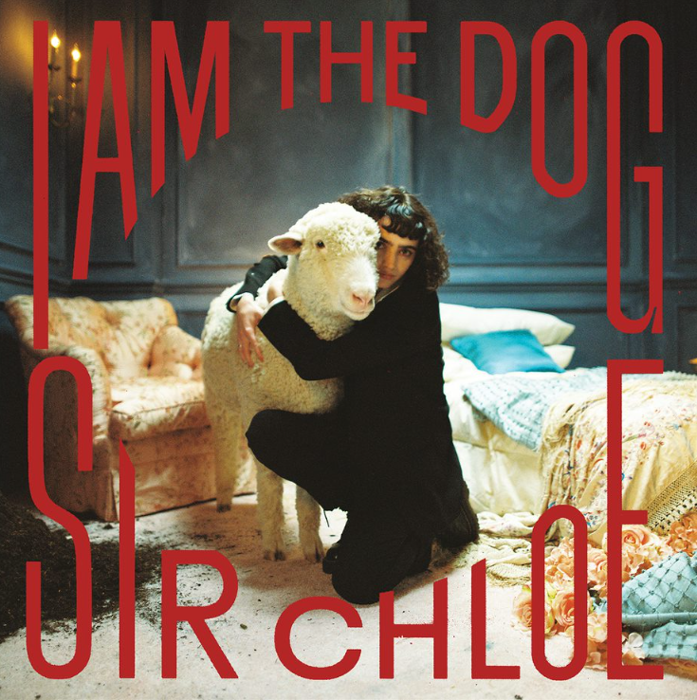
DOWNLOAD ARTWORK HERE
CREDIT: GRANT SPANIER

1. Should I
2. Salivate
3. Center
4. Know Better
5. Leash
6. Hooves
7. Obsession
8. Daddy’s Car
9. Cake
10. I Am The Dog
11. Feel Again

SIR CHLOE LIVE

MAY
18—New York, NY—Racket
24—Dublin, IR— The Academy, Green Room
25—Belfast, UK—Limelight 2
27—Leeds, UK—Live At Leeds Festival
30—Nottingham, UK—Rescue Rooms

JUNE
1—Manchester, UK—Band On The Wall
2—London, UK—Heaven
3—Brighton, UK—Patterns
5—Bristol, UK—Thekia
6—Birmingham, UK—O2 Institute 2
7—Glasgow, UK—SGW Galvanizers
9—Antwerp, BE—Trix
10—Hilvarenbeek, NL—Best Kept Secret Festival
13—Paris, FR— Le Trabendo
14—Frankfurt, DE—Brotfabrik
15—Cologne, DE—Luxor
16—Berlin, DE—Frannz
17—Linz, AT—Lido Sounds Festival
20—Stockholm, SE—Hus 7
21— Oslo, NO—Parkteateret
22—Copenhagen, DK—Lille Vega
24—Prague, CZ— Metronome
25—Warsaw, PL—Niebo
26—Budapest, HU—Akvarium Klub
28—Lucerne, CH— Schuur Lucerne
29—Milan, IT—Legends

JULY
2—Arras, FR—Main Square Festival
30—Vancouver, BC—Cobalt

AUGUST
1—Seattle, WA—Seattle Climate Pledge Arena*
2—Portland, OR—Hawthorne Theater
3—Bend, OR—Hayden Homes Amphitheater*
5—Concord, CA—Concord Pavilion*
7 —Los Angeles, CA—Kia Forum*
8—San Diego, CA—Viejas*
10—Santa Fe, NM—Meow Wolf
11—Phoenix, AZ—Footprint Center*
12—Las Vegas, NV—Michelob Ultra Arena*
14—Salt Lake City, UT—Soundwell
15—Morrison, CO—Red Rocks*
18—Rogers, AR—Walmart Amp*
19—Oklahoma City, OK—Beer City Music Hall
20—Houston, TX—Cynthia Woods Pavilion*
21—Dallas, TX—Dos Equis Pavilion*
22—Austin, TX—Moody Center*
24—Des Moines, IA—Wooly’s
25—Lawrence, KS—Bottleneck
26—Minneapolis, MN—7th St Entry
29—Indianapolis, IN—HIFI
30—Columbus, OH—The Basement
31—Chicago, IL—Huntington Bank Pavilion*

SEPTEMBER
2—Detroit, MI—Pine Knob Music Theater*
3—Toronto, ON—Budweiser Stage*
4—Montreal, QC—L’Escogiffe Bar
5—Boston, MA—MGM Music Hall*
6—Boston, MA—MGM Music Hall*
7—Albany, NY—Empire Underground
8—Philadelphia, PA—Mann Music Center*
9—Pittsburgh, PA—Thunderbird Cafe
10—Columbia, MD—Merriweather Post Pavilion*

* with Phoenix & Beck

###

CONNECT WITH SIR CHLOE
OFFICIAL | FACEBOOK | INSTAGRAM | TWITTER | SPOTIFY | YOUTUBE

For press inquiries, please contact:
Jessica Nall / Jessica.Nall@atlanticrecords.com
Libby Kober / Libby.Kober@atlanticrecords.com

