FOR IMMEDIATE RELEASE
MARCH 23, 2023

EMERGING R&B ARTIST TRAETWOTHREE RELEASES HIS SECOND EP
LONG STORY SHORT ON 3/23/2023
DOWNLOAD/STREAM LONG STORY SHORT
RELEASE ACCOMPANIED BY A COMPANION VISUAL FOR AFROBEAT-INSPIRED TUNE
“WATCH IT GROW” (FEAT. SEVYN STREETER)
WATCH/SHARE “WATCH IT GROW”
THE 6-TRACK EP FEATURES SEVYN STREETER, SYMBA, KALAN.FRFR & PLEASURE P
TRAETWOTHREE IS CURRENTLY PERFORMING ON NICK CANNON’S “FUTURE SUPERSTAR TOUR 2023”
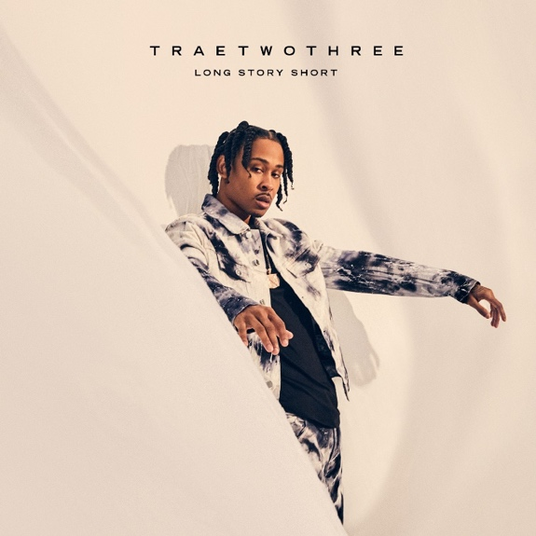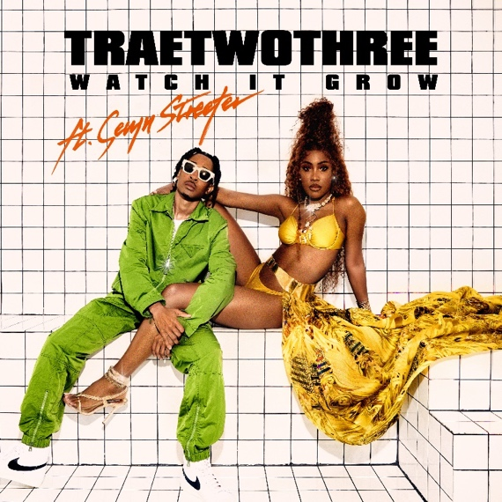
DOWNLOAD HI-RES EP ARTWORK | DOWNLOAD HI-RES SINGLE ARTWORK

“Perfect songs for the summer.” – HIP-HOP SINCE 1987

South Central R&B sensation TRAETWOTHREE has officially released his second EP, Long Story Short via Ncredible / Art@War / Atlantic Records. Today’s 3/23/2023 release holds special significance as it is not only a play on the artist’s stage name but also the area code for Los Angeles. The 6-track EP includes features from Sevyn Streeter, Symba, Kalan.FrFr and Pleasure P. The EP is also accompanied by the release of the sensual visual for “Watch It Grow” featuring Sevyn Streeter. The sexy, Afrobeat-influenced record taps into TRAE’s Nigerian roots while captivating his growing R&B fanbase.
“The EP was created mostly in LA over the course of eight months,” says TRAE of the EP’s creation. “All of the features were organic, everyone pulled up to the studio instead of just sending verses. It was all love from everyone. I wrote on all the records. And of course, me being a big fan of Sevyn, only made sense for her to jump on ‘Watch It Grow’. We had such a fun time making the song and the video. To watch her do her thing and really take over the song, the vibe, just everything was so dope. I loved how she made it come to life in the way she performed. It was amazing to me.”
“Working with TRAETWOTHREE was amazing,” says Sevyn Streeter. “We had a great time in the studio, working with him was super easy. I like the fact that he knows who he is but, shedding light on music that the world can really enjoy and relate too. That’s dope.”
(-more-)

LONG STORY SHORT TRACKLIST
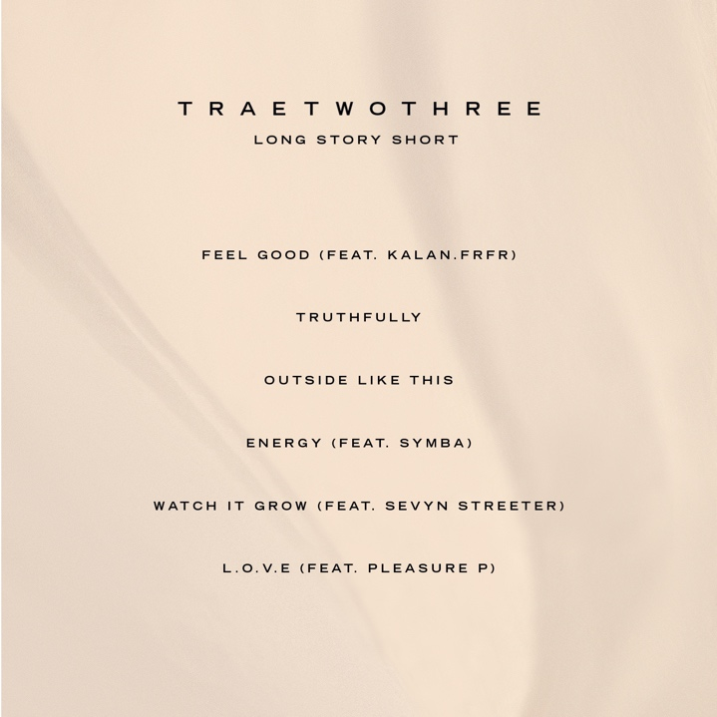
Prior to the EP’s release, TRAE also released the project’s first single, “Outside Like This.” The narration style single has seen steady growth having been added to Revolt, BET Jams, and BET Hip Hop video rotations and lauded a “#sleeper” on a recent episode of The Joe Budden Podcast. The official music video was directed by Keoni Marcelo (Yo Gotti, Ty Dolla $ign, Lil Wayne) who also directed the latest visual, “Watch It Grow.” Long Story Short also features production from Guitarboy (Trey Songz, Ciara, Symba, Chris Brown, Keyshia Cole), Sir Charles, KP, Slice, Hossy, and more.
What’s more, the rising R&B star is currently a special guest on Nick Cannon’s “Future Superstar Tour 2023.” The 24-city tour began on February 25th in LA at The Wiltern making stops across the U.S. before wrapping on April 8th in NY at the Hammerstein Ballroom. Purchase tickets HERE. Long Story Short is a follow-up to last year’s release of TRAETWOTHREE’s debut project, OUT THE DISTRICT. The project included such tracks as “710 (Feat. DW Flame),” “Stuck In My Ways (Feat. Blueface),” “Done Done,“ “Worth It (Feat. DDG), and “Keep Doing You,” the latter of which is joined by a Okezie Kenneth Nobuisi-directed official music video HERE.

ABOUT TRAETWOTHREE
TRAETWOTHREE embodies the best elements of his native Los Angeles. He switches lanes between the smooth hip-hop of a Sunday afternoon backyard party in South Central and the smoked-out woozy R&B of a joyride from Venice Beach to Malibu. At the same time, he channels Afrobeats rhythms befitting of the city’s African enclaves and his own Nigerian roots. As a kid growing up in The Crenshaw District, music proved to be a constant for TRAETWOTHREE. He initially developed his chops on saxophone in middle school in addition to listening to everyone from Erykah Badu and The Isley Brothers to Drake, J. Cole, and Nipsey Hussle as well as Afrobeats favorites Wizkid and Burna Boy. Since mom and dad were Jehovah’s Witnesses, he also learned about faith. By sixteen-years-old, he taught himself how to write and record music out of his D.I.Y. bedroom studio setup. A serendipitous encounter with the Ncredible team at the Dick’s Sporting Goods where TRAETWOTHREE worked, led to his deal with the label founded by Nick Cannon in conjunction with entertainment executive, James McMillan’s Art@War venture, and Atlantic Records, boosting his buzz and igniting his arrival in the process.

(-more-)

Throughout 2022, he tallied millions of streams across anthems such as “Drownin,” “Worth It (feat. DDG)”, “Stuck in My Ways (feat. BLUEFACE)”, “Keep Doing You,” “Vroom” [feat. Justina Valentine], and “710 (feat. DW Flame)”, leading up to his debut mixtape OUT THE DISTRICT. Meanwhile, AllHipHop.com applauded his “different sound that people have never heard before.” After earning acclaim from Billboard, VH1, Rated R&B, and many others, he reflects all of these vibes on his forthcoming project, Long Story Short [Ncredible/Art@War/Atlantic Records], and much more on the horizon.
CREDIT: JIMMY FONTAINE | DOWNLOAD HI-RES PRESS SHOT

# # #
CONNECT WITH TRAETWOTHREE
FACEBOOK | INSTAGRAM | TWITTER | YOUTUBE

PRESS CONTACT
FAIRLEY MCCASKILL | FAIRLEY.MCCASKILL@ATLANTICRECORDS.COM

