FOR IMMEDIATE RELEASE
MARCH 15, 2023

TEENAGE DISASTER SHARES CHILLING TRACK “VICTIM”

CUTTING-EDGE ARTIST-PRODUCER TO JOIN SUECO FOR US TOUR BEGINNING MAY 3

LABEL DEBUT PROJECT, CREEP, AVAILABLE NOW VIA ATLANTIC RECORDS HERE

LISTEN TO “VICTIM” HERE | WATCH MUSIC VIDEO HERE

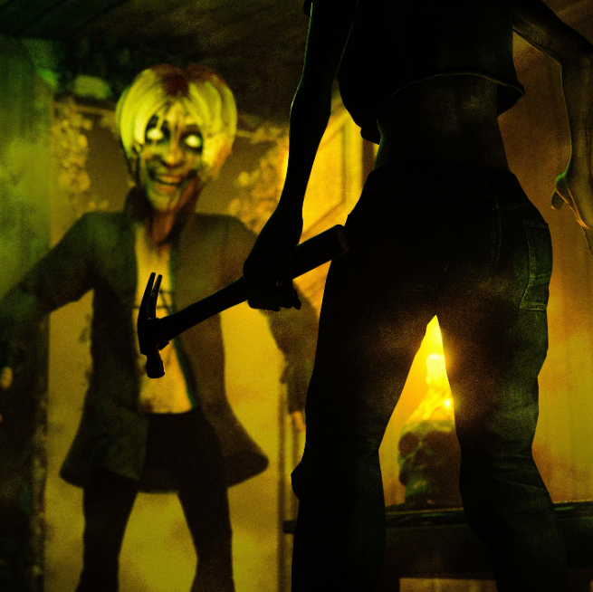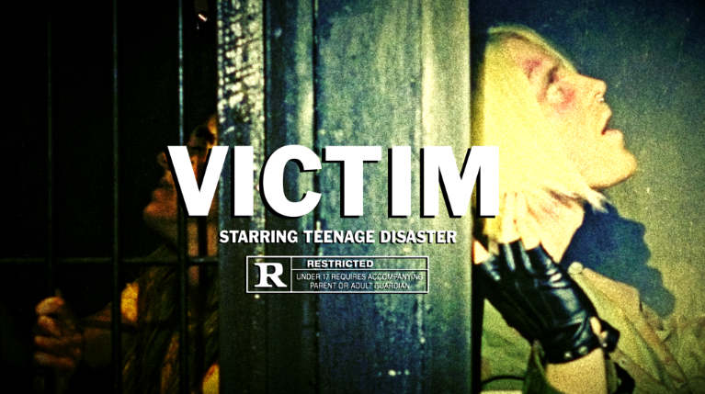
DOWNLOAD HI-RES ARTWORK + THUMBNAIL

Cutting-edge artist-producer Teenage Disaster has shared his latest and most chilling track thus far, “Victim” - Listen HERE. The track releases alongside an equally incendiary official music video – Watch HERE.

“Victim” arrives mere weeks after the deeply unnerving “Haylo,” which earned praise from Analogue Trash for its “hard-hitting emotional impact… The song and accompanying video tap into something raw and primal, a buzzsaw sound that feels part hyperpop, part Atari Teenage Riot.” “Haylo” is paired with a dark and sinister official music video - Watch HERE.

The chain of new releases follow in the dark footsteps of Teenage Disaster’s Atlantic Records label debut project, CREEP, available now at all DSPs and streaming services HERE. Highlights include such provocative singles as “Doubt,” “RELOAD (feat. Afourteen),” “Mask (feat. BLCKK),” “Chop Chop,” and “Takes 2 To Kill Me.”

Hailed by Rolling Stone for his “shambling, fuck-off rock, angsty guitar missiles, and ominous hip-hop, often from the perspective of threatening characters (killers, criminals, creeps, corpses, the usual),” Teenage Disaster – a.k.a. Humboldt County, CA native Thorne Baker – grew up in a home full of horror film paraphernalia, inspiring him to create his own captivating and often disturbing music, artwork, and animations. Teenage Disaster will mark “Victim” and more new music to come with an upcoming live run supporting Atlantic Records labelmate Sueco, set to get underway May 3 at New Haven, CT’s famed Toad’s Place. Additional dates will be announced. For complete details and ticket information, please visit www.teenagedisaster.com.

TEENAGE DISASTER
US TOUR 2023

MAY
3 – New Haven, CT – Toad’s Place
4 – Harrisburg, PA – Harrisburg University
6 – Washington, DC – Black Cat
8 – Richmond, VA – The Broadberry
10 – Cincinnati, OH – Top Cats
12 – Columbus, OH – Skully’s
13 – Indianapolis, IN – Hi Fi
14 – Grand Rapids, MI – Stache
16 – Springfield, MO – Outland Ballroom
17 – Nashville, TN – Basement East
19 – Carrboro, NC – Cat’s Cradle
20 – Charleston, SC – Music Farm

ALL DATES w/ SUECO

# # #

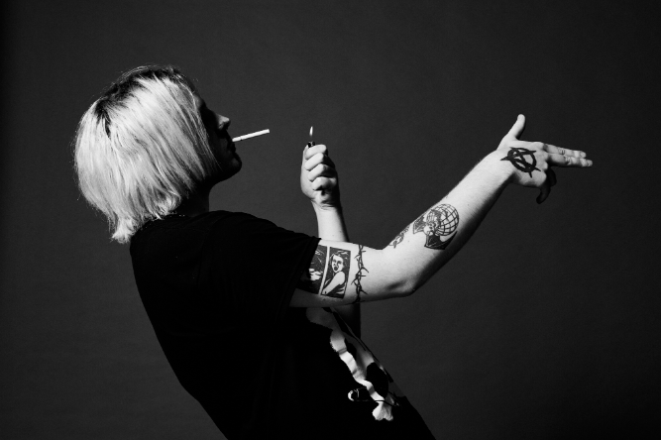
DOWNLOAD PRESS PHOTO HERE
CREDIT: JIMMY FONTAINE

CONNECT WITH TEENAGE DISASTER
OFFICIAL WEBSITE | INSTAGRAM | TIKTOK | TWITTER | YOUTUBE

CONTACT
Jessica Nall // Jessica.Nall@atlanticrecords.com

