FOR IMMEDIATE RELEASE
MARCH 3, 2023

GNASH TEAMS UP WITH MARK DIAMOND FOR NEW TRACK
“GLASS ON THE SHELF”

LISTEN HERE

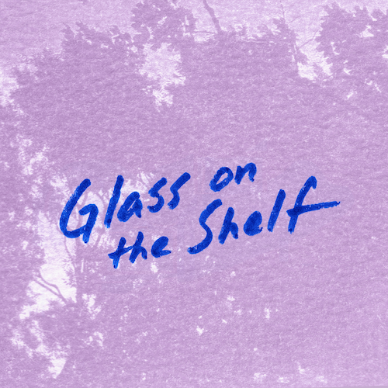
DOWNLOAD HI-RES ARTWORK HERE

6x RIAA Platinum-certified singer-songwriter gnash has joined forces with acclaimed singer-songwriter Mark Diamond for the new collaborative single, “Glass on the Shelf,” available now via Overall Recordings/Atlantic Records. The romantic and heartfelt track was written and produced by gnash – a.k.a. Garrett Nash – and Mark.

“’Glass on the Shelf’ is about love becoming a part of your everyday life & how small ‘big’ problems really are,” shared gnash. “‘There’s always something to complain about,’ but at the end of the day, if you find someone that gets you, & they mean no harm, do your best to ride through the ups & downs – trust me, it’s worth it.”

“Occasionally, inspiration strikes and a song comes together effortlessly,” shared Mark. “That’s what happened with ‘Glass on the Shelf,’ the first song gnash and I wrote together. We bumped into each other at a coffee shop and talked about collaborating someday, and before we knew it, this beautiful track was born. We’re both in long-term relationships, so this song’s message really resonated with us. I’m just grateful to be a part of it.”

“Glass on the Shelf” follows the recent debut of five, the fifth and latest installment in gnash’s ongoing monthly series of double-sided new singles. five – which features “Time” and “Life (Everybody Dies)” – Listen HERE.

The monthly succession of new singles began last October with one, featuring “Seasons” backed by the previously released “Palm Trees.” November then saw the arrival of two, which includes “Family, Man” (co-written and co-produced by gnash with singer-songwriter Annika Bennett) backed with the previously released “Money, Love & Death.” Next came three, featuring two brand new songs about love in the deeply moving “Guiding Light” and “I Got A Lot To Lose.” The series continued into 2023 with last month’s four, featuring “Rainbow” and “The Art of Letting Go.”

Last year also saw the premiere of gnash’s acclaimed collaboration with fellow chart-topping singer-songwriter Annika Wells for the playfully organic duet, “granola bars,” which followed a stunning series of deeply personal singles released by gnash under his birth name of Garrett Nash, including “Where The Sidewalk Ends“ (a collaboration with 7x JUNO Award-nominated Canadian singer-songwriter Scott Helman), “The Middle Of Nowhere,” “Super Glue,” Shwayze x Garrett Nash’s “Breathe In,” and a nostalgic cover of his childhood favorite, Fountains of Wayne’s “Stacy’s Mom.“

ABOUT gnash
Known for his genre-blurring brand of modern pop, gnash made his global breakthrough with 2016’s multi-platform blockbuster hit single, “i hate u, i love u.” The stripped-bare track reached the top 10 on Billboard’s “Hot 100” – where it spent an impressive 39 weeks – and singles charts around the world, earning 6x RIAA platinum certification and more than 2B global streams. Furthermore, the “i hate u, i love u” companion video is an unadulterated blockbuster, now with over 710M individual views via YouTube alone.

Along with his world-straddling popular success, gnash began receiving rapt attention from worldwide media, drawing critical acclaim from such top tier publications as the New York Times, Entertainment Weekly, Billboard, Vogue, and NYLON, to name but a few. 2018 saw gnash winning the iHeartRadio Titanium Award for his collaboration with MAX on “Lights Down Low.” 2019 followed with the release of a series of EPs with his RIAA gold certified full-length debut album, we, drawing praise from such outlets as The Guardian for its “highly intimate confessionals about doubt, anxiety and insecurity…the combination of charming tunes and humbling insights are truly lovely.”

As charming and idiosyncratic on stage as in the studio, gnash traveled North America on a number of tours, including 2019’s 40-date “the broken hearts club tour,” while also finding time for high-profile TV performances on NBC’s TODAY and Late Night with Seth Meyers. A strong advocate for mental health, gnash has long been open about his struggles, publicly acknowledging the benefits of therapy while also encouraging fans to find their own unique way to express themselves.

ABOUT MARK DIAMOND
Singer, songwriter, and producer Mark Diamond is a Seattle native who grew up listening to The Beatles, R.E.M., and Hootie and the Blowfish in his father’s 1969 Chevy Malibu. Achieving over 150M streams with his first independent album, 2021’s War (The Lost Recordings), Diamond quit his job at a coffee shop and has been writing and performing music fulltime ever since. After two EP projects on a major label, Diamond independently released his latest album, Fell Asleep In Paradise, in 2022.

# # #

DOWNLOAD PRESS PHOTOS HERE
PHOTO CREDIT: ROSABELLE EALES

CONNECT WITH gnash
WEBSITE | FACEBOOK | INSTAGRAM | TIKTOK | TWITTER | YOUTUBE

CONNECT WITH MARK DIAMOND
WEBSITE | INSTAGRAM | TIKTOK | YOUTUBE

For press inquiries, please contact:
Jessica Nall // Jessica.Nall@atlanticrecords.com

