GENRE-BENDING ARTIST GRANDMA UNVEILS SOPHOMORE EP ANGELHOOD

LISTEN TO ANGELHOOD EP HERE
LISTEN TO EP SINGLE “SOFT-GLOW” HERE

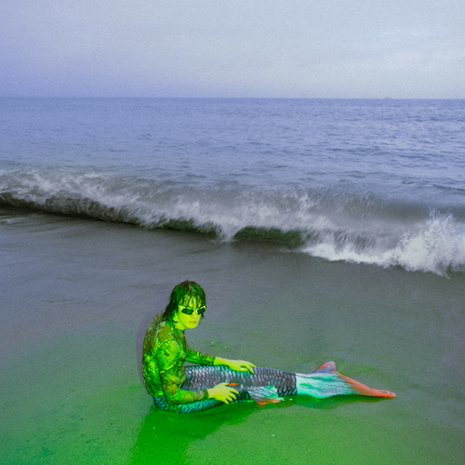
DOWNLOAD HI-RES ARTWORK

Genre-bending alternative artist grandma has shared his eagerly anticipated, weirdly wonderful sophomore EP Angelhood, where he combines the effect of an epicene 1970s rock star with that of a public-school e-boy. Angelhood is available now via Atlantic Records at all DSPs and streaming services HERE.

Today’s arrival of Angelhood is celebrated by the premiere of “soft-glow,” listen HERE. The choruses of ‘soft-glow’ embody the ethereal feeling of love combatted with soft verses that ironically target moments of depression and suicidal ideation.

Soft shoe-gaze vocals grouped with heavy rock production, the lyrical dynamic expresses the confusion of determining if someone has real feelings for you, or if you’re just being used. The song toggles between the feeling of mistrusting a loved one and just jumping directly into their world and psyche regardless of the consequence.

Angelhood further includes such standout tracks as “God Hired You To Be My Baby,” “I Met God Online“ and “Blue Atlanta,” all accompanied by inventive music videos streaming now at YouTube. A dreamy ode to darkness and disengagement, “Blue Atlanta” was met by applause from such outlets as Lyrical Lemonade, which declared it to be “an all-out spectacle…a very calm, peaceful vibe that clashes with these epic, momentous synths that never seem to get too over-the-top, but extend just enough emotion to allow grandma to truly let his passion and heart show.”

The name grandma seems at first unbefitting of multi-instrumentalist/producer Liam Hall, yet Angelhood gives us a few hints as to his unexpectedly pleasant grandmaternal ways. His lyricism is defined by cryptic aphorisms and somewhat deranged storytelling. Inquiries into spirituality and digital life are woven throughout, like whispers of an existential crisis accelerated by the relentlessness of time.

Central to Hall’s narrative is his hometown of Atlanta, a city whose home-grown genres like country, alternative rock, and trap all find a place in Angelhood’s sonic lexicon. While maintaining his penchant for skillful instrumentation, it seems Hall has escaped the irresistible call of nostalgia that defined his last project, the funk-infused Even If We Don’t Get It Together (2019), and instead embraced the uncertainty of the future with vulnerability and sincerity. Hall’s Southern charm lends a choirboy sweetness to the project’s underlying melancholia. Combining the effect of an epicene 1970s rock star with that of a public school e-boy, he electrifies the decentralized and liminal spaces of the Internet and the suburbs with a phantasmagoric exuberance.

Having collaborated with artists across a variety of genres including Rico Nasty, WILLOW, ericdoa, SoFaygo, YUNGBLUD, and JID, Hall continues to innovate his creative and original sound. Angelhood is the perfect soundtrack for flânerie, cyberstalking, photo manipulation, sowing discord on Discord, and manifestation, expertly capturing the furtiveness of coming of age, the ever-enchanting American dream, and the transformative effects of Internet use.

# # #

grandma
Angelhood EP
(Atlantic Records)

TRACKLIST
I Bleed
Angelhood
Blue Atlanta
soft-glow
Some Things Are Easier
I Meet God Online
Mission Statements
God Hired You To Be My Baby

# # #

CONNECT WITH GRANDMA
INSTAGRAM | TIK TOK | TWITTER | YOUTUBE

For press inquiries, please contact:
Kelly McWilliam // Kelly.McWilliam@AtlanticRecords.com
Gabrielle Reese // Gabrielle.Reese@AtlanticRecords.com

