FOR IMMEDIATE RELEASE

MARCH 31, 2023

**BIGWALKDOG LIGHTS UP *TRICK CITY* WITH SIX NEW TRACKS**

**MISSISSIPPI RAPPER DELIVERS DELUXE EXTENSION OF DEBUT MIXTAPE THAT ALREADY BOASTS OVER 300 MILLION STREAMS**

**NEW HIGHLIGHTS INCLUDE “**[**WHOLE NOTHER LEAGUE**](https://bigwalkdog.lnk.to/WholeNotherLeague)**,”**

**“**[**PROTECT ME FROM EVIL**](https://bigwalkdog.lnk.to/protectmefromevil)**,” “**[**WORLDWIDE**](https://bigwalkdog.lnk.to/Worldwide)**,”**

**AND “**[**FEELING LIKE WOP (FT. GUCCI MANE)**](https://bigwalkdog.lnk.to/FeelingLikeWop)**,”**

**ALL JOINED BY OFFICIAL MUSIC VIDEOS STREAMING NOW AT YOUTUBE**

***TRICK CITY (DELUXE)* AVAILABLE NOW VIA THE NEW 1017/ATLANTIC RECORDS**

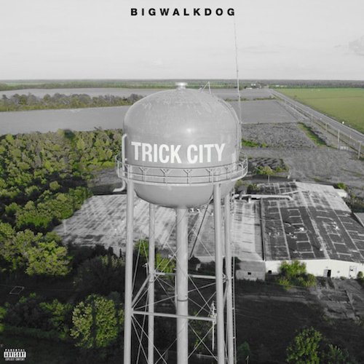

[DOWNLOAD](https://warnermusicgroup.app.box.com/s/fb5emo77j0253okx8d5r6b2h9o4xdaoh) HI-RES ARTWORK

*“One of the most promising artists of the New 1017, BigWalkDog boasts a gruff and intense delivery. It’s no surprise Gucci Mane signed him… one of the leaders of a new generation of Southern rappers putting their lives on wax.”* **- AUDIOMACK**

6’8” Magnolia State rapper **BigWalkDog** is back with an expanded edition of his breakthrough debut mixtape, *TRICK CITY*, available nowvia The New 1017/Atlantic Records at all DSPs and streaming services. ***TRICK CITY (DELUXE)*** now includes six additional new tracks, including “[Whole Nother League](https://bigwalkdog.lnk.to/WholeNotherLeague),” “[Protect Me From Evil](https://bigwalkdog.lnk.to/protectmefromevil),” “[Worldwide](https://bigwalkdog.lnk.to/Worldwide),” and “[Feeling Like Wop (Ft. Gucci Mane)](https://bigwalkdog.lnk.to/FeelingLikeWop),” all joined by official music videos streaming now at BigWalkDog’s hugely popular YouTube channel [HERE](https://www.youtube.com/channel/UCt5BMRlxtGQJ7hyqpr4Mg-A).

Released last September, *TRICK CITY* proved an instant smash, seeing BigWalkDog debuting at #19 on *Rolling Stone*’s Breakthrough 25 chart of “the fastest-rising artists of the month” and amassing over **300M streams** and counting. Hailed by *Audiomack* as *“one of the leaders of a new generation of Southern rappers putting their lives on wax”* after his debut release, the project includes such hard-hitting tracks as “[For Certain (Feat. Big30)](https://bigwalkdog.lnk.to/ForCertainVideo),” “[Nino](https://bigwalkdog.lnk.to/Nino),” “[Trap God (Feat. Gucci Mane)](https://bigwalkdog.lnk.to/TrapGod),” and “[Whole Lotta Ice (Feat. Lil Baby & Pooh Shiesty)](https://bigwalkdog.lnk.to/WholeLottaIce),” all joined by official visuals adding to his combined **250 MILLION** official YouTube views.

*“The 1017 signee leaves a strong impression on his debut mixtape… BigWalkDog kept his foot on the gas since inking a deal with Gucci Mane with a string of releases that have shown growth.”  -* **HOTNEWHIPHOP, *VERY HOTTTTT* EDITOR RATING**

TRICK CITY also features Gucci Mane & BigWalkDog’s smash collaboration “[Poppin](https://www.youtube.com/watch?v=dcbcxBSxQ0A),” accompanied by an official music video now boasting over 43M views after rising to #2 on YouTube’s “Trending” chart. BigWalkDog celebrated the track’s success with his late night network TV debut, teaming with Gucci for a fiery performance of “Poppin” on ABC’s *Jimmy Kimmel Live!*

One of the most hard-hitting and compelling new artists on The New 1017 roster, the Tutwiler, MS born BigWalkDog has unleashed a string of releases that showcase commanding bars and knockout hooks that prove impossible to shake - all spiced with the rapper’s one-of-a-kind brand of Southern gusto. Independent tracks such as “Tyson” and “B.T.D.” soon caught catching the attention of Gucci Mane, who swiftly signed BigWalkDog to his fast-growing The New 1017 label.

A wide span of powerful releases followed, including striking appearances on such The New 1017 label compilations as [*SO ICY BOYZ*](https://thenew1017.lnk.to/SoIcyBoyz) and the recently released [*SO ICY GANG: THE REUP*](https://thenew1017.lnk.to/TheReUp), all of which drew millions of streams alongside critical acclaim from such media outlets as *REVOLT*, which raved, “*BigWalkDog is quickly becoming one of the bigger faces on the Southern rap scene.*” “*BigWalkDog's approach is best described as relentless,*” agreed *XXL*. “*He finds the pocket of every song he's on and never lets up, and does so with the vigor of a rapper who knows he's meant for this.*”

“*Mississippi made me,*” says BigWalkDog, “*but I want BigWalkDog to be for the world. You can take your own feelings from it – whether they’re good or bad. I’m just being honest.*”

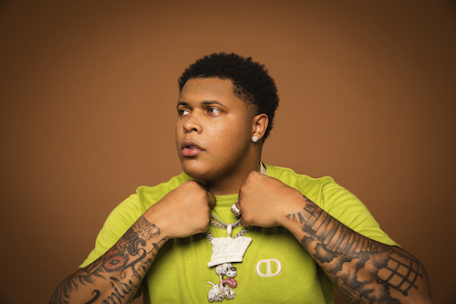

[DOWNLOAD](https://warnermusicgroup.app.box.com/s/yfqrk3t0dsbtumla7wuzqrxh11t9bh8d) HI-RES IMAGES // PHOTO CREDIT: KEENAN LITMON



# # #

**BIGWALKDOG**

***TRICK CITY (DELUXE)***

(1017 Global Music/Atlantic Records)

**TRACKLIST**

Trick

Know What I Mean (Feat. Gucci Mane)

Mary Jane

Pray

Whole Lotta Ice (Feat. Lil Baby & Pooh Shiesty)

I'm the One

What You Hear Pt. 1

Poppin (BigWalkDog & Gucci Mane)

Uncle Tommy

Beep

For Certain (Feat. BIG30)

SkyWalka

What You Hear Pt. 2

How It Go

I Chose

Onion Peeler

Trap God (Feat. Gucci Mane)

Nino

Son of A Gun

Came From The Bottom

**Feeling Like Wop (Feat. Gucci Mane) \***

**What You Hear Pt. 3 \***

**No Degrees \***

**Worldwide \***

**Whole Nother League \***

**Protect Me From Evil \***

* EXCLUSIVE TO DELUXE EDITION

# # #

**CONNECT WITH BIGWALKDOG**

[BIGWALKDOGMUSIC.COM](https://www.bigwalkdogmusic.com/) | [FACEBOOK](https://nam04.safelinks.protection.outlook.com/?url=https%3A%2F%2Fwww.facebook.com%2FBigwalkdog-113260807183403%2F&data=05%7C01%7CTiana.Timmerberg%40atlanticrecords.com%7Cf0cafdffd7a44c1e6c2e08da97576ad3%7C8367939002ec4ba1ad3d69da3fdd637e%7C0%7C0%7C637988698976165884%7CUnknown%7CTWFpbGZsb3d8eyJWIjoiMC4wLjAwMDAiLCJQIjoiV2luMzIiLCJBTiI6Ik1haWwiLCJXVCI6Mn0%3D%7C3000%7C%7C%7C&sdata=BiZ0%2F0LsB%2F16F3NLHJYt7EPaoqlNXW4ZizNhIyHJ7Rw%3D&reserved=0) | [INSTAGRAM](https://nam04.safelinks.protection.outlook.com/?url=https%3A%2F%2Fwww.instagram.com%2Fbigwalkdog1&data=05%7C01%7CTiana.Timmerberg%40atlanticrecords.com%7Cf0cafdffd7a44c1e6c2e08da97576ad3%7C8367939002ec4ba1ad3d69da3fdd637e%7C0%7C0%7C637988698976165884%7CUnknown%7CTWFpbGZsb3d8eyJWIjoiMC4wLjAwMDAiLCJQIjoiV2luMzIiLCJBTiI6Ik1haWwiLCJXVCI6Mn0%3D%7C3000%7C%7C%7C&sdata=s4QdVDJgZF4SP4knkBOoFQMRyfUUYO9ZqiNwkWXxakc%3D&reserved=0) | [YOUTUBE](https://www.youtube.com/channel/UCt5BMRlxtGQJ7hyqpr4Mg-A)

**BIGWALKDOG + 1017 GLOBAL MUSIC PRESS CONTACT:**

Ashley Kalmanowitz | Ashley.Kalmanowitz@atlanticrecords.com