FOR IMMEDIATE RELEASE
APRIL 07, 2023

LYRICAL MAESTRO CORDAE IS SET TO DOMINATE 2023
AS SPECIAL GUEST ON NF’S ‘HOPE TOUR’

TOUR WILL KICK OFF ON 7/12 WITH CORDAE ON ALL U.S. AND CANADA DATES

COMES OFF THE HEELS OF HIS LATEST SINGLE FEATURING ANDERSON .PAAK “TWO TENS”
ACCOMPANYING VISUAL NOW BOASTS OVER 4.7M VIEWS

TICKETS CAN BE PURCHASED HERE

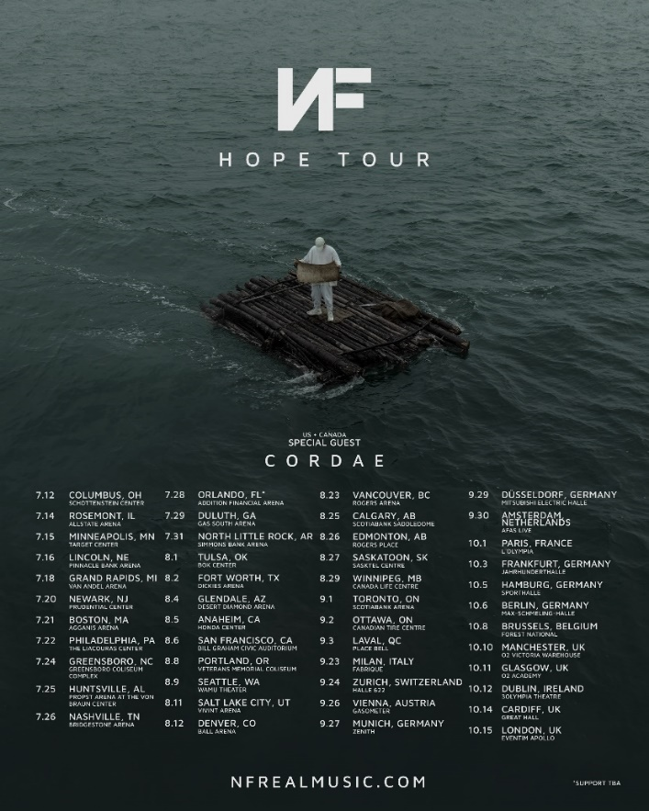

3x GRAMMY® Award-nominated and Emmy Award-winning rapper Cordae kicks off his quarter two in a major way with the announcement of his participation in NF’s upcoming ‘Hope Tour.’ The tour kicks off on July 12 in Columbus, OH spanning the U.S., Canada, and Europe. Cordae will perform on all U.S. and Canada dates through September. Tickets are now on sale and can be purchased at http://www.nfrealmusic.com/. The tour announcement also comes on the heels of his latest single featuring Anderson .Paak, “Two Tens,” with the companion visual now boasting over 4.7M views – Watch HERE. Cordae also recently appeared on HBO Max’s The Shop: Uninterrupted for Season 6 Episode 2 – The full episode can be viewed HERE.

NF HOPE TOUR 2023
FEATURING CORDAE

JULY
12 – Columbus, OH – Schottenstein Center
14 – Rosemont, IL – Allstate Arena
15 – Minneapolis, MN – Target Center
16 – Lincoln, NE – Pinnacle Bank Arena
18 – Grand Rapids, MI – Van Andel Arena
20 – Newark, NJ – Prudential Center
21 – Boston, MA – Agganis Arena
22 – Philadelphia, PA – The Liacouras Center
24 – Greensboro, NC – Greensboro Coliseum Complex
25 – Huntsville, AL – Propst Arena At The Von Braun Center
26 – Nashville, TN – Bridgestone Arena
28 – Orlando, FL – Addition Financial Arena
29 – Duluth, GA – Gas South Arena
31 – North Little Rock, AR – Simmons Bank Arena

AUGUST
1 – Tulsa, OK – Bok Center
2 – Fort Worth, TX – Dickies Arena
4 – Glendale, AZ – Desert Diamond Arena
5 – Anaheim, CA – Honda Center
6 – San Francisco, CA – Bill Graham Civic Auditorium
8 – Portland, OR – Veterans Memorial Coliseum
9 – Seattle, WA – WAMU Theater
11 – Salt Lake City, UT – Vivint Arena
12 – Denver, CO – Ball Arena
23 – Vancouver, BC – Rogers Arena
25 – Calgary, AB – Scotiabank Saddledome
26 – Edmonton, AB – Rogers Place
27 – Saskatoon, SK – Sasktel Centre
29 – Winnipeg, MB – Canada Life Centre

SEPTEMBER
1 – Toronto, ON – Scotiabank Arena
2 – Ottawa, ON – Canadian Tire Centre
3 – Laval, QC – Place Bell
23 – Milan, Italy – Fabrique
24 – Zurich, Switzerland – Halle 622
26 – Vienna, Austria – Gasometer
27 – Munich, Germany – Zenith
29 – Düsseldorf, Germany – Mitsubishi Electric Halle
30 – Amsterdam, Netherlands – AFAS Live

OCTOBER
1 – Paris, France – L’Olympia
3 – Frankfurt, Germany – Jahrhunderthalle
5 – Hamburg, Germany – Sporthalle
6 – Berlin, Germany – Max-Schmeling-Halle
8 – Brussels, Belgium – Forest National
10 – Manchester, UK – O2 Victoria Warehouse
11 – Glasgow, UK – O2 Academy
12 – Dublin, Ireland – 3Olympia Theatre
14 – Cardiff, UK – Great Hall
15 – London, UK – Eventim Apollo

# # #

ABOUT CORDAE
Cordae knows exactly what he wants to say. He chooses his words and phrases carefully. He speaks from a place of truth. That’s why the three-time GRAMMY® Award-nominated, Emmy-Award winning gold-selling Maryland-raised rapper has quietly become one of the modern generation’s most trusted narrators. A remarkable life has given him a lot to say. He went from trailer parks and public housing with his mom to stratospheric success. After a series of buzzing singles, he reached critical mass with his 2019 full-length debut, The Lost Boy. It bowed in the Top 15 of the Billboard Top 200 and included four gold-certified singles— “RNP” [feat. Anderson .Paak], “Have Mercy,” “Broke As Fuck,” and “Kung Fu.” Beyond unanimous praise from Billboard, Complex, High Snobiety, New York Times, Pitchfork, and Stereogum, he garnered a pair of GRAMMY® Award nominations in the categories of “Best Rap Album” for The Lost Boy and “Best Rap Song” for “Bad Idea” [feat. Chance the Rapper]. He’s the rare artist whose presence can be felt on-screen in a Super Bowl commercial alongside legendary Academy® Award-winning director Martin Scorsese and among XXL’s coveted “Freshman Class.” Along the way, he linked up with Roddy Ricch and Ant Clemons for “Gifted” as well as joining forces with Eminem for “Killer.” Absorbing wisdom from a life-changing trip to Africa, enduring the loss of a friend gone too soon, and evolving as an artist and a man, he tells this story in widescreen technicolor on his 2022 second full-length offering, From A Birds Eye View [ART@WAR/Atlantic Records]. Cordae followed up the release of his sophomore album with the Facebook exclusive premiere of his visual only, From A Birds Eye View (Live) album. As a follow up, Cordae released the collaborative single “Checkmate” with Hit-Boy from the official EA Sports Madden NFL 23 Soundtrack. He kicked off 2023, with his explosive collaboration with Anderson .Paak “Two Tens.”

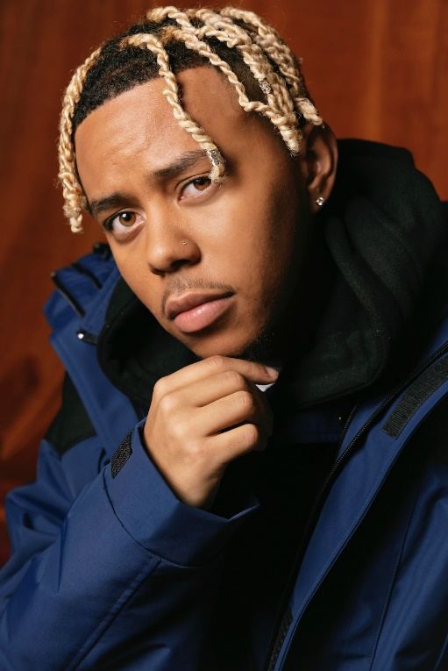

CONNECT WITH CORDAE
INSTAGRAM | YOUTUBE | TWITTER | FACEBOOK

FOR PRESS INQUIRIES
BRITTANY BELL // BRITTANY.BELL@ATLANTICRECORDS.COM

