FOR IMMEDIATE RELEASE
APRIL 24, 2023

daniel leggs shares “good kid”

rising alt-pop star follows debut ep with ambitious new single

“good kid” available now via Overall Recordings/Atlantic Records

listen to “good kid”

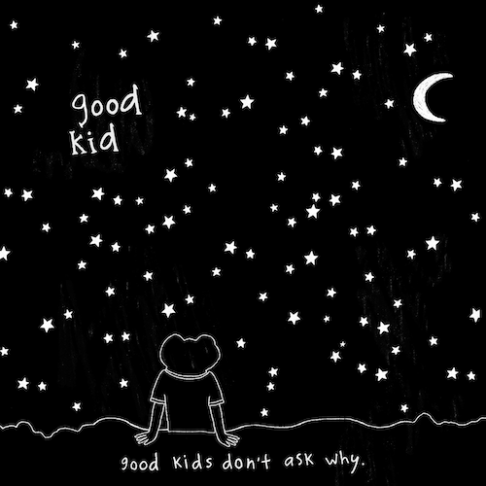
DOWNLOAD HI-RES ARTWORK

Rising alt-pop singer-songwriter-producer Daniel Leggs has shared his ambitious new single, “good kid,” available now via Overall Recordings/Atlantic Records.

“This song is super honest and plays like the journey in my mind when I have these thoughts,” says Daniel Leggs. “It starts off simple and innocent but builds into something so crazy. We wanted to write a song that felt like when you start to question things as a kid - the first time you looked up at the stars and thought, ‘Woah, how’d I get here?’ Someone commented online that it sounds like Billy Joel X Frank Ocean X Radiohead, which is exactly how I’d explain it.”

“good kid” follows the arrival earlier this year of Leggs’ long-awaited debut EP, runaway, available everywhere now HERE. The final installment in a remarkable series of monthly song premieres, the EP collects warm-hearted tracks like “sausalito,” “gatsby,” “stay in my dreams,” “ticket home” (co-written with 6x RIAA Platinum-certified singer-songwriter Garrett Nash), and the viral favorite, “crutches,” the latter of which is joined by a whimsical animated music video streaming HERE.

In a world of emotional uncertainty, music is the only thing Daniel Leggs is sure of. Growing up as a concert-trained pianist too shy to express himself in daily life beyond gratitude and kindness, the 23-year-old tunesmith has found himself via a series of intimate, ingenious pop ditties which expertly capture the ups, the downs, the heartbreak, and longing for something more of a gifted young artist making his way in 21st century New York City. Written, recorded, mixed, and mastered in a central Rhode Island basement studio, Leggs’ budgeted studio model produces a distinctive sound that combines relatable lyrics with experimental imperfections to manifest something beautiful and all his own.

Leggs kicked off 2023 with his most tender track to date, “last one standing,” joined by an official live performance video – filmed in Daniel’s kitchen – streaming now at YouTube HERE.

“I’m definitely an observer. I believe there’s so much power in the little things—whether it’s a phrase you hear a million times such as ‘good kid’ or a ‘small’ life event like a first date,” says Daniel Leggs. “I love turning these ‘details’ into songs. In a way, my music magnifies these little moments as big as possible. I believe by sharing them with one another we realize that they’re not so small after all. I hope I can just write the soundtrack to being human.”
# # #

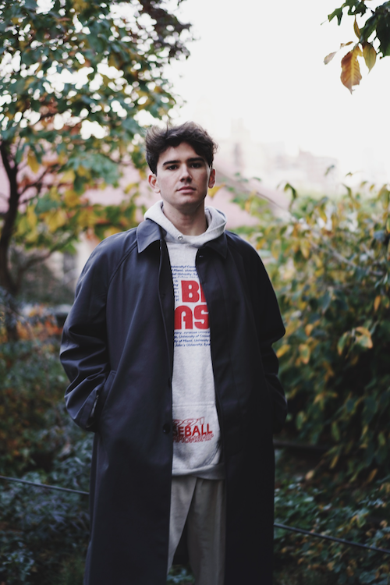
DOWNLOAD HI-RES IMAGE
PHOTO CREDIT: AUDREY BERGERON

CONNECT WITH DANIEL LEGGS
OFFICIAL | INSTAGRAM | SOUNDCLOUD | TIKTOK | TWITTER | YOUTUBE

For press inquiries, please contact:
Jessica Nall // Jessica.Nall@atlanticrecords.com

