

**ED SHEERAN RETURNS WITH “EYES CLOSED”**

**LONG-AWAITED NEW SINGLE ARRIVES TODAY ALONGSIDE**

**OFFICIAL MUSIC VIDEO**

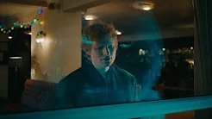

[**WATCH HERE**](https://es.lnk.to/eyesclosed/youtube) **/** [**LISTEN HERE**](http://es.lnk.to/eyesclosed)

**NEW ALBUM “ – “ (pronounced SUBTRACT)**

**ARRIVES EVERYWHERE MAY 5**

[**PRE ORDER**](https://es.lnk.to/subtract) **HERE**

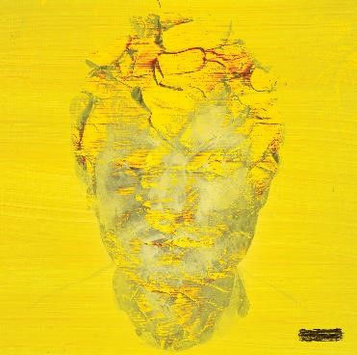

**CURRENTLY FEATURED ON THE APRIL COVER**

**OF ROLLING STONE IN THE U.S. AND 14 COUNTRIES AROUND THE WORLD AS THE MAGAZINE’S GLOBAL COVER STAR**

*“With Sheeran’s new album…he’s in sudden danger of achieving a new brand of musical coolness, thanks to some of his most unadorned and emotive songwriting.”*

[**READ THE FULL STORY HERE**](https://www.rollingstone.com/music/music-features/ed-sheeran-new-album-subtract-tour-cover-story-interview-1234694319/)

**FOUR-PART DOCUMENTARY “ED SHEERAN: THE SUM OF IT ALL”**

**BEGINS STREAMING MAY 3 ON DISNEY+**

[**WATCH OFFICIAL TRAILER**](https://www.youtube.com/watch?v=Qp8zMmpEU-E) **HERE**

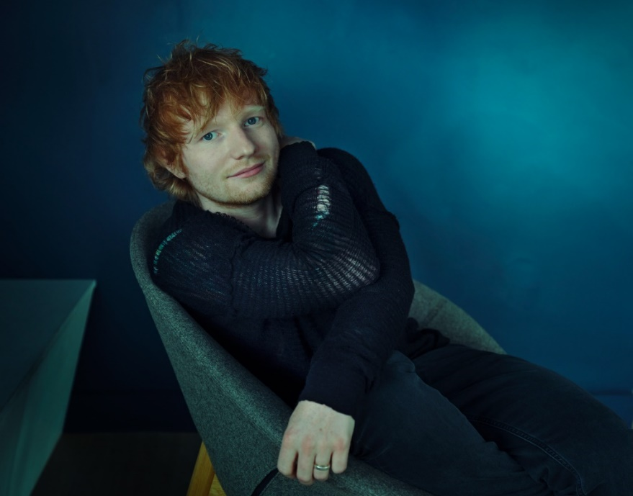

**ED SHEERAN PHOTOGRAPHED BY ANNIE LEIBOVITZ**

[**DOWNLOAD PRESS ASSETS HERE**](https://warnermusicgroup.box.com/s/q87mq0pbmvts4qabcvwpzl5cj6pb2yr2)

Global superstar Ed Sheeran has returned with a brand new song **“Eyes Closed”** – the lead single off of his forthcoming album “ – “ (pronounced Subtract) - alongside its official video ([listen here](https://es.lnk.to/eyesclosed) / [watch here](https://es.lnk.to/eyesclosed/youtube)).

Ed originally wrote “Eyes Closed” a few years back. Starting out as a break-up song, the lyrics took on a whole new meaning after Ed suffered heartbreaking loss which led him to revisit the track for “ – “. One of the most pop-leaning sonics on his highly anticipated new record, “Eyes Closed” captures the essence of love and loss, which is also reflected in the official video. Directed by Mia Barnes, we see Ed on a night out being followed by a blue monster - serving as a metaphor for grief, Ed is unable to shake it, wherever he goes, reminding him of the void that’s left in his life.

Speaking of the new song and the video, Ed says – ***“This song is about losing someone, feeling like every time you go out and you expect to just bump into them, and everything just reminds you of them and the things you did together. You sorta have to take yourself out of reality sometimes to numb the pain of loss, but certain things just bring you right back into it.***

***When I was thinking of concepts for the Eyes Closed music video, I wanted to make a video inspired by movies like Harvey, where the main character has an imaginary friend who’s a giant rabbit that no one can see. There’s also a book I read my daughters where sadness is encapsulated by an imaginary creature. Often sadness is something that follows you around, engulfing the rooms you’re in, and you can feel and see it, but no one else around you can. So I decided to create my own big blue monster for the video. He gets bigger and bigger as the video goes on, til he takes up whole rooms, and is all I can see, just like sadness.”***

Ed’s soul-baring, new album “ – “ will be released on May 5 via Atlantic Records and is available for pre-order [here](https://es.lnk.to/subtract) now. Written against a backdrop of grief and hope, Ed wrote and recorded the fourteen-track record with Aaron Dessner (of The National) in February last year after a series of hard-hitting events impacted his life.

Ed is currently featured on the April cover of Rolling Stone in the U.S. and 14 other countries around the world as the magazine’s global cover star. In one of his most revealing interviews to date, Ed opens up about the most tumultuous period of his life that ultimately inspired the songwriting for “ – “. Given an early listen to the music, Rolling Stone’s Brian Hiatt writes, “*With Sheeran’s new album…he’s in sudden danger of achieving a new brand of musical coolness, thanks to some of his most unadorned and emotive songwriting*.” Read the full story [here](https://www.rollingstone.com/music/music-features/ed-sheeran-new-album-subtract-tour-cover-story-interview-1234694319).

Announced earlier this week, his all-new, four-part documentary ‘Ed Sheeran: The Sum of It All” will be streaming on Disney+ starting May 3. Blending never-before-seen personal archive, interviews and performances, the intimate documentary explores how his personal experiences have shaped him to become the artist he is today. Watch the emotional, official trailer [here](https://www.youtube.com/watch?v=Qp8zMmpEU-E).

Ed is currently in midst of his worldwide “+ - = ÷ x Tour” (pronounced “The Mathematics Tour”). The North American leg hits stadiums across the continent for the first time since his history-making “Divide Tour” in 2018, which officially became the most-attended and highest-grossing tour of all time by its completion. Dates begin on May 6th at AT&T Stadium in Arlington, TX, before wrapping up on September 23rd at Sofi Stadium in Inglewood, CA (see attached itinerary). Ed closed 2022 topping Billboard’s Top Ticket Sales chart after wrapping the UK/European leg of the “+ - = ÷ x Tour,” performing in front of over 3 million people in 6 months, highlighted by a five-night stand at London’s Wembley Stadium.

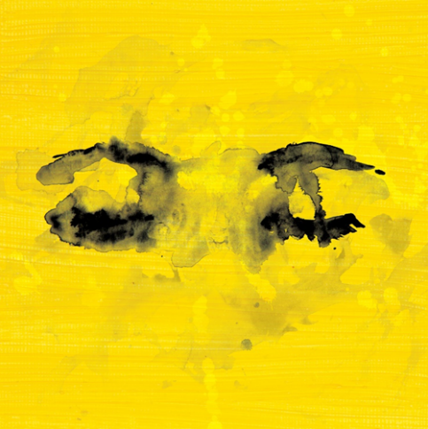

FOR MORE ON ED SHEERAN:

[OFFICIAL WEBSITE](http://www.edsheeran.com/splash/6thjan) | [INSTAGRAM](https://www.instagram.com/teddysphotos/) | [FACEBOOK](https://www.facebook.com/EdSheeranMusic/) | [TWITTER](https://twitter.com/edsheeran?ref_src=twsrc%5Egoogle%7Ctwcamp%5Eserp%7Ctwgr%5Eauthor) | [YOUTUBE](https://www.youtube.com/user/EdSheeran)

PRESS CONTACTS:

Glenn Fukushima – [glenn.fukushima@300elektra.com](mailto:glenn.fukushima@300elektra.com)

Jason Davis – [jason.davis@atlanticrecords.com](mailto:jason.davis@atlanticrecords.com)

**“+ - = ÷ x TOUR”**

**NORTH AMERICA 2023**

|  |  |  |
| --- | --- | --- |
| **May** |  |  |
| 6 | Arlington, TX | AT&T Stadium + × |
| 13 | Houston, TX | NRG Stadium + × |
| 20 | Tampa, FL | Raymond James Stadium + × |
| 27 | Atlanta, GA | Mercedes-Benz Stadium + × |

|  |  |  |
| --- | --- | --- |
| **June** |  |  |
| 3 | Philadelphia, PA | Lincoln Financial Field + × |
| 10-11 | East Rutherford, NJ | MetLife Stadium + × |
| 17-18 | Toronto, ON | Rogers Centre + % |
| 24  30 | Landover, MD  Foxborough, MA | FedExField + %  Gillette Stadium + % |

|  |  |  |
| --- | --- | --- |
| **July** |  |  |
| 1 | Foxborough, MA | Gillette Stadium + % |
| 8 | Pittsburgh, PA | Acrisure Stadium + % |
| 15 | Detroit, MI | Ford Field + % |
| 22 | Nashville, TN | Nissan Stadium + · |
| 29 | Chicago, IL | Soldier Field + · |

|  |  |  |
| --- | --- | --- |
| **August** |  |  |
| 5 | Kansas City, MO | GEHA Field at Arrowhead Stadium + · |
| 12 | Minneapolis, MN | U.S. Bank Stadium + · |
| 19 | Denver, CO | Empower Field at Mile High + · |
| 26 | Seattle, WA | Lumen Field + ≠ |

|  |  |  |
| --- | --- | --- |
| **September** |  |  |
| 2 | Vancouver, BC | BC Place + ≠ |
| 9 | Las Vegas, NV | Allegiant Stadium - ≠ |
| 16 | Santa Clara, CA | Levi’s© Stadium - ≠ |
| 23 | Inglewood, CA | SoFi Stadium - ≠ |

+ Khalid

- Russ

× Dylan

% Rosa Linn

· Cat Burns

≠ Maisie Peters