ED SHEERAN ANNOUNCES NEW ALBUM “-“
OUT EVERYWHERE MAY 5 VIA ATLANTIC RECORDS
“-“ (pronounced subtract) IS THE LAST IN THE GLOBAL SUPERSTAR’S DECADE-SPANNING MATHEMATICAL ALBUM ERA
PRE ORDER '-' HERE

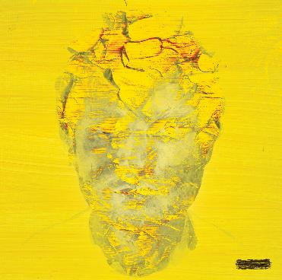
ED SHEERAN PHOTOGRAPHED BY ANNIE LEIBOVITZ:
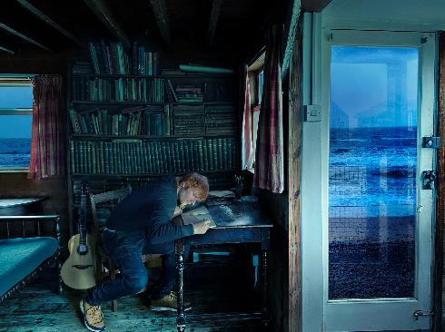

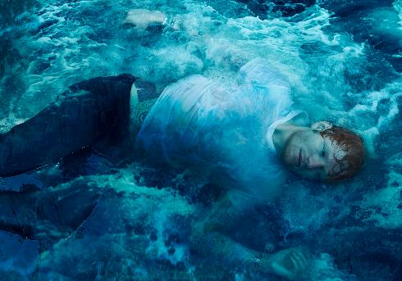
DOWNLOAD NEW PHOTOS & "-" ALBUM ARTWORK
Global superstar Ed Sheeran has announced his new album “-“ (pronounced subtract) - the last in his decade-spanning mathematical album era – will arrive everywhere on May 5 via Atlantic Records. The album is available for pre-order HERE.

An album that revisits Ed’s singer/songwriter roots, and one that was written against a backdrop of personal grief and hope, “-“ presents one of the biggest stars on the planet at his most vulnerable and honest. In Ed’s own words:

“I had been working on Subtract for a decade, trying to sculpt the perfect acoustic album, writing and recording hundreds of songs with a clear vision of what I thought it should be. Then at the start of 2022, a series of events changed my life, my mental health, and ultimately the way I viewed music and art.

Writing songs is my therapy. It helps me make sense of my feelings. I wrote without thought of what the songs would be, I just wrote whatever tumbled out. And in just over a week, I replaced a decade’s worth of work with my deepest darkest thoughts.
Within the space of a month, my pregnant wife got told she had a tumour, with no route to treatment until after the birth. My best friend Jamal, a brother to me, died suddenly and I found myself standing in court defending my integrity and career as a songwriter. I was spiralling through fear, depression and anxiety.
I felt like I was drowning, head below the surface, looking up but not being able to break through for air.
As an artist I didn’t feel like I could credibly put a body of work into the world that didn’t accurately represent where I am and how I need to express myself at this point in my life. This album is purely that. It’s opening the trapdoor into my soul. For the first time I’m not trying to craft an album people will like, I’m merely putting something out that’s honest and true to where I am in my adult life.
This is last February’s diary entry and my way of making sense of it. This is Subtract.”

Since he first learned to play ‘Layla’ by Eric Clapton on guitar at the age of 12-years-old, Sheeran’s love of the singer/songwriter began. Growing up with the likes of Damian Rice, Bruce Springsteen and Bob Dylan playing on repeat in his parents’ house – artists that his dad, John, introduced him to – “-“ was always on Ed’s horizon. Yet as the songs and writing process took on a whole new meaning and direction after a series of hard-hitting events impacted Ed’s world in 2022, one thing that remained untouched was his strong desire to make a record anchored in his love of singer/songwriter compositions. And now, as he gears-up for the release of his most soul-baring work to date, “-“ serves as a timely reminder for why Sheeran remains one of the most gifted lyricists of his generation; an artist who breaks down his own experiences for fans to seek comfort and belonging.

“-“ is the result of Sheeran pushing the boundaries of his songcraft, as he delivers the most profound songwriting of his career. Teaming-up with Aaron Dessner (The National) on writing and production after the pair joined forces following an introduction from mutual friend Taylor Swift, Ed and Aaron began crafting the album in February last year. Writing over 30 songs during their month-long studio stint, the album’s fourteen tracks are seamlessly tied together by exquisite production from paired back, folk-leaning textures to bolder, full-band/orchestral arrangements.

Ed Sheeran burst onto the global music scene in 2011 with his debut album “+”. Rapidly establishing himself as a history-making artist, he followed with “x”, “÷”, “No.6 Collaborations Project” and “=” - a catalog that has seen Sheeran become one of the world’s biggest musical success stories of the 21st century.

“-“ TRACKLIST:
Boat
Salt Water
Eyes Closed
Life Goes On
Dusty
End Of Youth
Colourblind
Curtains
Borderline
Spark
Vega
Sycamore
No Strings
The Hills of Aberfeldy

* * *

FOR MORE ON ED SHEERAN:
OFFICIAL WEBSITE | INSTAGRAM | FACEBOOK | TWITTER | YOUTUBE

PRESS CONTACTS:
Glenn Fukushima – glenn.fukushima@300elektra.com
Jason Davis – jason.davis@atlanticrecords.com

# # #

