FOR IMMEDIATE RELEASE
APRIL 14, 2023

R&B SENSATION JOSH LEVI RETURNS WITH “EGO”

SULTURY SINGLE ARRIVES A WEEK BEFORE ONE YEAR ANNIVERSARY OF THE RELEASE OF CRTICIALLY ACCLAIMED SINGLE, VICES

LISTEN TO “EGO” | WATCH OFFICIAL VISUAL

DOWNLOAD HI-RES ARTWORK HERE

Rising R&B sensation Josh Levi has shared his eagerly awaited new single, “EGO,’ available now via Raedio/Atlantic Records at all DSPs and streaming services HERE. The braggadocious new track is joined by an official visualizer premiering today at YouTube HERE.

“EGO” marks the latest single since the 2022 summer release of Levi’s sophomore EP, DISC TWO. The critically acclaimed EP includes such hit singles as “VICES” and “ALL OVER AGAIN,” both joined by official music videos streaming now at the official Josh Levi YouTube channel HERE. Levi blessed fans with show-stopping renditions of both tracks, filmed exclusively for Vevo at Vevo’s Brooklyn, NY studio, streaming now via YouTube HERE and HERE.

A personal favorite of Justin Bieber (who shared the song on his Instagram feed and story), “VICES” proved a phenomenon upon its arrival last year, featured on GRAMMY.com’s “R&B Is Alive And Well” playlist, accompanied by an exclusive feature which named Levi among the next-gen R&B “Artists Who Are Pushing The Genre Forward,” hailing him for his “soulful and electric sounds.”

DISC TWO also includes powerhouse singles such as “NASA,” “DON’T THEY REMIX (FEAT. NORMANI)” (which exclusively premiered on Apple Music’s The Zane Lowe Show), and “SHE KEEPS COMIN,” the latter joined by an astonishing self-shot live performance video streaming via YouTube HERE.

Levi marked DISC TWO with his first ever headline tour run to date, “The VICES Tour,” kicking off with a sold-out show at Los Angeles, CA’s Peppermint Club and followed by full houses in San Francisco, Chicago, Houston, New York, Atlanta, and other major markets across the country.

DISC TWO was further celebrated with a stunning live rendition of “VICES” on The Terrell Show, as well as an exclusive interview with Rated R&B. What’s more, the rising star displayed his intimate approach to modern R&B with an exhilarating live performance video of “NASA,” streaming HERE.

Levi’s voice is featured on the GRAMMY® Award-nominated, RIAA Gold-certified worldwide smash, “Nobody Like U,” as Aaron Z, a member of the teenage heartthrob boyband 4*Town in Disney/Pixar’s blockbuster Turning Red. Written by GRAMMY® Award-winning singer-songwriters Billie Eilish and Finneas O’Connell, “Nobody Like U” proved an immediate Billboard “Hot 100” smash upon its arrival last February – Levi’s first appearance on the overall chart. The song’s global success rocketed Levi’s monthly Spotify listeners to more than 4.5M and went on to not only earn RIAA Gold certification along with honors including a prestigious GRAMMY® Award nomination for “Best Song Written For Visual Media,” but also an MTV Movie & TV Awards nod for “Best Musical Moment.”

Performances in recent months include a live version of live performance of “NOSEBLEED” complimented by live guitarist, J Hawk. Watch HERE. The simplistic yet mesmerizing visual takes you on an emotional rollercoaster capturing his hemorrhaging love story. Also “IF THE WORLD” for Genius’s hugely popular Open Mic series, presented by M&M’s (streaming HERE), as well as an angelic rendition of “HEAVEN” accompanied by harpist Sara Kawai (streaming HERE).

Named by PEOPLE as one of “25 Emerging Musical Artists You Should Add to Your Playlist,” Josh Levi immediately captivates with each inhale of experience and exhale of emotion. The Houston, TX-raised and Los Angeles-based singer, songwriter, and actor developed a fervent fan base through roles on such hit series as Friday Night Lights as well as a series of viral YouTube covers and consistent touring.

Levi’s 2020 debut EP, DISC ONE – highlighted by such tracks as “IF THE WORLD,”– earned high profile media attention from the likes of Billboard, Wonderland, V, and Earmilk, which applauded the project as “an all-encompassing showcase of how much of an anomaly he is.” As a result, the gifted young artist caught the attention of Issa Rae's label imprint, Raedio, featuring his 2021 single, “What’s The Use,” on the soundtrack to her critically acclaimed HBO Series, Insecure: Season 5. The track proved an instant smash for Levi, named by Billboard at #6 on their “Tunefind Top TV/Movie Syncs of 2021.”

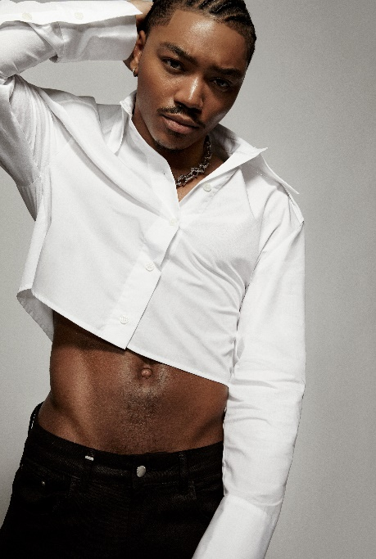
DOWNLOAD HI-RES PRESS IMAGE // PHOTO CREDIT: BLAIR CALDWELL

CONNECT WITH JOSH LEVI
OFFICIAL | FACEBOOK | INSTAGRAM | TIKTOK | TWITTER | YOUTUBE

PRESS CONTACT:
Brittany Bell | Brittany.Bell@atlanticrecords.com

