KAMAUU MAKES COLORS DEBUT WITH “THE VIBE”
DEBUT ALBUM LACUNA IN THE HOUSE OF MIRRORS ARRIVING THIS FRIDAY 4/28;
AVAILABLE FOR PRE-ORDER NOW

SET TO PERFORM AT THE SOMETHING IN THE WATER FESTIVAL THIS SATURDAY 4/29 IN VIRGINA BEACH, VA
WATCH/SHARE COLORS PERFORMANCE
DOWNLOAD/STREAM “THE VIBE”
PRE-ORDER LACUNA IN THE HOUSE OF MIRRORS
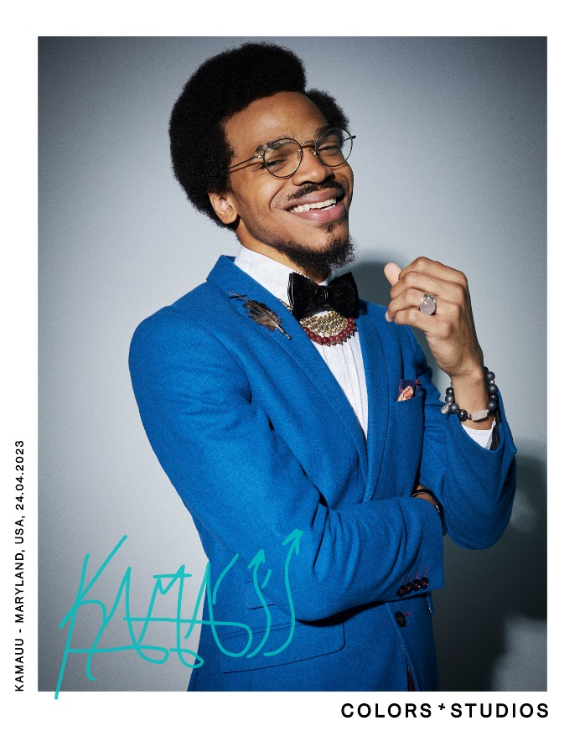
Today, multi-hyphenate artist, KAMAUU, has officially made his COLORS debut with a live performance of “the vibe,” which is included on KAMAUU’s upcoming debut album, LACUNA In The House Of Mirrors, launching this Friday, April 28th and is now available for pre-order. The 11-track album features Grammy-nominated Houston artist, Tobe Nwigwe, British artist, 6x MOBO nominee, Mercury, and Brit nominated artist Kojey Radical as well as Siimbiie Lakew, and Cocoa Sarai.
KAMAUU
LACUNA IN THE HOUSE OF MIRRORS
ATLANTIC RECORDS (4/28)

- switch up
- don’t play with my money (feat. Tobe Nwigwe)
- the vibe
- advantages
- antidote (feat. Kojey Radical & Siimbiie Lakew)
- flings
- for my love
- open letter
- driving scenes (feat. Cocoa Sarai)
- situations
- home

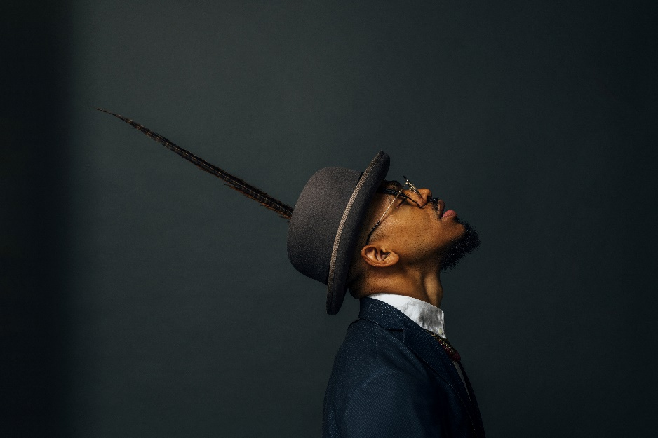
DOWNLOAD HI-RES IMAGES HERE
Credit: Arturo Olmos

KAMAUU
Maryland-based artist, rapper, poet, and thinker KAMAUU made his first proper debut with his appearance on “QUEEN” from No Wyld’s critically acclaimed Ascension EP after officially signing with Atlantic Records in 2015. His unique sonic experimentation made huge waves in 2016, when he released A Gorgeous Fortune EP. His first solo single “Jusfayu” went on to generate over 21.8M global streams and was handpicked by NPR as one of their “Songs We Love.” KAMAUU was also featured on The Birth of a Nation: The Inspired By Album with “The Icarus.” A year later, he unleashed his full-length mixtape, TheKAMAUU-CASSETTE: ŭRTH GōLD, and continued to stoke buzz. He later carefully assembled his third offering for the label, TheKAMAUU-CASSETTE: MíXD GRēēNS which was released during the summer of 2019. Since then KAMAUU has dropped a few notable singles including “MANGO” feat. Adi Oasis (17M+ views) and the remix feat. Masego. The first single from his highly anticipated debut album LACUNA In the House of Mirrors, “flings,” is a seamless, high-energy blend of R&B, funk, and hip-hop. Produced by DJ FU with co-production from Mick Schultz, it’s a distinctive reflection on pain, escapism, addiction, and the degradation of spiritual health. “flings” was followed up by “antidote,” a single about the importance of spiritual wealth, soul gold.
KEEP UP WITH KAMAUU
INSTAGRAM | TWITTER | FACEBOOK | YOUTUBE | WEBSITE

PRESS CONTACT
SELAM BELAY // SELAM.BELAY@ATLANTICRECORDS.COM

- DoloBhana no spacing
- No Wyld correct spelling
- Mick Schultz Producer name
- “the vibe” lower case
- Vieux Diop - Jali (Artist/Song)

