LUH TYLER SURPRISES FANS WITH
MY VISION: RELOADED

NEW VERSION OF RECENTLY RELEASED MIXTAPE FEATURES FIVE ADDITIONAL SONGS INCLUDING COLLABORATION WITH LIL UZI VERT & NEW VERSION OF FAN FAVORITE "JAYDA WAYDA"

DOWNLOAD/STREAM MY VISION: RELOADED

“Talented Emerging Artist You Don’t Want To Miss” – PEOPLE

"Luh Tyler has a lot to celebrate..." - BILLBOARD

“Coolest 16-year-old in America” – PITCHFORK

“Rapper to watch in 2023” – COMPLEX
“An actual overnight sensation” – XXL

“A precociously charismatic rapper at just 17 years old” – FADER

“Already one of (if not the) hottest young rappers coming up” – HIPHOPDX

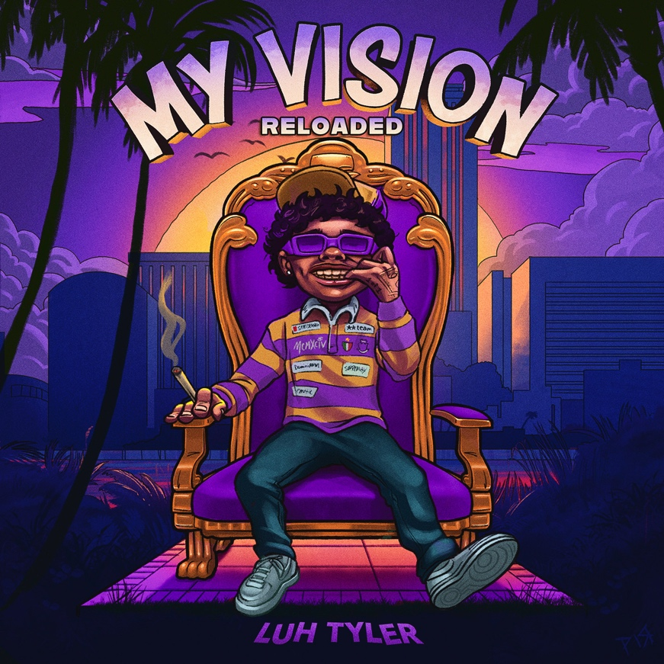
DOWNLOAD HI-RES ARTWORK

(New York, NY – April 4, 2023) Just days after releasing his debut mixtape, rising 17-year-old rapper Luh Tyler’s surprises fans with MY VISION: RELOADED. [Download/Stream]. This enhanced version features five additional songs including two new songs - "Ransom" featuring Lil Uzi Vert and "On A Tuesday" - as well as fan favorites, such as "Jayda Wayda."

The Tallahassee native’s 12-track project arrived last Friday alongside the official video for “You Was Laughing,” directed by Cotto0verDidIt – Watch here.

My Vision includes features from NoCap, Anti Da Menace, Loe Shimmy and production from ForeveRolling (Gucci Mane, BigWalkDog, Lil Durk), Al Geno (Quavo, Lil Baby) and LuciG (PopSmoke, Rod Wave).

My Vision was announced last month after the release of both “Back Flippin,” and “Fat Racks Pt.2” with BabyTron. In less than a year of releasing music, Tyler has amassed more than 43 million streams, received cosigns from hip-hop heavyweights Drake, Lil Uzi Vert, Chris Brown, Coi Leray, Kehlani, Trippie Redd, Rubi Rose and more with critical praise from Complex, Pitchfork, XXLand HipHopDX.

In 2022, Luh Tyler caught the world’s attention with “Law and Order” and fan favorite, “Jayda Wayda.”

MY VISION: RELOADED TRACKLIST
My Vision
Stand On Biz
Ransom Ft. Lil Uzi Vert
On A Tuesday
Poppin Shit Ft. Anti Da Menace
Fat Racks Pt. 2 Ft BabyTron
Hit The Top
Santa Ft Loe Shimmy
Back Flippin
Can't Move Wrong Ft Trapland Pat
Moncler On My Coat
Gettin' Fishy ft SCY Jimm & Wizz Havin
Weeks Ft. NoCap
You Was Laughing
Jayda Wayda
A Day In The Noya ft. Loe Shimmy
Fat Racks

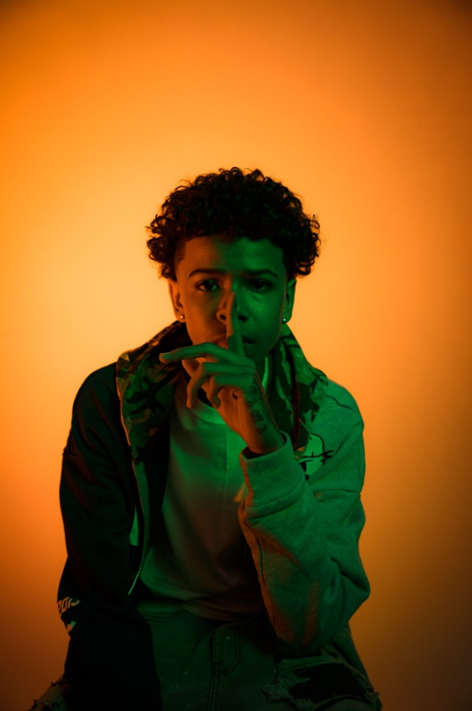
DOWNLOAD PRESS PHOTO (Credit: dill35mm)

For all Luh Tyler press inquiries, please contact:
Jason Davis | Jason.Davis@atlanticrecords.com

ABOUT LUH TYLER
Wielding a wavy flow, irresistible melodies, and inventive dynamics, Luh Tyler animates bouncy anthems with undeniable unpredictability. He switches lanes seamlessly between his signature laidback cadence and airy high register, touting a style all his own. It’s why he’s quietly emerged as a vibrant voice out of his native Tallahassee, FL all before the age of 16. Growing up the youngest of three kids in “a good family,” he initially excelled on the basketball court as a point guard before picking up a mic in high school. Inspired by local favorites Wizz Havin, Trapland Pat, L.O.E. Shimmy, and more, he started to upload music of his own. Following “5 On It Freestyle,” he gained traction on Spotify and YouTube with “Jayda Wayda.” Meanwhile, YouTube views on “Law & Order” soared. DJ Booth touted him as one of “10 Rappers You Should Know Right Now,” and Stereogum christened him, “Best new rapper.” During late 2022, Tyler released “Back Flippin,” the in demand song he teased weeks prior on Tik Tok, which immediately bolstered with support from the likes of Jordan Ross, Chris Brown and Kehlani while Pitchfork declared “…Luh Tyler’s music makes you long for the days when chilling was your only responsibility…his punchlines are boosted by his icy delivery.” Now, he continues to surprise on a series of 2023 singles and his forthcoming debut project.

