2x GRAMMY® AWARD-WINNING MULTI-PLATINUM ARTIST
LAUREN DAIGLE
DEBUTS MUSIC VIDEO FOR LATEST SINGLE “THANK GOD I DO”

SELF-TITLED ALBUM RELEASING MAY 12
VIA ATLANTIC RECORDS/CENTRICITY MUSIC

PRE-SAVE LAUREN DAIGLE ALBUM HERE
WATCH VIDEO FOR “THANK GOD I DO” HERE

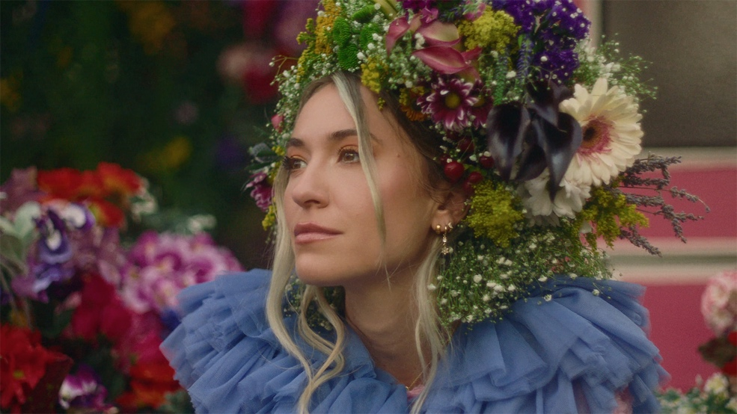

Today, two-time GRAMMY Award Winner and multi-platinum artist Lauren Daigle has released the official music video for her latest single “Thank God I Do.” Filmed in Daigle’s native New Orleans, the visually stunning piece welcomes the viewer into a world of vibrant color and beauty inspired by the city she holds so dear. “Thank God I Do,” debuted last month to critical acclaim, excitement from fans, record-breaking streams across all DSPS, and 120+ radio adds over multi-formats making it the biggest single launch at radio in Daigle’s career to date. The success was then punctuated by a national televised performance on The Today Show. Watch the official video for “Thank God I Do” HERE.

“Thank God I Do” is the first single from, Lauren Daigle, which will be released on May 12th via Atlantic Records/Centricity music and marks a new creative chapter and team for Daigle. Led by GRAMMY®-winning producer Mike Elizondo and featuring co-writes with award-winning songwriters, including Natalie Hemby, Shane McAnally, Amy Wadge, Jason Ingram, Lori McKenna and Jon Greene, Daigle created a body of work which showcases the multi-faceted artist’s stunning and powerful voice, rich storytelling and incredible musicality. This fall, Daigle will embark on a highly-anticipated US arena tour, The Kaleidescope Tour, which kicks off on September 6 in Memphis, TN. Tickets are now on sale at www.laurendaigle.com.

Since the release of her GRAMMY® Award-winning, platinum-certified 2018 album Look Up Child – which includes the breakthrough hit single “You Say” – Daigle has been a mainstay on the Billboard charts. When Look Up Child debuted at No. 3 on the Top 200 Albums chart, Daigle became the first female artist in history to simultaneously hit the Top 10 on both Billboard’s Pop and Christian Album charts. She went on to break another record when the LP reached 100 weeks at No. 1 on the Top Christian Albums chart, which is the greatest number of weeks that any artist has spent at the top of any individual album chart. Similarly, the 5x platinum-certified “You Say” is the longest-running No. 1 to appear on any weekly Billboard chart. Daigle is a two-time Grammy®, seven-time Billboard Music Award, four-time American Music Award, and ten-time GMA Dove Music Award winner.

CONNECT WITH LAUREN DAIGLE
Website | Facebook | Instagram | Twitter | TikTok | YouTube

For More Information, Please Contact:
Sheila Richman | Atlantic Records | Sheila.Richman@atlanticrecords.com
Katy Carmichael | Atlantic Records | Katy.Carmichael@atlanticrecords.com

Paul Freundlich | PFA Media | paulf@pfamedia.net
Alicia Krass | PFA Media | akrass@pfamedia.net
