LUH TYLER ANNOUNCES THE “MY VISION TOUR”
PRESENTED BY ROLLING LOUD

UPCOMING TOUR DATES INCLUDE STOPS IN NEW YORK CITY,
LOS ANGELES, ATLANTA, DALLAS, ORLANDO & MORE
FESTIVAL PERFORMANCES INCLUDE ROLLING LOUD MIAMI, PORTUGAL & GERMANY, LYRICAL LEMONADE SUMMER SMASH & COLOURS

RISING RAPPER’S FIRST EVER TOUR FOLLOWS RECENT RELEASE OF
DEBUT MIXTAPE MY VISION: RELOADED

TICKETS FOR THE “MY VISION TOUR” ARE ON SALE NOW AT
WWW.REALLUHTYLER.COM

DOWNLOAD/STREAM MY VISION: RELOADED

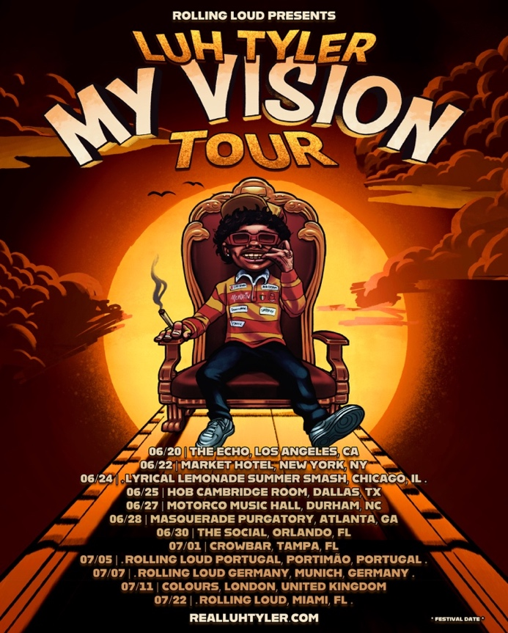
DOWNLOAD ADMAT

“Coolest 16-year-old in America” – PITCHFORK

“His boisterous bars and technical wizardry become more impressive as it sinks in that this kid is still so young.” – STEREOGUM

“The overall impression is that of a natural…crystallizes the Tallahassee rapper’s status as the most exciting young rapper in Florida.” – COMPLEX
“An actual overnight sensation.” – XXL

“A precociously charismatic rapper at just 17 years old.” – FADER

“Talented Emerging Artist You Don’t Want To Miss!” – PEOPLE

"Luh Tyler has a lot to celebrate..." - BILLBOARD

“Already one of (if not the) hottest young rappers coming up.” – HIPHOPDX

(New York, NY – April 12, 2023) Rising 17-year-old rapper LUH TYLER continues his run as the “coolest teenager in rap” with the “MY VISION TOUR” presented by Rolling Loud. Named after his recently released debut mixtape, the “MY VISION TOUR” marks the Tallahassee native’s first ever tour.

The “MY VISION TOUR” kicks off on June 20th at Los Angeles’ The Echo and continues through mid-July with stops in New York City, Los Angeles, Chicago, Dallas and Orlando. Tickets for the “MY VISION TOUR” are on sale now at www.realluhtyler.com.

In addition to these dates, Tyler is also slated for high profile festival appearances at Rolling Loud Miami, Portugal and Germany, as well as Lyrical Lemonade Summer Smash and Colours.

Earlier this month, Luh Tyler surprised fans with MY VISION: RELOADED, an extended version of his debut mixtape, MY VISION, which was originally released days prior. Featuring five additional songs including "Ransom" featuring Lil Uzi Vert and "On A Tuesday," as well as fan favorites, such as "Jayda Wayda," MY VISION: RELOADED was released alongside a companion visual for “You Was Laughing,” which has nearly 1 Million views in less than two weeks.

MY VISION: RELOADED is available now via Motion Music/Atlantic Records. Download/Stream HERE.

MY VISION was announced last month after the release of both “Back Flippin,” and “Fat Racks Pt.2” with BabyTron. In less than a year of releasing music, Tyler has amassed more than 43 million streams, received cosigns from hip-hop heavyweights Drake, Lil Uzi Vert, Chris Brown and Coi Leray, to name a few as well as critical praise from Stereogum, Billboard, FADER, Complex, Pitchfork, XXL and more.

For all Luh Tyler press inquiries, please contact:
Jason Davis | Jason.Davis@atlanticrecords.com

MY VISION TOUR DATES
6/20/23 – Los Angeles, CA @ The Echo
06/22/23 – New York, NY @ Market Hotel
6/24/23 –Chicago, IL @ Lyrical Lemonade Summer Smash
6/25/23 – Dallas, TX @ HOB Cambridge Room
6/27/23 – Durham, NC @ Motorco Music Hall
6/28/23 – Atlanta, GA @ Masquerade - Purgatory
6/30/23 – Orlando, FL @ The Social
7/1/23— Tampa, FL @ Crowbar
7/5/23 Portimao, Portugal @ Rolling Loud Portugal
7/7/23 –Munich, Germany @ Rolling Loud Germany
7/11/23 – London, UK @ Colours
7/22/23 – Miami, FL @ Rolling Loud Miami

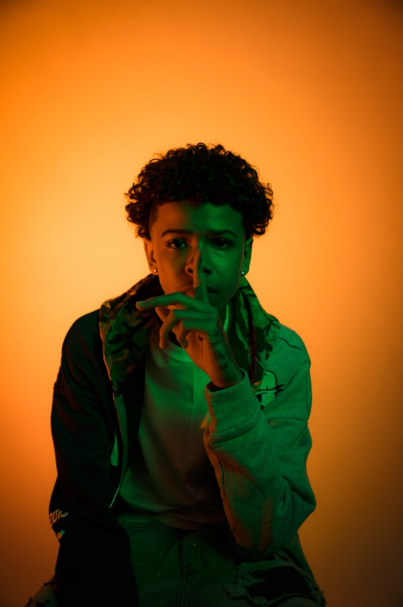
DOWNLOAD PRESS PHOTO (Credit: dill35mm)

ABOUT LUH TYLER
Wielding a wavy flow, irresistible melodies, and inventive dynamics, Luh Tyler animates bouncy anthems with undeniable unpredictability. He switches lanes seamlessly between his signature laidback cadence and airy high register, touting a style all his own. It’s why he’s quietly emerged as a vibrant voice out of his native Tallahassee, FL all before the age of 16. Growing up the youngest of three kids in “a good family,” he initially excelled on the basketball court as a point guard before picking up a mic in high school. Inspired by local favorites Wizz Havin, Trapland Pat, L.O.E. Shimmy, and more, he started to upload music of his own. Following “5 On It Freestyle,” he gained traction on Spotify and YouTube with “Jayda Wayda.” Meanwhile, YouTube views on “Law & Order” soared. DJ Booth touted him as one of “10 Rappers You Should Know Right Now,” and Stereogum christened him, “Best new rapper.” During late 2022, Tyler released “Back Flippin,” the in demand song he teased weeks prior on Tik Tok, which immediately bolstered with support from the likes of Jordan Ross, Chris Brown and Kehlani while Pitchfork declared “…Luh Tyler’s music makes you long for the days when chilling was your only responsibility…his punchlines are boosted by his icy delivery.” Now, he continues to surprise on a series of 2023 singles and his forthcoming debut project.

