FOR IMMEDIATE RELEASE
APRIL 21, 2023

OHGEESY SHARES OFFICIAL REMIX FOR MULTIMILLION-STREAMING HIT SINGLE “GEEKALEEK” FEATURING BIA

OFFICIAL TRACKLIST REVEALED FOR EAGERLY AWAITED NEW SOLO MIXTAPE GEEZYWORLD 2

GEEZYWORLD 2 ARRIVES VIA ATLANTIC RECORDS ON FRIDAY, MAY 5

PRE-ORDERS/PRE-SAVES AVAILABLE NOW

LISTEN TO “GEEKALEEK (FT. BIA)” HERE

DOWNLOAD HI-RES ARTWORK

“A decade into his career, OHGEESY is just getting started.” - HYPEBEAST

Multiplatinum rap hero OHGEESY has shared “GEEKALEEK (Ft. BIA),” a brand-new reworking of his current hit single, “GEEKALEEK (Ft. Cash Kidd),” available today via Atlantic Records at all DSPs and streaming services. Alongside the remix of the multimillion-streaming hit single, OhGeesy has unveiled the GEEZYWORLD 2 track list featuring Kalan.FrFr, Bino Rideuax, 03 Greedo and more.

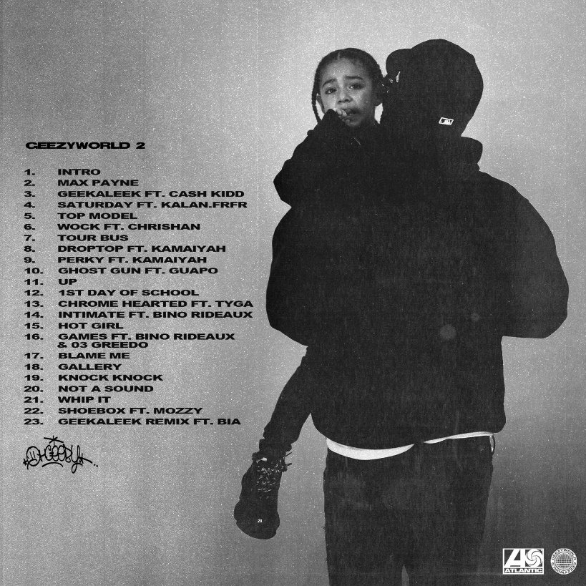
DOWNLOAD HI-RES TRACK LISTING ARTWORK

Now boasting over 17.4M+ global streams and counting, “GEEKALEEK (Ft. Cash Kidd)” is featured on OHGEESY’s eagerly awaited new mixtape, GEEZYWORLD 2, arriving Friday, May 5. Pre-orders/pre-saves are available now, as well as pre-orders for physical copies HERE. The track – which sees OHGEESY flowing over a repurposed sample of Petey Pablo’s 2003 crunk smash, “Freek-A-Leek” – was met by instant praise from such outlets as REVOLT and Passion of the Weiss‘s “The Rap-Up,” which declared it “an early contender for song of the summer.” An official companion video – now with close to 4M views – is streaming now at YouTube.

What’s more, GEEZYWORLD 2 – which follows OHGEESY’s acclaimed 2021 solo debut mixtape, GEEZYWORLD – includes such recent anthems as “Gallery,” “Knock Knock,” “Up, “1st Day of School,” and “Chrome Hearted (Ft. Tyga),” all of which are joined by official music videos currently boasting a combined 10M+ views via YouTube alone.

Hailed in a recent HYPEBEAST feature interview as “a lone star and certified expert in experimentation, flow and writing killer hooks,” OHGEESY recently introduced fans to GEEZYWORLD 2 on a wide-ranging North American live run that saw him supporting GRAMMY® Award-nominated rapper YG’s “The Red Cup Tour” as well a top-billed hometown performance at Inglewood, CA’s Rolling Loud California. Additional dates will be announced soon. For updates, please visit www.ohgeesyofficial.com.

In addition, OHGEESY recently teamed with rising hip-hop star Bankrol Hayden for the star-studded new single, “Bop Slide (Ft. Blueface, OHGEESY & Maxo Kream),” available now at all DSPs and streaming services.

ABOUT OHGEESY:
California never gave rise to a rapper quite like OHGEESY. The Los Angeles-born Mexican American multiplatinum artist, entrepreneur, and visionary not only continues the legacy of his hometown, but he also puts a whole culture rarely represented in hip-hop on his back with pride, poise, and power. As such, he emerges as a trailblazer with vicious wordplay, vibrant storytelling, and a vital message. Breathing new life into the culture, he co-founded Shoreline Mafia during 2016. He locked down the group’s legacy with the double-platinum “Bands,” platinum-certified “Musty” and “Nun Major,” and the gold-certified “Bottle Service” and “Whuss The Deal.” During 2021, he served up his solo debut, GEEZYWORLD, which led him to his first sold-out tour. Among many highlights, “Get Fly (Ft. DaBaby)” raked in over 37M Spotify streams, while “Keeper (Ft. A Boogie Wit Da Hoodie)” posted up 23M Spotify streams. Right out of the gate, Pitchfork proclaimed, “GEESY is well placed to thrive as a lone star. GEEZYWORLD is a quintessential L.A. rap record.” On its heels, he supported the release with a massive sold-out headline tour. His world as a rising superstar has expanded to include exclusive merchandise with his line OTXBOYZ sold through his GEEZYWORLD web site. At the same time, he co-owns Mexican seafood spot Sunset Mariscos inside of the famed Fred Segal store in West Hollywood.

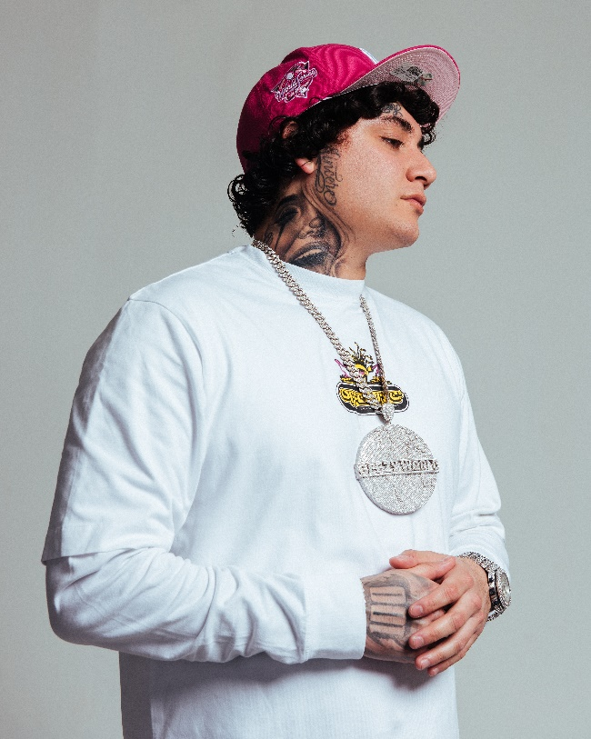
DOWNLOAD HI-RES PRESS IMAGE // PHOTO CREDIT: EMILIO SANCHEZ
# # #
CONNECT WITH OHGEESY
OHGEESYOFFICIAL.COM | FACEBOOK | INSTAGRAM | TWITTER | YOUTUBE

PRESS CONTACT:
Brittany Bell | Brittany.Bell@atlanticrecords.com

