FOR IMMEDIATE RELEASE
APRIL 14, 2023

RISING ALT-COUNTRY STAR TANNER USREY MAKES ATLANTIC RECORDS’ DEBUT WITH “GIVE IT SOME TIME”

WIDE-RANGING LIVE SCHEDULE SET THROUGH SEPTEMBER
INCLUDING DATES WITH ELLE KING, CHARLES WESLEY GODWIN, AND THE STEEL WOODS

LISTEN TO “GIVE IT SOME TIME” | WATCH OFFICIAL MUSIC VIDEO

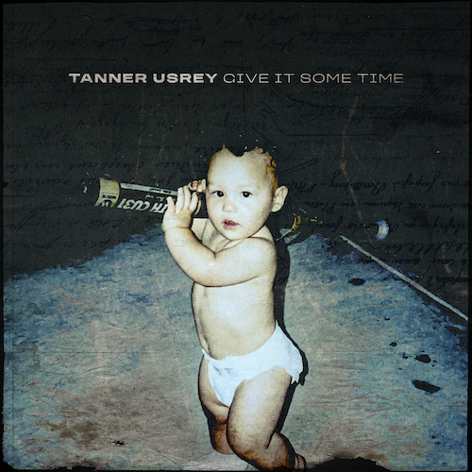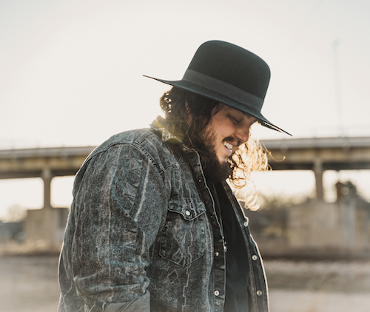
DOWNLOAD HI-RES PRESS IMAGE // PHOTO CREDIT: TRENTON JOHNSON
DOWNLOAD HI-RES ARTWORK

Rising country troubadour Tanner Usrey is celebrating his signing to Atlantic Records with today’s release of his label debut single, “Give It Some Time,” available now at all DSPs and streaming services. The track arrives alongside the exclusive Billboard signing announcement, plus a companion music video for the debut single premieres today at YouTube HERE.

Co-written by Usrey and producer Beau Bedford (Jonathan Tyler, The Texas Gentlemen), “Give It Some Time” threads dusty acoustic guitar and unfiltered lyrics against an organ-laden beat, building towards an emotionally charged guitar solo as scorching as the Texas-born singer, songwriter, and guitarist’s pleading vocal delivery.

“I started writing this song about a year and a half ago,” says Tanner Usrey. “It wasn’t one that came easy, by any means. I had the hook and a verse down when I went to start the record with Beau Bedford. And we finished the song in an hour and recorded it later that day. It’s an anthem about change, holding on to the person you love, and riding out the storm, because things will get better with time. This song means a lot to me, it’s one that I had to work at for a long time to write, and it’s our first single release with Atlantic, so I’m super excited about working together with this awesome team and seeing what we can accomplish together.”

An electrifying and energetic live presence who played over 180 shows in 2022 alone, Usrey will continue his non-stop touring with an upcoming series of live dates that will see him on the road through the summer. Highlights include headline shows, festival appearances, and dates alongside such like-minded artists as Elle King, Charles Wesley Godwin, and The Steel Woods. For complete details and ticket availability, please visit www.tannerusreymusic.com/tour-dates.

ABOUT TANNER USREY
Tanner Usrey has earned national applause for channeling a classic spirit from a personal perspective, blending straight-shooting storytelling with country grit, rock ‘n’ roll energy, and Americana eloquence. Inspired by a range of influences – spanning George Strait, Tom Petty, Lynyrd Skynyrd, and The Rolling Stones to his favorite band Whiskey Myers – Usrey grew up in the small town of Prosper, TX, where he worked as a skip tracer while honing his signature style by writing countless songs and performing gigs anywhere that had a stage. In 2019, he quit his job and unveiled the Medicine Man EP, followed in 2021 by the SÕL Sessions EP, earning tens of millions of streams and featured placement on the highly rated Yellowstone Season 4 finale Usrey kicked off 2023 with “Take Me Home,” drawing over 10M streams thus far. Now, as the latest member of the world-renowned Atlantic Records roster, Tanner Usrey is poised to bare it all with “Give It Some Time” and more new music to come.

“I hope you hear what you want to hear, enjoy it, resonate with it, and know it’s real,” Usrey says. “It’s been a wild ride. I’ve busted my ass. I started off doing all of this on my own, so it’s crazy to see how this and the team around me have grown. People are going after real music right now, and that’s great. I’m looking forward to seeing where it goes next.”

TANNER USREY
ON TOUR 2023

APRIL
14 – New Braunfels, TX – Gruene Hall
15 – Palestine, TX – Wiggy Thump 2023 *
20 – Richmond, VA – The National †
21 – Philadelphia, PA – Brooklyn Bowl †
22 – Baltimore, MD – Rams Head Live! †
25 – Salt Lake City, UT – Union Event Center #
27 – College Station, TX – The Tap
28 – Stephenville, TX – LJT Texas Music Festival *

MAY
2 – Venice, NE – Buck’s Bar & Grill
3 – Venice, NE – Buck’s Bar & Grill
5 – Wichita, KS – Wave
6 – Stillwater, OK – Calf Fry Festival *
12 – Shreveport, LA – Louisiana Grandstand
13 – Midlothian, TX – Union 28
18 – Little Rock, AR – The Rev Room
19 – Mountain Home, AR - Oasis
20 – Nashville, TN – Brooklyn Bowl Nashville ^
25 – Chattanooga, TN – Barrelhouse Ballroom
26 – Phenix City, AL – Phenix City Amphitheater ^
27 – McCaysville, GA – TOONEYS

JUNE
2-4 – Gardnerville, NV - BackCountry Festival *
15 – Salmon, ID – Sweet Water Hollow ^
17 – Spokane, WA – Martin Woldson Theater at the Fox ^
18 – Seattle, WA – Tractor Tavern ^
22 – Pendleton, OR – Jackalope Jamboree *
23 – Great Falls, MT – Beacon Icehouse
24 – Filer, ID – Gordy’s HWY 30 Music Festival *

JULY
22 – New Braunfels, TX – Whitewater Amphitheater
27 – Floyd, VA – FloydFest *
28 – Ft. Smith, AR – Peacemaker Festival *

AUGUST
26 - Henriette, MN – Northwoods Jam *

SEPTEMBER
3 – Lake View, IA – Stone Pier Summer Concert Series

* Festival Performance
† w/ Charles Wesley Godwin
# w/ Elle King
^ w/ The Steel Woods

# # #
CONNECT WITH TANNER USREY
OFFICIAL | FACEBOOK | INSTAGRAM | TWITTER | YOUTUBE
N”

