FOR IMMEDIATE RELEASE
MAY 18, 2023

JASON DERULO SHARES “WHEN LOVE SUCKS (FEAT. DIDO)”

MULTIPLATINUM GLOBAL SUPERSTAR RETURNS WITH LATEST CLUB-POP SMASH

SULTRY NEW SINGLE INTERPOLATES DIDO’S 1999 CLASSIC, “THANK YOU”

LISTEN TO “WHEN LOVE SUCKS (FEAT. DIDO)”

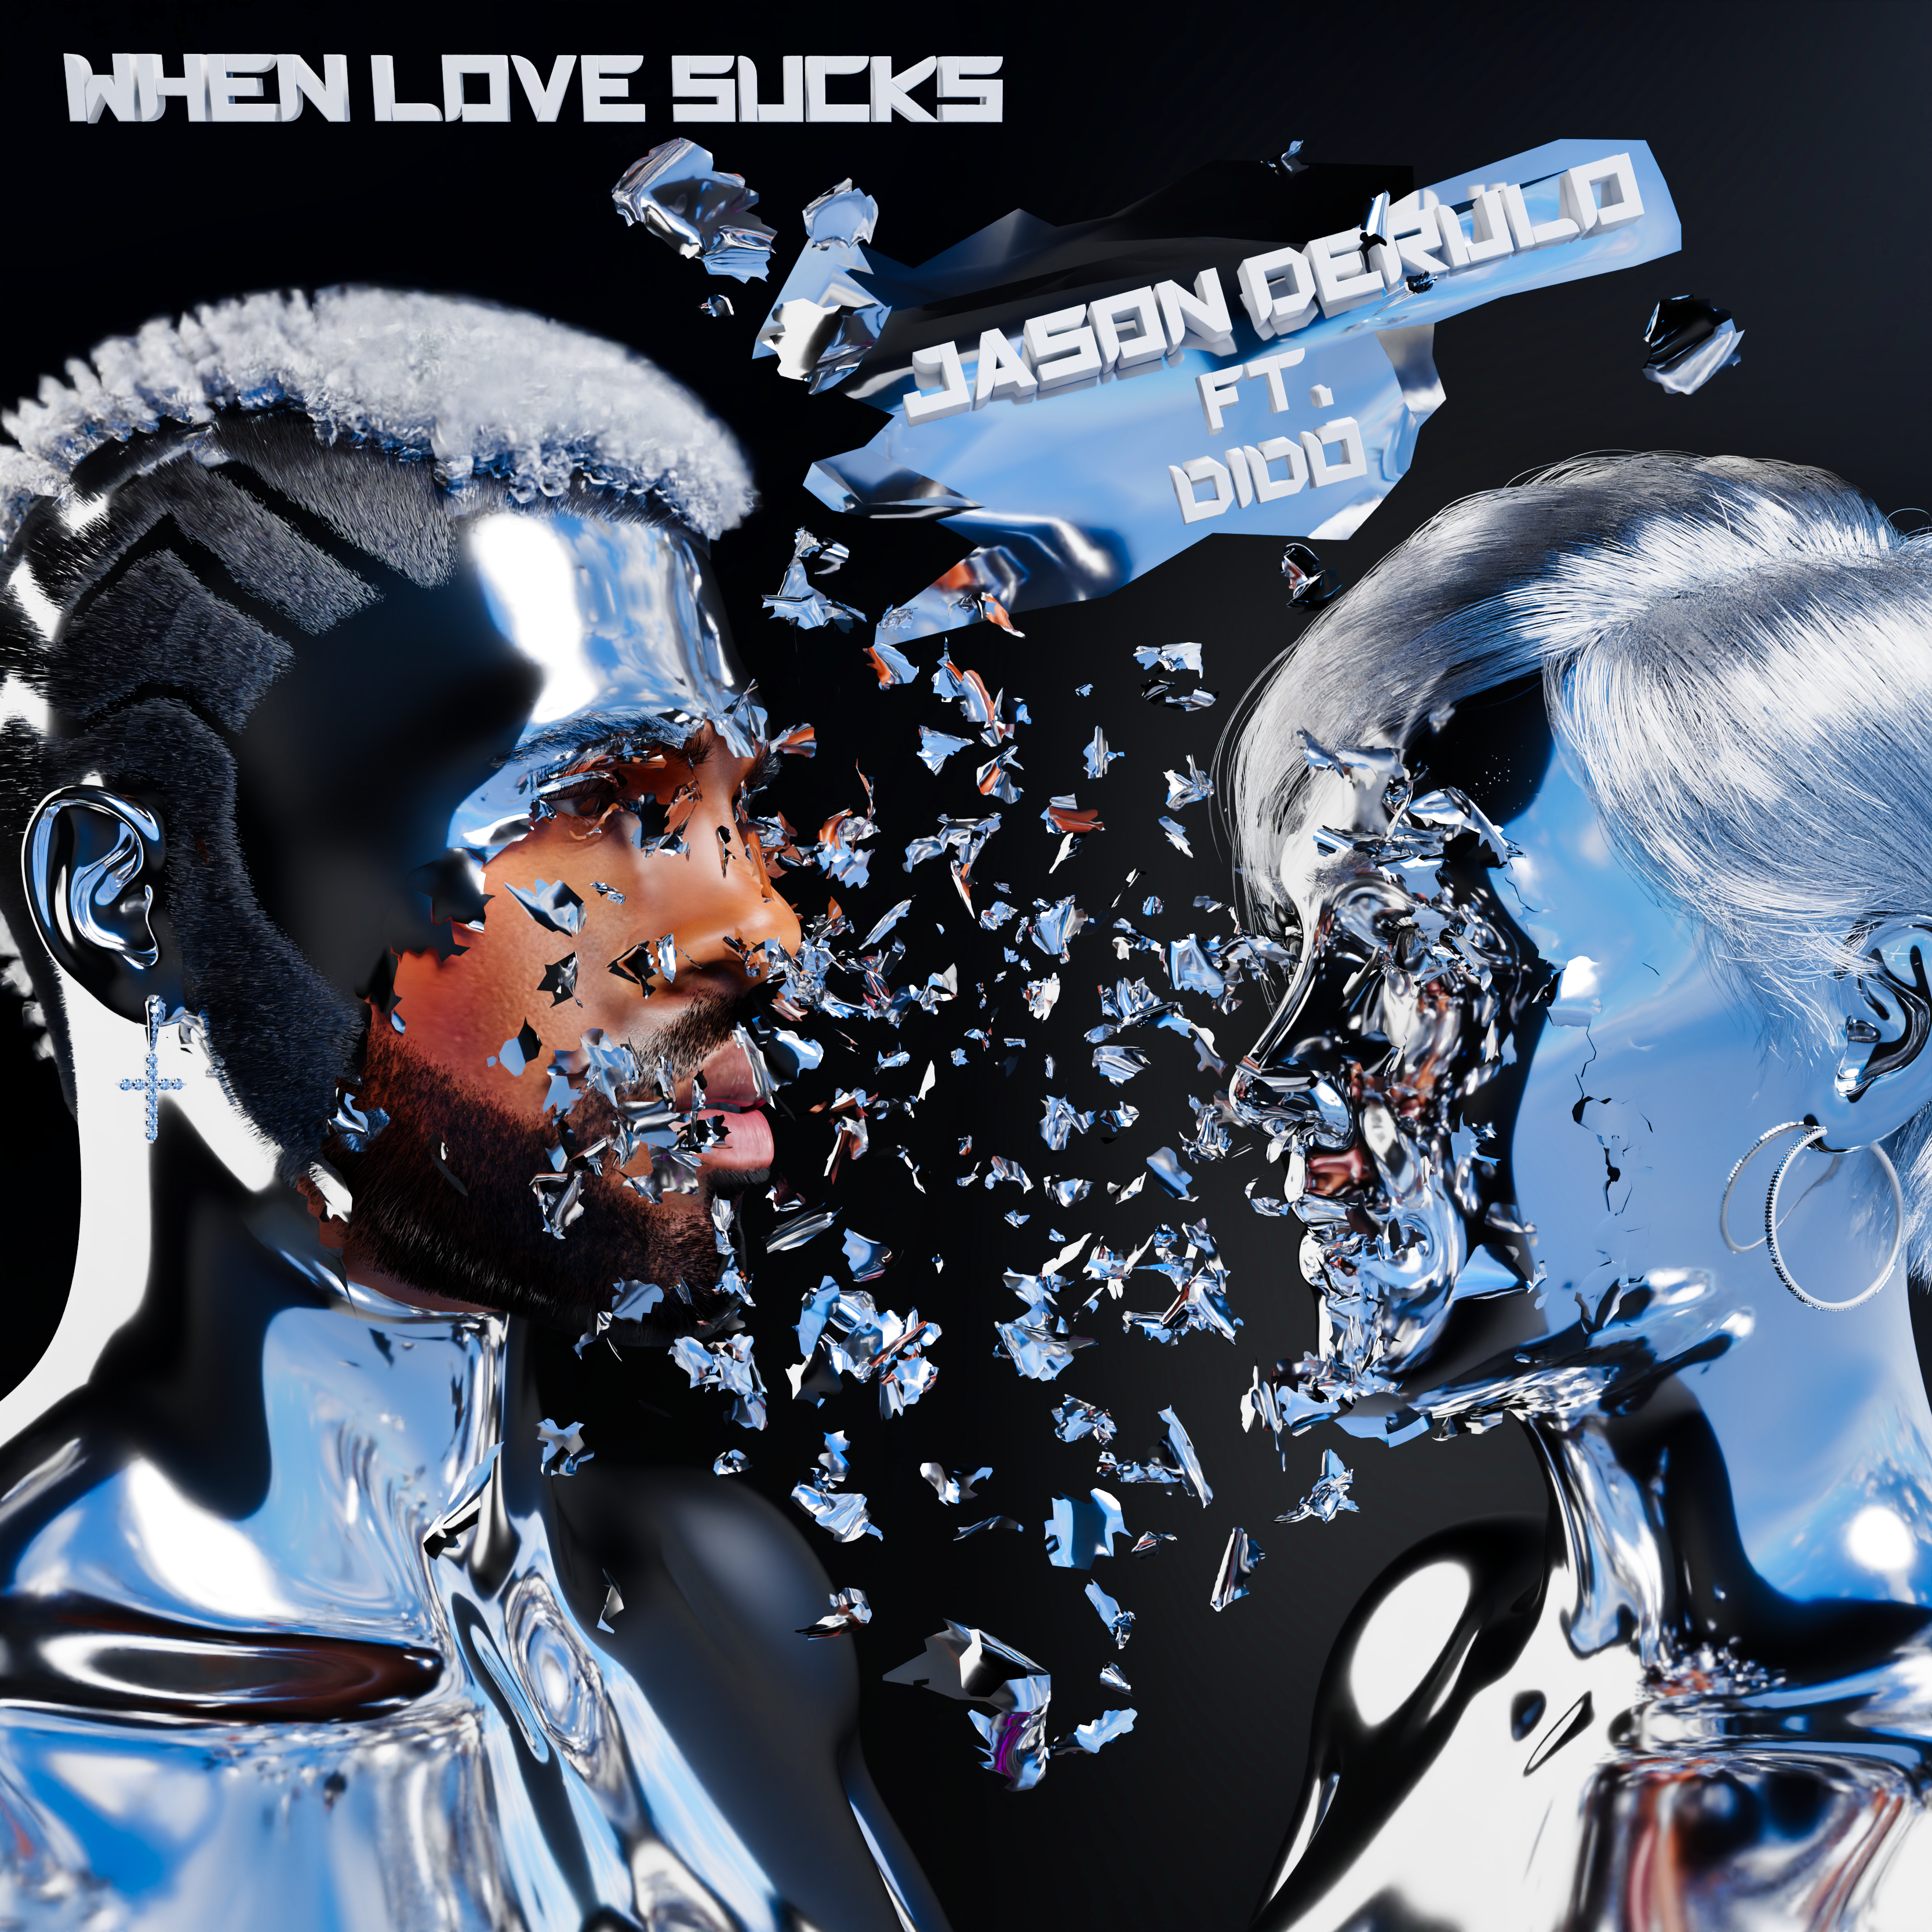
DOWNLOAD HI-RES ARTWORK HERE

Multiplatinum global superstar Jason Derulo has shared his latest club-pop smash, “When Love Sucks (Feat. Dido),” available now via Atlantic Records at all DSPs and streaming services HERE. Produced by Pink Slip (One OK Rock, Royal & The Serpent), the sultry track interpolates Dido’s 1999 top 3 hit single, “Thank You,” famously sampled in Eminem’s classic “Stan”.

“….AND I CAN’T LIE
WHEN LOVE SUCKS, IT SUCKS
YOU’RE THE BEST & THE WORST I’VE HAD
BUT IF YOU’RE THERE WHEN I WAKE UP
THEN, IT’S NOT SO BAD”

“When Love Sucks (Feat. Dido)” marks the latest in a string of blockbuster hits for Derulo including “Glad U Came,” available now via Atlantic Records at all DSPs and streaming services HERE. Produced by Pink Slip, Jakke Erixson (Ava Max, Lauren Spencer Smith), Sam Martin (David Guetta, Maroon 5), Spencer Bastian (Rita Ora, Chromeo), and Tor Eimon (Faouzia, Chloe Tang), the smoothly dynamic track is accompanied by an official lyric video streaming at YouTube HERE, and has been streamed over 4 million times globally thus far.

This winter saw the release of Derulo and David Guetta’s feel-good collaboration, “Saturday/Sunday.” The ultimate showcase for both artists’ signature approach towards club-ready pop anthems, the irresistibly energetic track is joined by an official dance video streaming at Derulo’s hugely popular YouTube channel HERE.

Derulo – who is currently starring among the coaching panel on The Voice Australia – celebrated “Saturday/Sunday” with a full-length live performance on the third annual NFL TikTok Tailgate, the league’s ultimate pregame party before Super Bowl LVII, live from State Farm Stadium in Glendale, AZ. In addition, portions of Derulo’s performance – which saw him joined by a pack of robot dogs and included such hits as the RIAA platinum-certified “Talk Dirty” – was televised in the FOX Super Bowl LVII Pregame Show.

ABOUT JASON DERULO
Forward-thinking, genre-defying, and massively creative, Jason Derulo has staked his claim as one of the most dynamic forces on the global pop landscape. Since breaking through with his 5x RIAA Platinum-certified single, “Whatcha Say,” the award-winning singer-songwriter who has a net worth in excess of $100 million, has sold more than 250M singles worldwide and achieved 15 Platinum singles including “Wiggle“, “Talk Dirty“, “Want to Want Me,” “Trumpets,” “It Girl“, “In My Head,” “Ridin’ Solo,” “Don’t Wanna Go Home,” “Marry Me,” “ The Other Side,” “Get Ugly,” “Swalla,” “Savage Love” and “Take You Dancing.” Since the start of his solo recording career in 2009, he has earned over 18.2B worldwide streams, and built an unstoppable social media following of over 117M followers across all platforms. Now at work on his highly anticipated fifth album – and full-length debut for Atlantic Records – Derulo has delivered an ongoing series of smash singles that have drawn a stunning 500M+ views, including the irresistibly buoyant “Acapulco,” the RIAA platinum-certified “Take You Dancing,” and Jawsh 685 x Jason Derulo’s 3x platinum-certified chart-topper, “Savage Love (Laxed – Siren Beat).” The latter track – and its official BTS remix – proved an unstoppable international sensation upon its 2020 arrival, peaking at #1 on Billboard’s “Hot 100” as well as atop charts in 16 additional countries around the world.

A truly multi-dimensional creator, Derulo has also established himself as an actor and businessman, investing in enterprises like Catch L.A. and Rumble Boxing, becoming part-owner of Bedlam Vodka, launching an innovation-minded podcast, and developing a line of supplements and fitness products with the Najafi Group and BodyBuilding.com. What’s more, Derulo unveiled Jason Derulo’s UZO, an immersive new graphic novel from Z2 Comics based on a TikTok character created by the artist himself.

With his TikTok regularly amassing over 10M views per post, Derulo notes that the platform has drastically reshaped his relationship with his fans. Derulo is now amongst TikTok’s biggest superstars, currently the 4th most followed male on the video-sharing platform with the 11th biggest account overall. He continues to see his already astronomical TikTok presence growing daily, now boasting more than 57.9M followers worldwide and over 1.2B likes. Reclaiming his title as the TikTok king, last year saw the summer smash single “Slidin’” released alongside a fan-challenged TikTok video to his own rendition of the electric slide (streaming HERE). His knack for laying undeniably catchy melodies on top of fun, upbeat productions, was the formula for his Summer takeover. To celebrate the single, Derulo hosted a wildly extravagant ”Slidin’” Weekend in Miami with some of his closest creator friends. The weekend included a private “Slidin’” jet set from LA to Miami; an insanely large “Slidin’” mansion; a sexy “Slidin’” yacht party; hibachi, dinners, clubbing and more (watch HERE).

ABOUT DIDO
Dido’s titanic success started when she released her debut record in 1998. No Angel’s success grew to eventually become the bestselling album of 2001 (Consisting of the classic hits ’Thank You’, ‘Here With Me’). She won several awards, including Best British Album and Best Female at the Brit Awards, alongside sweeping up MTV Europe Music Award for Best New Act. 'Thank You’ went on to another level of success when American rapper Eminem asked to sample it as a collaboration with her.

She went on to release 'Life For Rent' in 2003 which introduced the world to 'White Flag' and 'Life for Rent’.

Dido was on the road for 9 years touring, promoting, releasing new music which included her release of Life For Rent in 2003. She performed ‘White Flag' to a TV audience of billions at three of Live8 shows in 2005 (London, Cornwall and Paris) before stepping away for a moment to take some time out and performed with other British and Irish artists in the Band Aid 20 version of the charity single "Do They Know It's Christmas?".

Both of these albums are among the best-selling albums in UK chart history.

In 2008 came the release of ’Safe Trip Home’ and in 2011 she received an Academy Award nomination for Best Original Song for her release of"If I Rise,” a collaboration with producer A.R. Rahman which featured in the movie '127Hours’ , a thriller film directed by Danny Boyle. It won the Broadcast Film Critics Association Award for Best Song.

She was ranked on the Billboard chart of the top Billboard 200 artists of the 2000s (2000–2009) based on the success of her albums in the first decade of the 21st century.

'Girl Who Got Away,’ came in 2013, but as per her decision with Safe Trip Home, Dido opted not to take it on the road. They were two records she wrote from a different dimension of life, through pregnancy and after the birth of her son and she was very much for people discovering the music in a different way to when she had toured her previous records.

In 2013 came The Greatest Hits before her departure with Sony Records.

Now signed to BMG, 2018 saw a new release ’Still On My Mind’ which she went on tour after 15 years of not touring.

Just recently Dido appeared on American singer-songwriter Caroline Polachek's album alongside singer Grimes, and is credited as a co-writer.

Outside of her own releases, Dido has also cowritten a number of songs for other artists, including Britney Spears ‘I’m Not a Girl, Not Yet a Woman’ and Rihanna’s ‘Never Ending’ on her album ‘Anti’.

# # #

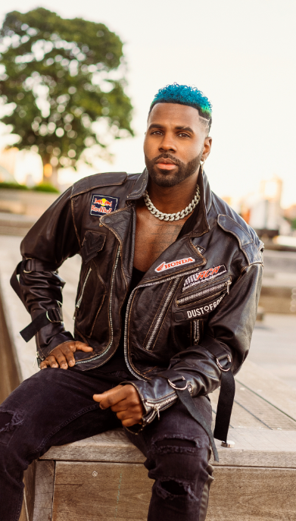
DOWNLOAD PRESS PHOTO HERE
PHOTO CREDIT: PETER O’DOWD

CONNECT WITH JASON DERULO
OFFICIAL | FACEBOOK | INSTAGRAM | TIKTOK | TWITTER | YOUTUBE

PRESS CONTACT FOR JASON DERULO
FAIRLEY MCCASKILL | FAIRLEY.MCCASKILL@ATLANTICRECORDS.COM

PRESS CONTACT FOR DIDO
VIKKI JOSEPHS | VIKKI.JOSEPHS@LMEWORLDWIDE.COM

