FOR IMMEDIATE RELEASE
MAY 12, 2023

BABY FISHER MAKES IT “RAIN” WITH NEW RELEASE
FROM UPCOMING EP CHAPTER 1

LOS ANGELES-BASED MODERN ROCKER SHARES LATEST SINGLE
IN REMARKABLE RUN OF NEW RELEASES

“RAIN” AVAILABLE NOW VIA ATLANTIC RECORDS/ARTHOUSE RECORDS

LISTEN TO “RAIN” | WATCH OFFICIAL LYRIC VIDEO | PRESAVE CHAPTER 1 EP

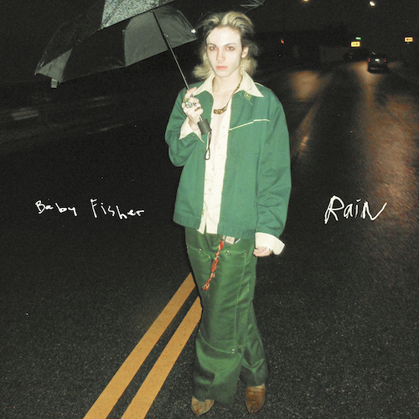
DOWNLOAD HI-RES ARTWORK HERE

Los Angeles-based modern rocker Baby Fisher is back with his latest powerhouse single, “Rain”, from his upcoming EP Chapter 1 releasing Friday, June 2nd. “Rain” is available now via Atlantic Records/Arthouse Records on all DSPs and streaming services HERE. An official lyric video premieres today at YouTube HERE.

“This song feels like the last scene of your favorite movie,” says Baby Fisher. “It feels like finally getting over the ex that you can’t seem to stop thinking about. I gave this song everything I’ve got and I want you to devour it and then spit it back into my lovely eyeliner covered face. My songs are little slices of my life served like a fancy prosciutto platter strictly for your pretty ears. This song is a piece of me that I want to gift to you. This is yours to keep.”

“Rain” continues a remarkable run of emotionally charged new tracks from Baby Fisher, “This Is The End,” “Sick Of This,” and “Don’t Cut Your Hair,” all of which are joined by companion music videos – as well as intimate live performances, acoustic versions, and more – streaming now at his official YouTube channel HERE.

Currently boasting more than 7M TikTok likes, Baby Fisher – a.k.a. Sam Fisher – grew up in Van Nuys, CA, listening to Bruce Springsteen, whiny voice singers of the 90s, and rap music. He moved to Burbank at the age of 10 and at 12, began playing guitar. After just four months, he started gigging regularly at local blues bars, playing alongside with veteran studio musicians who had previously worked with the likes of Elvis Presley, Etta James, and more. Inspired, Fisher spent most of his high school years making music, reading, sewing his own clothes, and hanging out with kids that were way too old for him. Being the youngest, they called him Baby, bestowing upon him his distinctive musical moniker. Fisher continued to push his music forward, weaving sounds of classic 60s and 70s rock with 21st century energy and a one-of-a-kind lyrical perspective fueled by his love for “Charles Bukowski and a good viewpoint, driving at 2 am, and too many women who were far too pretty for me.”

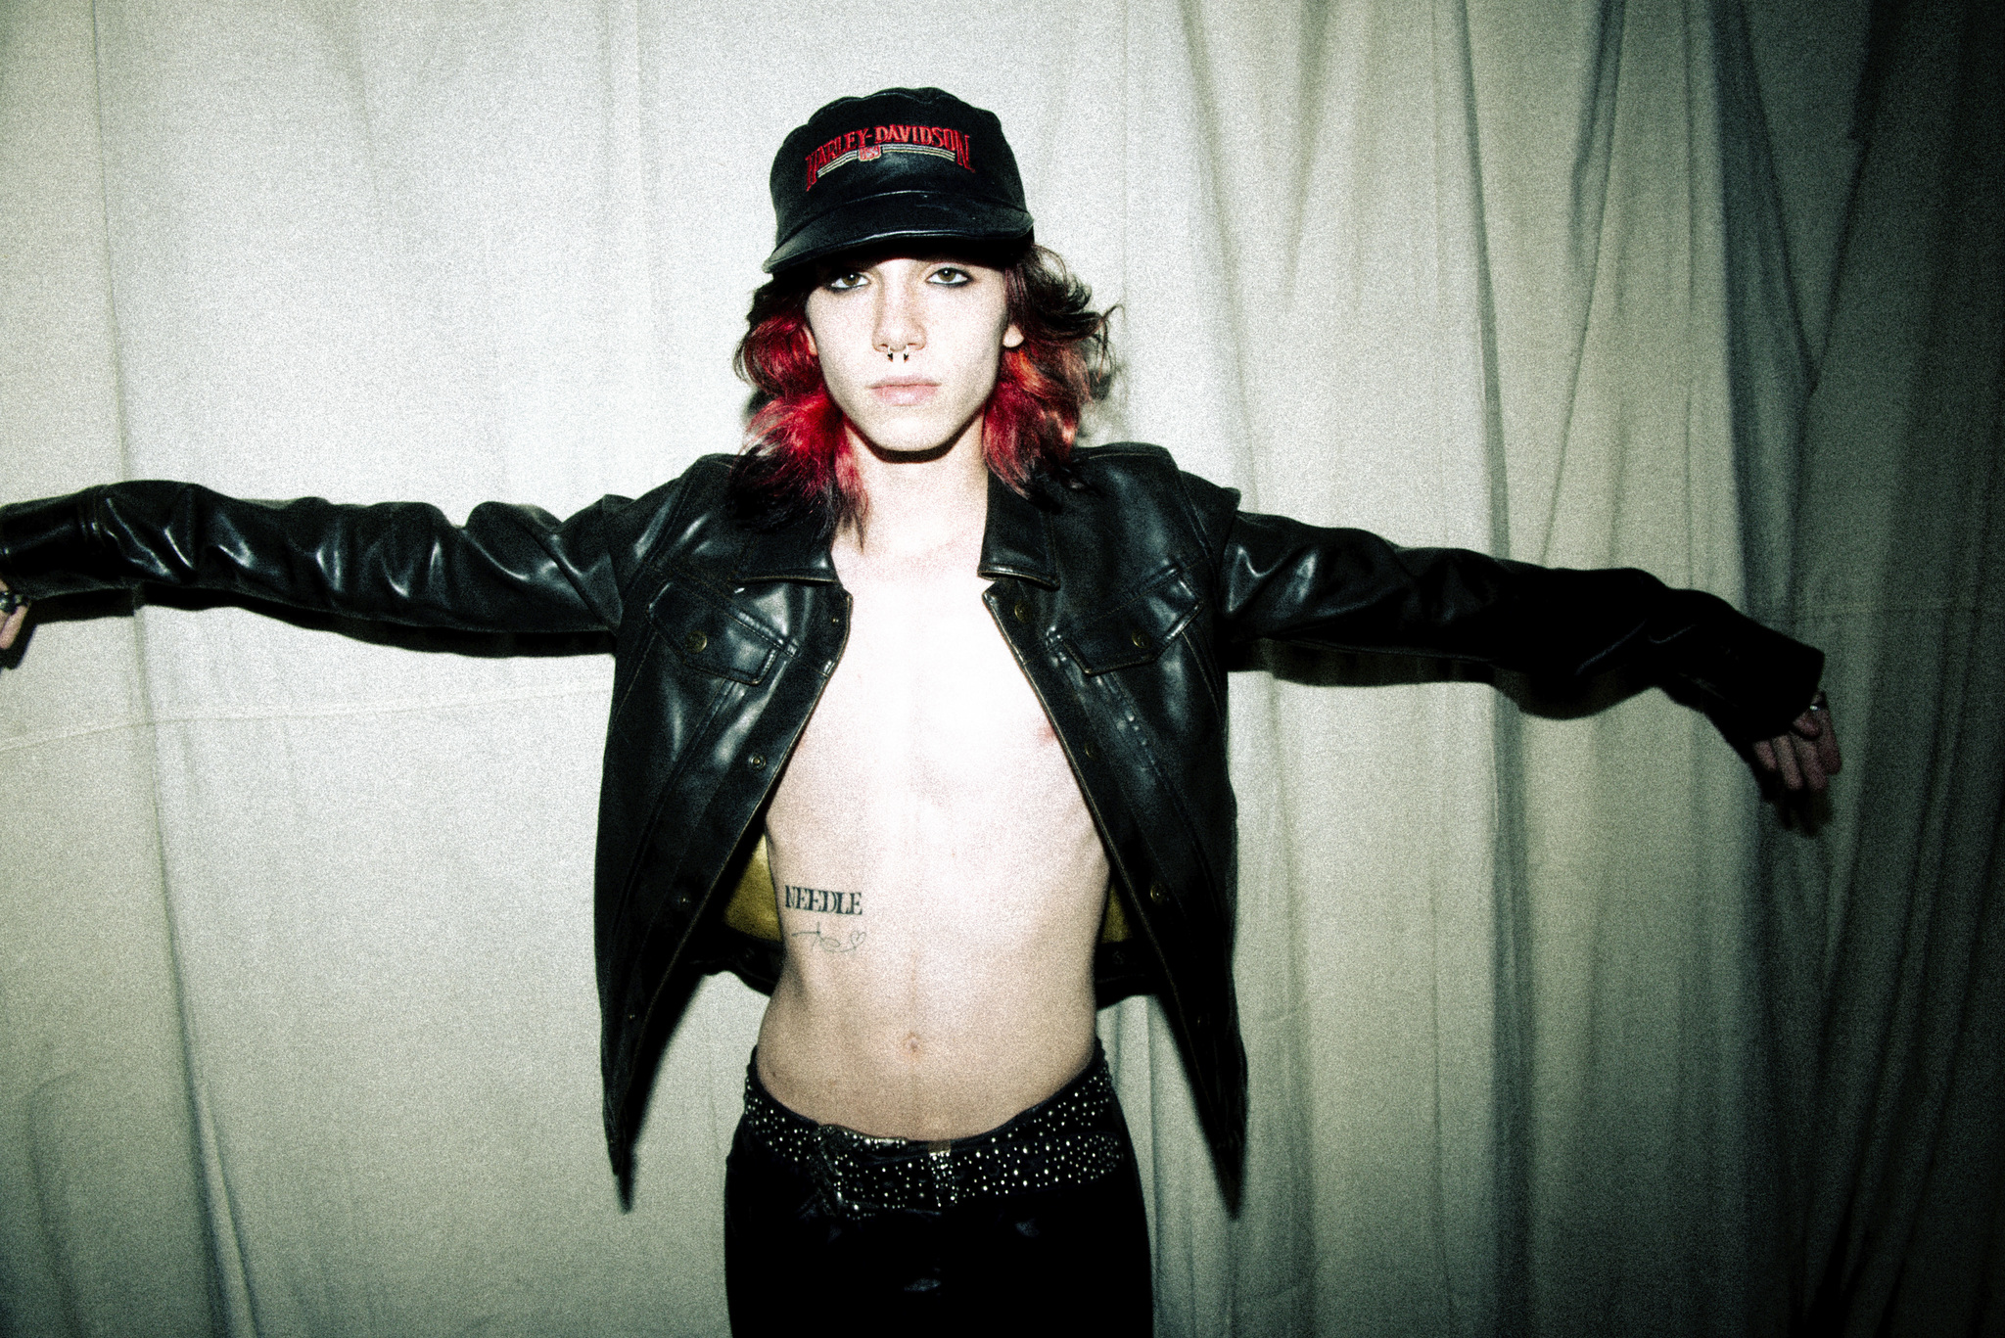
DOWNLOAD PRESS PHOTO // PHOTO CREDIT: JACQUELINE JUSTICE

Chapter 1 EP Tracklist:
Don’t Cut Your Hair
RAIN
Sick of This
Gas Money
Jesus & Mary Jane
This is the End

ABOUT BABY FISHER:
Hi, I’m Sam Fisher aka Baby Fisher, born July 25, 2005. I grew up in the valley (Van Nuys, CA) listening to Bruce Springsteen, whiny voice singers of the 90s and rap. Moved to Burbank at the age of 10 and was possibly the LEAST cool kid in both elementary and middle school. At 12 I started playing guitar, about 4 months in of playing I started gigging regularly at blues bars with studio musicians from the 60s/70s who worked with Elvis, Etta James, etc. All my love goes out to them, if it wasn’t for them, I’d still be daydreaming about being a musician. I dove headfirst into the high school dumpster fire at 14 while simultaneously spending all my time making music, reading, sewing my own clothes or hanging out with kids that were way too old for me and doing exactly what they shouldn’t. I was the youngest, so they called me Baby (hence Baby Fisher). I found myself sprinting into bum territory and instantly turned in the right direction. I fell in love with Bukowski and a good viewpoint, driving at 2 am and too many women who were far too pretty for me. These loves quickly turned into song inspiration. Y’know I once wrote to my favorite author at age 10 and he wrote back. He told me a very simple thing that really stuck with me; “there’s no magic in books, they’re just words strung one after another, the magic happens in the reader’s head. All you’ve got to do is learn to get the order right.” The same applies to these songs. All they are is silly little documentations of my life. There’s nothing spectacular or fantastic or whatnot. All the magic comes from you. It’s already there, the music is just what brings it out. There’s no me without you.
# # #

CONNECT WITH BABY FISHER
BABYFISHEROFFICIAL.COM | INSTAGRAM | TIKTOK | YOUTUBE

PRESS CONTACT:
Paige.Rosoff@atlanticrecords.com
Big Beat Records | Atlantic Records

