FOR IMMEDIATE RELEASE
MAY 12, 2023

Charlotte Cardin is “Looping”

Streisand-Sampling track from globally-acclaimed singer-songwriter out now

’99 nights’ Headline tour tickets on sale now, US Dates kicking off October 24th

DOWNLOAD HIGH-RES IMAGES + ARTWORK

STREAM “LOOPING”: LINK

Globally-acclaimed singer-songwriter Charlotte Cardin has premiered new track “Looping” – available now via Atlantic Records. The song arrives alongside news of Cardin’s 99 Nights international headline tour, kicking off August 31st in Trois-Rivières, QC before hitting the US in October with stops at New York’s Irving Plaza on October 27th and Los Angeles’ El Rey Theatre on November 7th. Tickets go on sale starting Friday, May 12 at 10am local time, for full routing and ticket information, please visit charlottecardin.com.

Co-written/produced with Mr Hudson, Felix Joseph & Jason Brando and sampling “The Way We Were” by Barbara Streisand, “Looping” marks the second new release from Cardin following last month’s infectious single “Confetti.” Deemed “an anthem for wallflowers” by Genius and amongst the “best new pop music” by Uproxx, the song continues to captive listeners via a newly released English-French version last week (listen here). Both songs arrive amidst a mysterious 99 night countdown teased by Cardin on social media, due to complete on June 9th.
“I thought I was writing about Mr Hudson’s dog who sees life in black and white. Jay was under the impression we were writing about my obsessive thought patterns. Felix was randomly sampling Barbara Streisand’s ‘The Way We Were“. And somehow all of this made sense. Or did it? Fuck, I’m looping again.” – CHARLOTTE CARDIN

Cardin released her debut full-length album Phoenix in 2021 to widespread acclaim (and platinum certification in Canada) including a sweep of 2022 Juno Awards that included wins for Artist, Album, Pop Album and Single of the Year and a 2022 Polaris Music Prize nomination. Praised by HYPEBAE for its “rippling melodies” and “stunningly raw vocals,” the album held the #1 spot in Canada for two weeks and boosted Cardin to over 313 million combined global streams to date. The album was celebrated with an elaborate and immersive ticketed livestream performance dubbed “The Phoenix Experience,” in addition to an expanded deluxe edition. The stunning body of work features stand-out singles “Meaningless” and “Sex To Me,” the latter of which was featured last month on the second season of Netflix’s Sex/Life.

Following the success of her Big Boy EP across Canada, Cardin made waves worldwide with her major label and US debut Main Girl EP in 2017. Featuring the standout title track and breakthrough “Dirty Dirty,” Main Girl quickly gained critical acclaim from the likes of The FADER, Harper’s BAZAAR, Interview, NYLON, PAPER, W Magazine & more. The release simultaneously sparked a whirlwind two-year journey around the globe that saw Cardin support the likes of Nick Murphy and BØRNS, in addition to selling out headline shows on multiple continents (including 29 shows on her 2022 North American Phoenix Tour) and gracing the stages of festivals such as Bonnaroo, Lollapalooza, Austin City Limits, Osheaga & Festival d’Été de Québec.

Charlotte Cardin – “99 Nights Tour”
8/31 – Trois-Rivières, QC @ Amphithéâtre Cogeco
9/7 – Quebec City, QC @ l'Agora - Port du Québec
9/8 – Quebec City, QC @ l'Agora - Port du Québec
9/13 – London, UK @ KOKO
9/14 – Manchester, UK @ Band on the Wall
9/15 – Bristol, UK @ Thekla
9/21 – Brussels, BE @ La Madeleine
9/22 – Amsterdam, NL @ Tolhuistuin
9/23 – Cologne, DE @ Club Volta
9/26 – Munich, DE @ Ampere
9/27 – Berlin, DE @ Columbia Theater
9/28 – Hamburg, DE @ Kent Club
9/30 – Istanbul, TR@ Zorlu PSM
10/24 – Washington, DC @ Union Stage
10/25 – Boston, MA @ Brighton Music Hall
10/27 – New York, NY @ Irving Plaza
10/28 – Philadelphia, PA @ The Foundry at the Fillmore
10/30 – Chicago, IL @ Lincoln Hall
11/4 – Phoenix, AZ @ Crescent Ballroom
11/5 – San Diego, CA @ House of Blues - Voodoo Room
11/7 – Los Angeles, CA @ El Rey Theatre
11/9 – San Francisco, CA @ The Independent
11/11 – Portland, OR @ Mission Theater
11/12 – Seattle, WA @ Neumos
11/17 – Vancouver, BC @ Commodore Ballroom
11/18 – Victoria, BC @ Capital Ballroom
11/22 – Edmonton, AB @ Midway Music Hall
11/23 – Calgary, AB @ The Palace Theatre
11/24 – Saskatoon, SK @ Coors Event Centre
11/25 – Winnipeg, MB @ Park Theatre
1/23 – Strasbourg, FR @ La Laiterie
1/24 – Paris, FR @ L’Olympia
1/26 – Bordeaux, FR @ Krakatoa
1/27 – Toulouse, FR @ Le Métronum
1/30 – Lille, FR @ Théâtre Sébastopol
1/31 – Caen, FR @ Big Band Café
2/2 – Rennes, FR @ L’antipode
2/3 – La Roche Sur Yon, FR @ Quaim
2/9 – Laval, QC @ Place Bell
2/10 – Laval, QC @ Place Bell

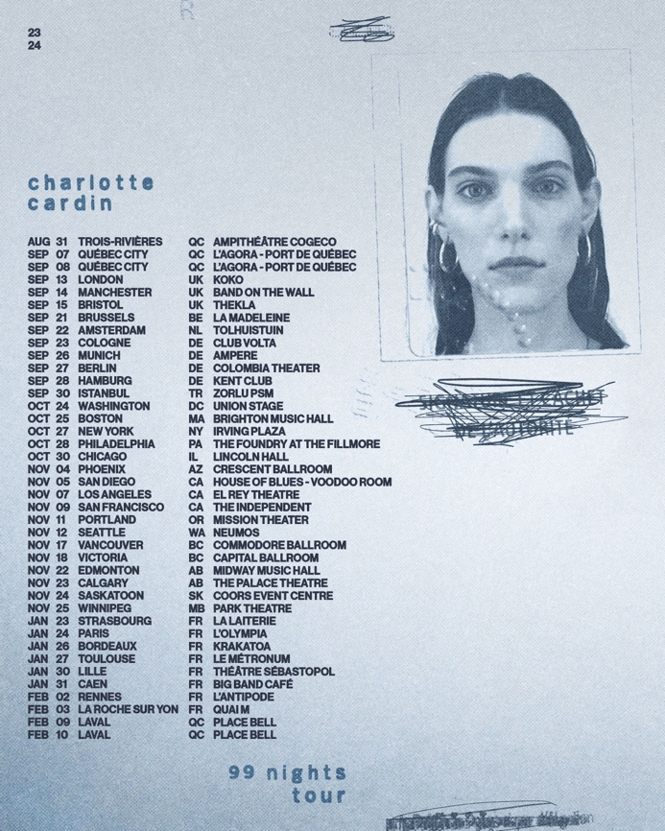

CONNECT:
CHARLOTTECARDIN.COM | TIKTOK | INSTAGRAM | TWITTER | YOUTUBE | FACEBOOK | PRESS ASSETS

CONTACT:
Ted Sullivan | ted.sullivan@atlanticrecords.com
Christina Kotsamanidis | Christina.Kotsamanidis@atlanticrecords.com

