FOR IMMEDIATE RELEASE

MAY 25, 2023

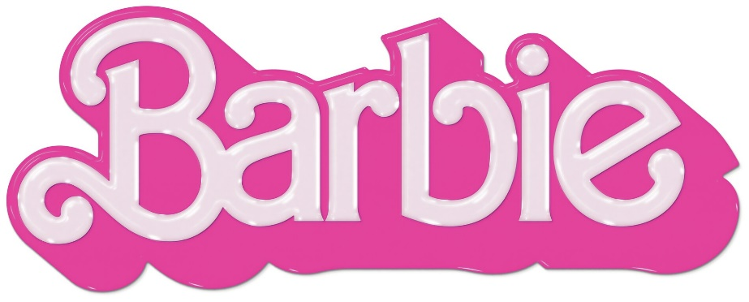

ATLANTIC RECORDS ANNOUNCES NEW STAR-STUDDED SOUNDTRACK
BARBIE THE ALBUM WITH ELECTRIFYING FIRST SINGLE “DANCE THE NIGHT”
FROM GLOBAL SUPERSTAR DUA LIPA OUT NOW

DAZZLING “DANCE THE NIGHT” VIDEO WITH SPECIAL APPEARANCE FROM
BARBIE WRITER/DIRECTOR/EXECUTIVE PRODUCER GRETA GERWIG STREAMING NOW HERE

ALL-NEW COMPANION ALBUM TO WARNER BROS. PICTURES’ HIGHLY ANTICIPATED FILM
INSPIRED BY MATTEL’S BARBIE FEATURES MASSIVE NEW TRACKS FROM AN UNPRECEDENTED LINEUP OF
GLOBAL SUPERSTARS INCLUDING NICKI MINAJ, ICE SPICE, LIZZO, KAROL G, CHARLI XCX,
PINKPANTHERESS, TAME IMPALA, THE KID LAROI AND MORE

SOUNDTRACK EXECUTIVE PRODUCED BY
OSCAR, GOLDEN GLOBE AND 7X GRAMMY® AWARD WINNING ARTIST AND PRODUCER MARK RONSON

BARBIE + BARBIE THE ALBUM ARRIVE EVERYWHERE ON JULY 21ST

DOWNLOAD HI-RES IMAGES HERE
DUA LIPA PHOTO CREDIT: TYRELL HAMPTON

Atlantic Records is proud to announce BARBIE THE ALBUM, the groundbreaking and star-studded musical companion to the highly anticipated summer event film Barbie, starring Margot Robbie and Ryan Gosling as Barbie and Ken and distributed by Warner Bros. Pictures. The soundtrack campaign kicks off today with the electrifying first single “Dance The Night” from 3x GRAMMY® Award-winning global superstar Dua Lipa, who also makes a special appearance in the film. “Dance The Night” was produced by Mark Ronson, Andrew Wyatt and the Picard Brothers. The sexy, fit for summer track can be heard in the film’s global official trailer, which launched earlier today, and arrives alongside a dazzling official video featuring a special appearance from Barbie writer/director/executive producer Greta Gerwig (“Little Women,” “Lady Bird”) – watch HERE. BARBIE THE ALBUM is now available for pre-order HERE and arrives in stores and at all online retailers on Friday, July 21st in conjunction with the theatrical release of the feature film.

BARBIE THE ALBUM will feature new tracks from an unprecedented lineup of artists including Nicki Minaj and Ice Spice, Lizzo, KAROL G, Charli XCX, PinkPantheress, Ava Max, Dominic Fike, Khalid, The Kid LAROI, Tame Impala, HAIM, GAYLE and FIFTY FIFTY feat. Kali. Barbie star Ryan Gosling also joins the robust roster of soundtrack artists with his iconic original song performed as his character, Ken. See below for full tracklisting.

BARBIE THE ALBUM continues the hugely successful partnership between Atlantic Records and Warner Bros. Pictures. The two companies previously teamed up for 2020’s BIRDS OF PREY: THE ALBUM which spawned the RIAA Certified 2x Platinum smash “Boss B*tch” by Doja Cat, along with the 2016’s GRAMMY® Award-nominated SUICIDE SQUAD: THE ALBUM, which topped album charts in over 70 countries around the world, including two consecutive weeks on the Billboard 200, and featured the RIAA Certified Diamond hit “Heathens” by Twenty One Pilots.

BARBIE THE ALBUM was executive produced by internationally renowned DJ and Oscar, Golden Globe and 7x GRAMMY® award winning artist and producer, Mark Ronson and Barbie writer/director/executive producer Greta Gerwig. The soundtrack album was Produced and overseen by Atlantic Records’ West Coast President, Kevin Weaver (Soundtrack Album Producer of The Greatest Showman, Suicide Squad, Daisy Jones & The Six, Birds Of Prey, Furious 7, The Fault in Our Stars, The Fate of the Furious) and Atlantic Records’ EVP and Co-Head of Pop/Rock A&R, Brandon Davis. Named by Rolling Stone as a “soundtrack guru,” Weaver is a GRAMMY® Award winner and five-time nominee, who has produced numerous multi-platinum soundtrack projects that have amassed tens of millions of albums sold worldwide. Additional key players involved on the project include Soundtrack Album Co-Producers, Brandon Creed and Joseph Khoury, as well as the Barbie Music Supervisor and Album Executive Producer, George Drakoulias.

ABOUT BARBIE
To live in Barbie Land is to be a perfect being in a perfect place. Unless you have a full-on existential crisis. Or you’re a Ken. Warner Bros. Pictures Presents a Heyday Films Production, a LuckyChap Entertainment Production, an NB/GG Pictures Production, a Mattel Production, Barbie. The film will be distributed worldwide by Warner Bros. Pictures and released in theaters only nationwide on July 21, 2023 and internationally beginning July 19, 2023. Directed by Greta Gerwig, Barbie stars Margot Robbie, Ryan Gosling, America Ferrera, Kate McKinnon, Issa Rae, Rhea Perlman, and Will Ferrell. The film is written by Greta Gerwig & Noah Baumbach, based on “Barbie” by Mattel, and produced by David Heyman, Margot Robbie, Tom Ackerley and Robbie Brenner. The executive producers are Michael Sharp, Josey McNamara, Ynon Kreiz, Courtenay Valenti, Toby Emmerich and Cate Adams. The film’s music supervisor is George Drakoulias, with music by Mark Ronson and Andrew Wyatt.

BARBIE THE ALBUM
TRACKLIST

- Lizzo – Pink
- Dua Lipa – Dance The Night
- Nicki Minaj & Ice Spice – Barbie World (with Aqua)
- Charli XCX – Speed Drive
- KAROL G – WATATI (feat. Aldo Ranks)
- TBA
- Tame Impala – Journey To The Real World
- Ryan Gosling – I’m Just Ken
- Dominic Fike – Hey Blondie
- HAIM – Home
- TBA
- The Kid LAROI – Forever & Again
- Khalid – Silver Platter
- PinkPantheress – Angel
- GAYLE – butterflies
- Ava Max – Choose Your Fighter
- FIFTY FIFTY – Barbie Dreams (feat. Kali)

CONNECT:
BARBIETHEALBUM.COM | INSTAGRAM | TIKTOK | TWITTER | FACEBOOK

PRESS CONTACT:
ANDREW GEORGE
ANDREW.GEORGE@ATLANTICRECORDS.COM

