JACK HARLOW TAKES YOU AROUND LOUISVILLE IN
“THEY DON’T LOVE IT” OFFICIAL MUSIC VIDEO

WATCH HERE
Directed by: Eliel Ford

NEW ALBUM ‘Jackman.’ OUT NOW

DOWNLOAD/STREAM

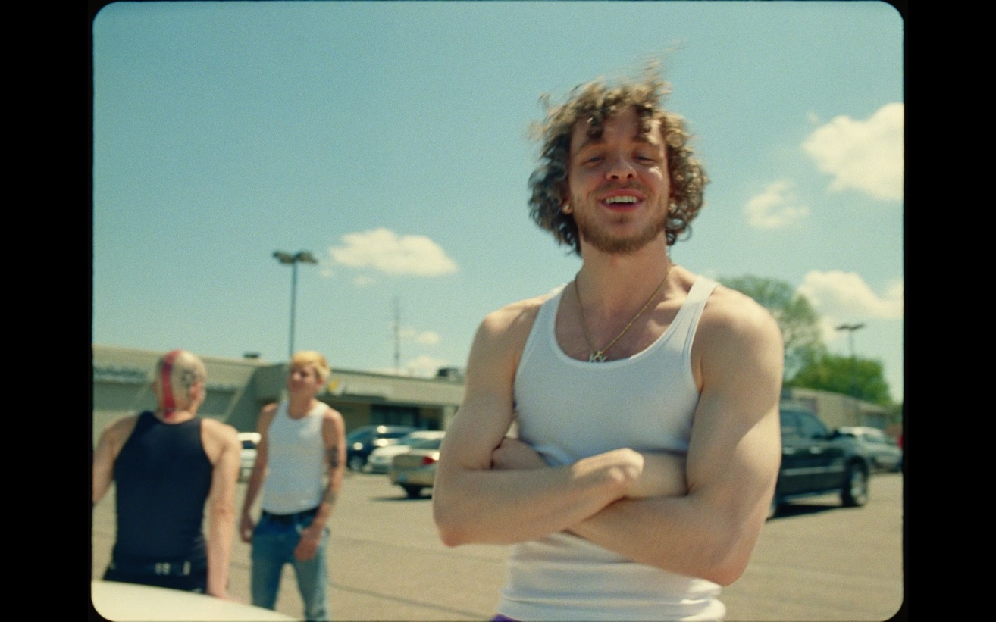

“Instead of resting on his laurels and focusing on Hollywood, however, Harlow is back with Jackman., a semi-surprise release and a surprisingly urgent showcase of his technical skills as an MC…after becoming a star, he’s gone back to basics to illustrate his skills before the spotlights arrived.”
– BILLBOARD

“You can tell Jack Harlow had a point to prove with this album. It was a strategic project that aims to show his skill and appreciation for the genre. I think he accomplished what he set out to do. Jackman. is a concise body of work that pushes Harlow forward as a rapper that listeners should take seriously. There are fun and energetic moments on the project, but what makes it stand out is Harlow’s maturity and delivery over more classic production. I think Harlow just hit his personal best with Jackman. “
– COMPLEX

“…third album Jackman, a lean, 24-minute burst of mixtape-style energy that probably makes the best case to date for Harlow as “rapper” rather than “sensation.” The maturity and depth on display on Jackman. may not be enough to silence haters or mollify critics but it’s a step up in lyricism that shows that Harlow has much, much more to offer. “
– ROLLING STONE

“On his third major label album, “Jackman,” Jack Harlow leans away from the lithe boasts that shaped “Come Home the Kids Miss You,” his 2022 breakthrough LP. Instead, he pivots to issues… he raps about these topics with self-awareness and skepticism.”
– NEW YORK TIMES

For all press inquiries, please contact:
Jason Davis – jason.davis@atlanticrecords.com

* * *

ABOUT JACK HARLOW
Hailed as the “hitmaker of tomorrow” by Variety, multiple GRAMMY-nominated rapper/actor/entrepreneur born Jackman Harlow is one of music’s brightest stars. The Louisville, KY native boasts six GRAMMY Award nominations, two #1 singles, nearly 30 RIAA platinum certifications, and over 10 billion career streams to date. Harlow released his critically acclaimed, RIAA platinum certified debut album, THATS WHAT THEY ALL SAY in December 2020, which featured the chart-topping, 8x Platinum worldwide hit, “WHATS POPPIN,” which earned him his first GRAMMY nomination for “Best Rap Performance,” along with a wide array of other award nominations.

The Generation Now/Atlantic Records rap superstar reached even greater heights in May 2022, with his Gold-certified sophomore album, COME HOME THE KIDS MISS YOU, highlighted by the bombastic Platinum-certified lead single “Nail Tech” and the chart topping, multiple-GRAMMY-nominated, 2X platinum single “First Class,” which made a spectacular debut at atop the Billboard “Hot 100,” marking his first solo #1 single, while earning the biggest streaming week of 2022.

Harlow has graced the covers of Rolling Stone, GQ, Forbes, Variety, Complex, SPIN, Footwear News and XXL’s coveted Freshman Class Issue, and brought his captivating live show to TV with performances on Saturday Night Live, The Tonight Show Starring Jimmy Fallon, Jimmy Kimmel Live!, MTV Video Music Awards, BET Awards and Kids Choice Awards, to name a few.

This Spring, Harlow will make his acting debut, starring in the remake of the cultural classic, “White Men Can’t Jump.”

* * *

NEW PRESS IMAGE – Photo Credit: Julian Buchan
*download here; please use only this image*



  

