FOR IMMEDIATE RELEASE
MAY 9, 2023

KAMAUU ANNOUNCES “LACUNA IN THE HOUSE OF MIRRORS TOUR”

FIRST HEADLINE TOUR SET TO KICK OFF IN ATLANTA, GA ON SEPTEMBER 6TH

TICKETS ON SALE FRIDAY, MAY 12

DOWNLOAD/STREAM LACUNA IN THE HOUSE OF MIRRORS

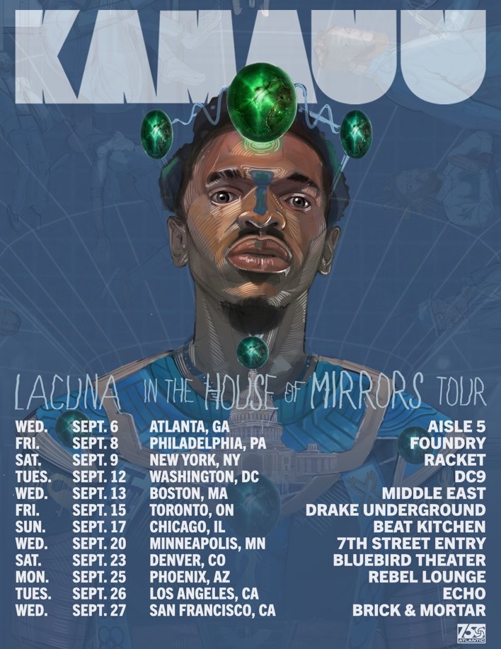
DOWNLOAD HI-RES ARTWORK

Multi-hyphenate artist, KAMAUU, has announced his first-ever headlining tour, the LACUNA in The House Of Mirrors Tour. Last month KAMAUU released his debut album, LACUNA in The House Of Mirrors. The 11-track album features Grammy-nominated Houston artist, Tobe Nwigwe, British artist, 6x MOBO nominee, Mercury, and Brit-nominated artist Kojey Radical as well as Siimbiie Lakew, and Cocoa Sarai along with production from DJ FU and co-production from Mick Schultz. The official tour will kick off on 9/6 in Atlanta, GA, and span across 12 cities before wrapping in San Francisco, CA on 9/27. Tickets will go on sale this Friday at 10am local time and can be purchased at www.kamauu.world/tour.
Since the release of his debut album, KAMAUU has shown no signs of slowing down, launching a short series of intimate sets between New York’s DUMBO House and LA’s SOHO House Warehouse. He celebrated the release of LACUNA in The House Of Mirrors with his performance at this year’s Something In The Water Festival in Virginia Beach, VA. The inventive artist will continue his streak of performances with an upcoming appearance at the Sound Music Festival in Brooklyn, NY on Saturday, May 20th. KAMAUU also recently launched a capsule collection with the fashion house, Error NYC. Deemed “an attractive collection of useful things to wear,” the collection titled “Waya,” premiered this past Saturday. In addition to premiering the items, KAMAUU performed a short loop pedal piece and walked the runway.

LACUNA IN THE HOUSE OF MIRRORS TOUR
SEPTEMBER
6 – Atlanta, GA – Aisle 5
8 – Philadelphia, PA – Foundry
9 – New York, NY – Racket
12 – Washington, D.C. – DC9
13 – Boston, MA – Middle East
15 – Toronto, ON – Drake Underground
17 – Chicago, IL – Beat Kitchen
20 – Minneapolis, MN – 7th Street Entry
23 – Denver, CO – Bluebird Theater
25 – Phoenix, AZ – Rebel Lounge
26 – Los Angeles, CA – Echo
27 – San Francisco, CA – Brick & Mortar
# # #
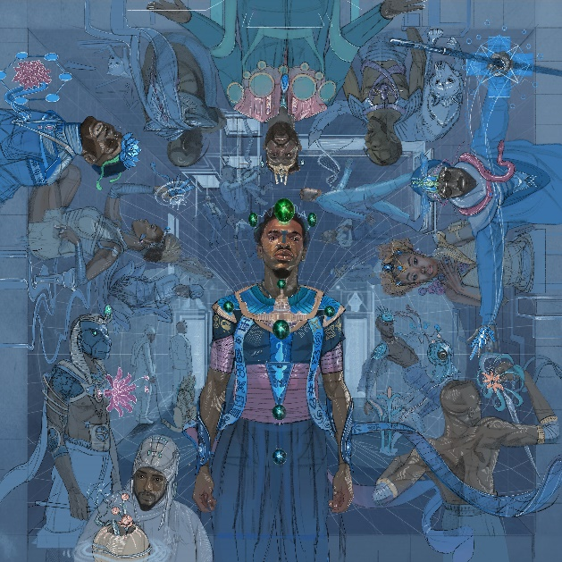
DOWNLOAD HI-RES ARTWORK

KAMAUU
LACUNA IN THE HOUSE OF MIRRORS

- switch up
- don’t play with my money (feat. Tobe Nwigwe)
- the vibe
- advantages
- antidote (feat. Kojey Radical & Siimbiie Lakew)
- flings
- for my love
- open letter
- driving scenes (feat. Cocoa Sarai)
- situations
- home

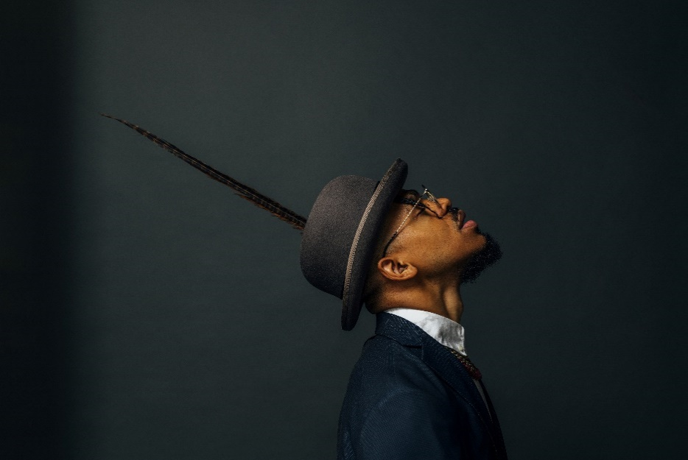
DOWNLOAD HI-RES IMAGES HERE
Credit: Arturo Olmos

KAMAUU
Maryland-based artist, rapper, poet, and thinker KAMAUU made his first proper debut with his appearance on “QUEEN” from No Wyld’s critically acclaimed Ascension EP after officially signing with Atlantic Records in 2015. His unique sonic experimentation made huge waves in 2016 when he released A Gorgeous Fortune EP. His first solo single “Jusfayu” went on to generate over 22M global streams and was handpicked by NPR as one of their “Songs We Love.” KAMAUU was also featured on The Birth of a Nation: The Inspired By Album with “The Icarus.” A year later, he unleashed his full-length mixtape, TheKAMAUU-CASSETTE: ŭRTH GōLD, and continued to stoke buzz. He later carefully assembled his third offering for the label, TheKAMAUU-CASSETTE: MíXD GRēēNS which was released during the summer of 2019. Since then, KAMAUU has dropped a few notable singles including “MANGO” feat. Adi Oasis (18M+ views and 50M streams) and the remix feat. Masego. The first single from his highly anticipated debut album LACUNA in The House Of Mirrors, “flings,” is a seamless, high-energy blend of R&B, funk, and hip-hop. Produced by DJ FU with co-production from Mick Schultz, it’s a distinctive reflection on pain, escapism, addiction, and the degradation of spiritual health. “flings” was followed up by “antidote,” a single about the importance of spiritual wealth, soul gold featuring 6x MOBO, Mercury, & Brit nominated artist Kojey Radical and skillful lyricist Siimbiie Lakew. The 11-track album features Grammy-nominated Houston artist, Tobe Nwigwe and Cocoa Sarai.

KEEP UP WITH KAMAUU
INSTAGRAM | TWITTER | FACEBOOK | YOUTUBE | WEBSITE

PRESS CONTACT
SELAM BELAY // SELAM.BELAY@ATLANTICRECORDS.COM

