FOR IMMEDIATE RELEASE
APRIL 5, 2023

MAHALIA RETURNS WITH “TERMS AND CONDITIONS”
ACCCOMPANIED BY COMPANION VISUAL
MAHALIA’S SECOND ALBUM WILL BE ARRIVING SUMMER 2023
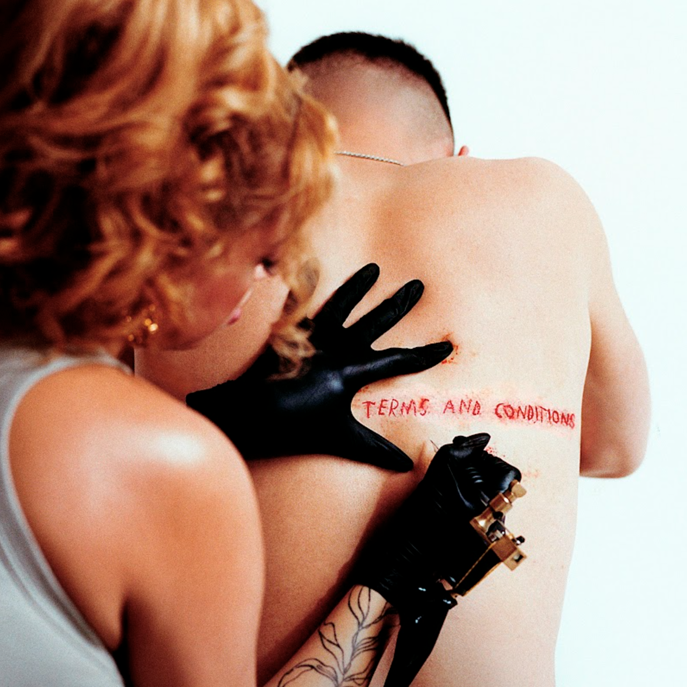

WATCH HERE | LISTEN HERE

Further to announcing that her highly anticipated second album is complete, today, GRAMMY-nominated R&B star Mahalia has returned with her brilliant and bold new single ‘Terms and Conditions’ - available now, globally via Atlantic Records.

“I’m quite emotional about this release finally being everybody else’s!” says Mahalia on the release of her luminescent new single. “It’s almost like a love letter to myself whilst being a warning to others. It’s all about setting boundaries and deciding what things I would no longer compromise on. I made this song with my wonderful friend and artist, Raye and two of my favorite producers - The Elements. This record is just the first taste from my upcoming second album and I can’t wait to see if people like it!”

Having teased the single to fans across her social platforms over the last month, the highly anticipated release marks her first of 2023, and follows on from her previous release ‘Bag Of You’ which landed in November 2022.

Making a triumphant return with this up-tempo ode to knowing your worth and implementing boundaries; Mahalia hones in on her signature style as she writes about the nitty gritty of relationships, respect and compromising.

The last few years have marked many achievements for the Leicester-born star. Beginning 2020 with her second BRIT nomination, Mahalia featured on up-and-coming fellow Midlands rapper Pa Salieu’s debut mixtape, ‘Send Them To Coventry’, whilst also gracing the tracklist of Headie One’s #1 album ‘Edna’. Subsequently, Mahalia also received a GRAMMY nomination for ‘All I Need’ - Jacob Collier’s single of which she features alongside US rapper, Ty Dolla $ign. Shortly after, Mahalia concluded the year with three MOBO nominations for ‘Best Female Act’, ‘Best R&B/Soul Act’ and ‘Album Of The Year’ for her debut album, ‘Love and Compromise’, winning in the first two categories. In 2021, Mahalia was also nominated for her first ever Ivor Novello award for her 2020 collaboration with UK lyricist Pa Salieu for his single ‘Energy’ and subsequently concluded the year with an incredible headline show at London’s prestigious venue, O2 Brixton Academy. Adding to her long list of achievements Mahalia opened for Adele at her 2022 BST shows in Hyde Park last Summer whilst also joining Alicia Keys during her o2 Arena shows in London - she then concluded the year on a high, winning her third MOBO Award for Best R&B/Soul Act.

Besides the awards and nominations, it’s also been a time of deep personal growth, one that Mahalia describes as a real rollercoaster in her personal and professional life. Reflection has been the thread running through Mahalia’s writing and while the current global situation offers little more than uncertainty, the singer hopes that her music will encourage her listeners to carve out time to also look back and re-evaluate: “We’re all fixated on how we can make ourselves better but I want people to also reminisce on lovely or painful situations they’ve lived through and how they’ve helped shape the people they are now.”

Stay tuned for news on the release of Mahalia’s highly anticipated second album which will be arriving this summer.

# # #

CONNECT WITH MAHALIA
OFFICIAL WEBSITE | TWITTER | FACEBOOK | INSTAGRAM

PRESS CONTACT
ARIANA WHITE | ARIANA.WHITE@ATLANTICRECORDS.COM

