FOR IMMEDIATE RELEASE
MAY 4, 2023

TION WAYNE RETURNS WITH NEW SINGLE ‘HEALING’

ACCOMPANIED BY A COMPANION VISUAL

FOLLOW-UP TO “LET’S GO (FEAT. AITCH)”

WATCH/SHARE “HEALING”
DOWNLOAD/STREAM “HEALING”

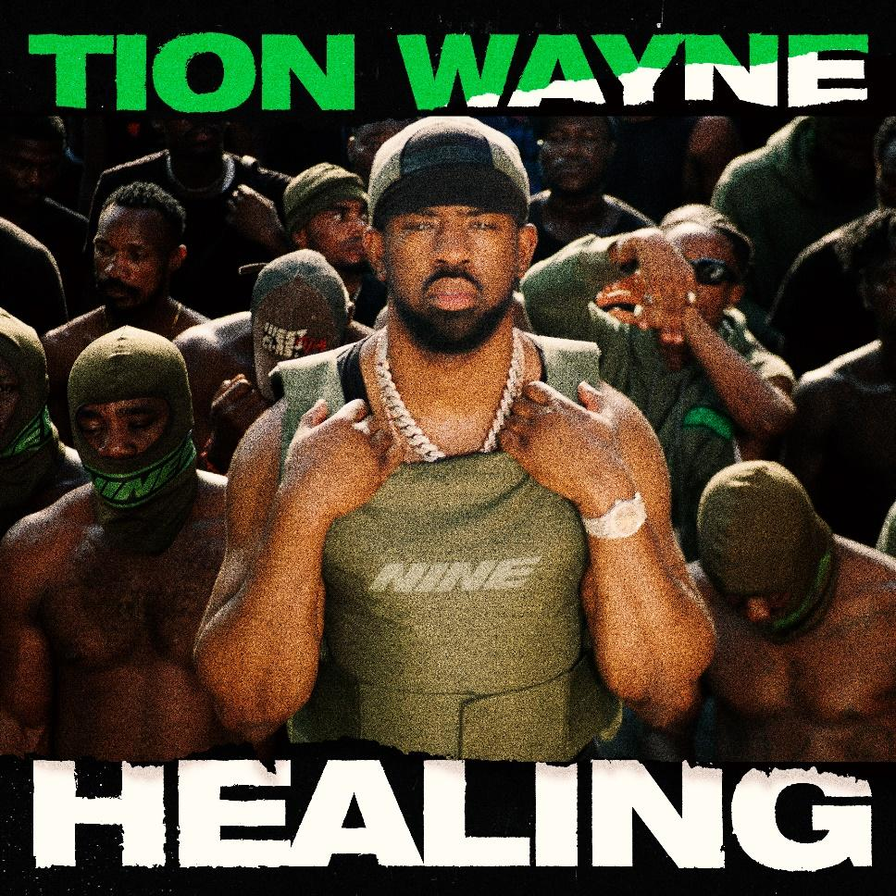

Today UK titan Tion Wayne, is back with his latest smash ‘Healing,’ produced by Crumz & GA [Raye, Blanco] the track is available to stream HERE.

Following on from his super smash ‘Let’s Go’ featuring Aitch, the MOBO winning, Brit-nominated rapper delivers quick fire bars, whilst reminiscing and reflecting on the changes and experiences he’s encountered, declaring it’s now time to heal.

The visuals shot by WOWA [AJ Tracey, Aitch] take us on a journey replicating his familiar environments from London to West Africa and India, the latter destination paying homage to the late Indo- Canadian rapper Sidu Moose Wala, who constantly fought to break down systematic barriers within the diaspora. Watch the video for ‘Healing’ HERE.

With billions of streams, Tion’s epic track Body (featuring Russ Millions), was the first ever drill track to reach No.1 in the UK, Ireland, Australia and New Zealand and is one of the most viewed videos on YouTube & GRM Daily as well as one of the most used sounds on TikTok.

With 6 UK Top 10 hits to his name, a top 5 debut album (Green With Envy) and a collaboration with Central Cee and Ed Sheeran on the ‘Bad Habits (Fumes The Engineer Remix)’, Tion Wayne has morphed into one of the UK’s biggest stars, with sold shows across the UK and stellar support across BBC Radio 1 and 1Xtra, he’s also topped some of the Spotify top playlists like Hot Hits UK, Rap UK and Who We Be. Alongside co-signs and collaborations with the likes of Stormzy, Rema, Central Cee, Jack Harlow, D-Block Europe, NSG and Rudimental to name a few. Tion Wayne continues to go from strength to strength.

FOLLOW TION WAYNE
TWITTER| INSTAGRAM | TIKTOK
PRESS CONTACT
SELAM BELAY | SELAM.BELAY@ATLANTICRECORDS.COM

