BALU BRIGADA ARE “2GOOD”

RISING ALT-POP DUO PRECEDE UPCOMING EP WITH EXHILARATING NEW SINGLE

FIND A WAY EP ARRIVES EVERYWHERE ON FRIDAY, JULY 28

LISTEN TO “2GOOD” | WATCH OFFICIAL MUSIC VIDEO

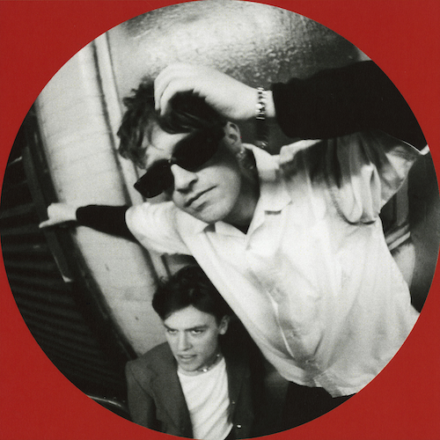
DOWNLOAD HI-RES ARTWORK CREATED BY BALU BRIGADA HERE

“Balu Brigada is the groove-pop duo you've been waiting for.” – PEOPLE

“Balu Brigada are all about experimentation, inspired by genre-mashing musical giants Gorillaz and Frank Ocean. Their songs perfectly soundtrack coastal road trips, summer BBQs and flirty dancefloor moments – effortless, laidback cool….Balu Brigada’s time is now.” – ONES TO WATCH

Rising alt-pop duo Balu Brigada have shared their exhilarating new single, “2good,” premiering today at all DSPs and streaming services alongside an official music video streaming now at YouTube HERE.

“2good” ushers in the New Zealand-born, Brooklyn, NY-based band’s eagerly awaited new EP, Find A Way, arriving everywhere on Friday, July 28. Pre-orders/pre-saves are available now HERE. The project was first unveiled alongside the heartbreakingly funky title track, “Find A Way,” joined by an official music video streaming now at YouTube HERE.

“‘2good’ is about the never-ending mood swing of life, and how lucky you are when you find someone that will stick with you through it all. A balance of jaded melancholy and unhinged euphoria, it’s a song that acknowledges your personal flaws, and how grateful you are to have someone who tolerates you despite them.’”

Hailed by i-D as “an actual band of brothers making tunes stacked with hooks that’ll run circles around your brain for days,” multi-instrumentalist/songwriter/producer brothers Henry and Pierre Beasley have fast garnered a loyal following and critical acclaim for Balu Brigada’s signature blend of irresistible hooks and introspective lyricism. Currently based in Brooklyn, NY, the Auckland, NZ-born Beasleys have spent much of the past few years creating a unique future-facing sound of their own, prioritizing dual vocals, prominent bass hooks, and punchy drums while showcasing a left-of-center pop sensibility and natural ability to skate genres, including such dynamic yet poignant singles as “Designer” and “OH! Not Again,” as well as last year’s debut EP, I Should Be Home, all of which have earned Balu Brigada applause from such outlets as Rolling Stone, Ones To Watch, and PEOPLE, the latter of which named the band to its “Talented Emerging Artists Making Their Mark” list, praising their “soaring falsetto choruses, synth hooks and an irresistible, underlying groove.”

“‘Find A Way’ is a bittersweet mantra that we’ve had for the last couple of years,” say Balu Brigada. “Whether it was ‘Find a way to get to America’ or ‘Find a way to maintain a long-distance relationship’ or even just ‘Find a way to be present and happy.’ Our career so far has been a series of step-by-step moments that have led us closer to our dream of writing and playing music across the world. Neither of us are big planners so we’ve had to learn to trust our instincts and take things one step at a time, even if we don’t know what the following two steps are. We often talk about how we have to ‘follow our nose’ on things, but that would have been a really shit title for an EP, so when we wrote the song ‘Find A Way’, it felt like a good way to sum up our experience in writing this project.”

DOWNLOAD HI-RES PRESS PHOTO(S) HERE

CONNECT WITH BALU BRIGADA
WEBSITE | FACEBOOK | INSTAGRAM | TWITTER | YOUTUBE

Press Contact:
Paige.Rosoff@atlanticrecords.com

