FOR IMMEDIATE RELEASE
JUNE 2, 2023

CKAY HITS FANS WITH ANOTHER LOVE SONG ‘NWAYI’

ACCOMPANIED BY COMPANION VISUAL

SAD ROMANCE DELUXE SLATED FOR RELEASE LATER THIS MONTH

WATCH HERE | STREAM HERE

Emo-Afrobeats singer-songwriter and Africa’s Boyfriend, CKay stays true to his sound as he romances listeners with his new song titled ‘nwayi.’ The single revisits themes of desire and infatuation, a fundamental element in his music that fans have long adored. This love song is CKay’s second release of the year, announcing his upcoming Sad Romance Deluxe album slated for release in June and now available for pre-sale.
Last year September saw the release of CKay's debut album, Sad Romance, making 2022 a significant year for him as the album garnered over 380 million streams since release and continues to grow. Earlier this year, CKay released an upbeat Sad Romance Remix Pack followed by his first new offering of the year, HALLELUJAH, featuring fellow Nigerian superstar Blaqbonez. ‘nwayi’ is CKay’s second offering from the Sad Romance Deluxe album that takes his fans on a journey of love. Produced by CKay and BMH, ‘nwayi’ is within the superstar’s emo-Afrobeats realm as he professes his undying love and how he cannot live without his partner.

The official music video for ‘nwayi’ was shot in Lagos, Nigeria, and directed by Ahmed Mosh. The visuals for ‘nwayi’ tell an alluring Shakespearean story featuring CKay and his love interest. As with CKay’s poetic lyrics, CKay tells a story of love with romantic scenes in a carriage on the beach but ends with a twist.
As CKay prepares to release his Sad Romance Deluxe album, fans across the globe will have an opportunity to watch him perform at Weekend Festival in Finland, the HIPHOP OPEN festival in Stuttgart, Lollapalooza in Paris, HIPHOP OPEN festival in Stuttgart and a performance in his home country, Nigeria.

ABOUT CKAY

Chukwuka Ekweani, known publicly as CKay, is the rising star in the ever-burgeoning Afrobeats scene. A multi-talented artist, whether behind the boards as a producer or in front of the mic performing his self-penned songs, it is CKay’s single-minded vision that shines through. The self-defined Emo-Afrobeat star has and continues to soar up charts across the globe thanks to his first globally recognized single ‘love nwantiti’.

The Nigerian singer, songwriter, and producer originally released ‘love nwantiti (ah ah ah)’ back in 2019 as part of his debut EP, CKay The First. In 2021, CKay became the most streamed artist of the year and became the first African artist with two tracks on the Global Spotify Top 30 simultaneously. ‘love nwantiti’ has been certified platinum/multi-platinum in five countries, including the United States, India, and Italy. The viral hit has also been certified gold in the UK, Australia, South Africa, and New Zealand. CKay became the first African artist in 50 years to hold a top 5 position on the UK Singles Chart for 4 straight weeks with ‘love nwantiti’.
CKay has continued to create a global presence with accomplishments such as the “most Shazam-ed song in the world”. ‘Emiliana’, followed suit and racked in global chart positions and currently has just over 400 million streams worldwide. ‘Emiliana’ peaked at #1 on the UK Afrobeats Chart, #2 on Shazam Top 200 (Afrobeats), and #1 in six countries on Apple Music.

CKay’s debut album Sad Romance was released last year and has since had over 380 million streams worldwide. With over 3.5 billion streams to his name and new music slated for 2023, CKay is in a prime position to continue his upward trajectory as a globally recognized singer-songwriter and producer.

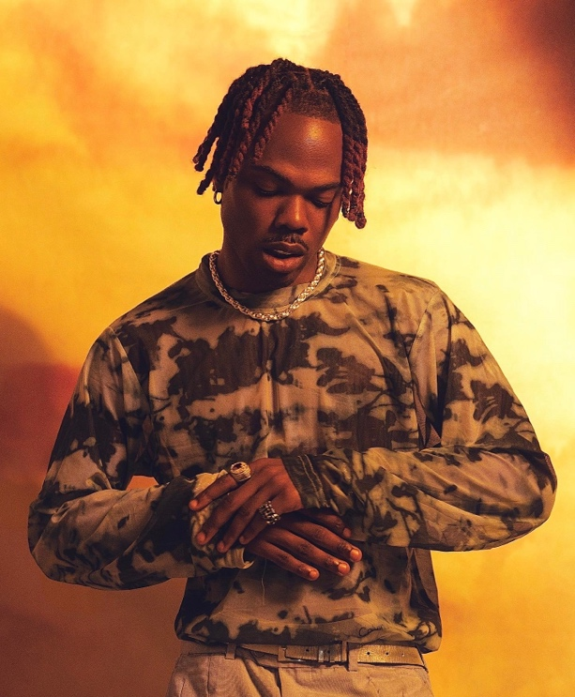

CONNECT WITH CKAY:
TWITTER | FACEBOOK | INSTAGRAM | TIKTOK | YOUTUBE

PRESS CONTACT:
ARIANA.WHITE@ATLANTICRECORDS.COM

