FOR IMMEDIATE RELEASE
JUNE 23, 2023

CHARLOTTE LAWRENCE IS BACK WITH “BOYS LIKE YOU”

ACCLAIMED SINGER-SONGWRITER SHARES FUN NEW SUMMER ANTHEM

LISTEN TO “BOYS LIKE YOU” | WATCH VIDEO

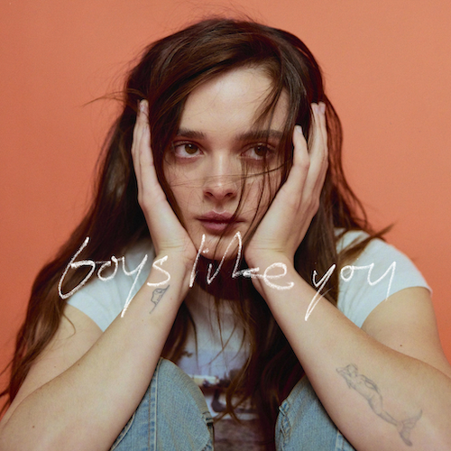
DOWNLOAD HI-RES ARTWORK

Los Angeles-based singer-songwriter Charlotte Lawrence has shared her jubilant new pop anthem, “Boys Like You.” Produced by Dallas Caton (Bazzi, Em Beihold) and Nick Long (Machine Gun Kelly, Blink-182) and co-written by Lawrence, Caton, Long, Ali Tamposi (Beyoncé, Kelly Clarkson), and Roman Campolo (BTS, Elton John), the raw and honest song arrives alongside a video – Watch HERE.

“I wrote ‘Boys Like You’ for anyone who ever wanted someone who didn’t want them back,” says Lawrence. “They might play around with the idea of it, even send some mixed signals, but ultimately, they don’t love you like you love them. We’ve all been there. It hurts, but it doesn’t have to pull you under. I’m dancing through the ache, and I hope you can dance with me. ‘Boys Like You’ is fun and joyful. It’s filled with flirty summer longing… just like me. Hope you love it.”

“Boys Like You” marks the latest in a series of heartfelt releases from Lawrence, including the powerhouse “Bodybag,” featured on Apple TV’s new hit series Shrinking (starring Jason Segal and Harrison Ford) and joined by an official visualizer. “A searing take on the end of a relationship that you’re not quite ready to leave,” wrote NYLON, while Ones To Watch declared the “beautiful ballad” to be “Lawrence’s most sonically beautiful music to date with raw lyricism that digs deep into an exploration of pain in its most honest form, using the most minor details to cut deep into the heart.”

Last year saw Lawrence earn acclaim for the evocatively beautiful “Morning.” Produced by Ben Gibbard (Death Cab for Cutie, The Postal Service) and Andy Park (Phoebe Bridgers, Mac Miller) and co-written by Lawrence, Gibbard, and Park, the track arrived alongside a stunning music video. “Morning” was met by praise from high profile media outlets worldwide, including Wonderland which wrote, “With a cinematic music video masterfully capturing the melancholic themes that lace the new track, one that boasts ripples of an acoustic guitar and the angelic vocals catapulting the rising talent towards industry domination, it is one sure to pierce the soul and ignite some serious sad girl feels.”

Hailed by Billboard for her “haunting take on pop rock,” Lawrence has quickly proven a landmark artist, fusing deeply personal lyrics with larger-than-life melodies and epic choruses to create a remarkable, multi-faceted musical vision all her own. The Los Angeles-based singer-songwriter has earned critical acclaim – and millions of worldwide streams – for breakthrough hits such as “Just The Same,” “Sleep Talking,” “Why Do You Love Me,” “Navy Blue,” and “Joke’s On You,” the latter of which was featured on Atlantic Records’ hit 2020 soundtrack, BIRDS OF PREY: THE ALBUM.

2021 saw the arrival of Charlotte, an intimate collection of songs detailing Lawrence’s struggles with anxiety, addiction, and dependence on such standout tracks as “Talk You Down,” “You,” and more. The EP “displays a young artist working with full confidence in her abilities,” wrote CLASH, while Atwood Magazine simply raved, “A stunningly evocative and visceral 22-minute affair, Charlotte showcases the expansive breadth and intimate depth of Charlotte Lawrence’s seemingly limitless artistry – finding her dwelling in the caverns of the self and rising to breathtaking heights as she bares her soul for all to see, hear, and feel.”

Lawrence – who followed Charlotte with the stripped-down companion volume, Charlotte (Acoustic) – celebrated the EP with her late night TV debut, performing “Talk You Down,” on ABC’s Jimmy Kimmel Live! and swiftly followed by a stellar rendition of “You“ on CBS’s The Late Show With Stephen Colbert. Having firmly established herself as a major new pop force, Lawrence has received critical applause from an array of publications, including Vanity Fair, Cosmopolitan, Harper’s Bazaar, W, i-D, V Magazine, Hypebae, Ones To Watch, and many more. Now, with “Boys Like You” and more new music to come, Charlotte Lawrence continues to push her innovative blend of dark pop aesthetics with alternative rock energy even further into the extraordinary unknown.

“I want to share pain and heartbreak and sex and all the emotions everybody feels,” says Lawrence, “and hopefully people can connect to that and relate. I always thought that I shouldn’t be vocal about what I wanted to do. I was shy and scared. Finally I’ve grown enough as a person that I feel confident to say I want to perform in arenas and share my music with as many people as I can. I wanna do everything.”

# # #

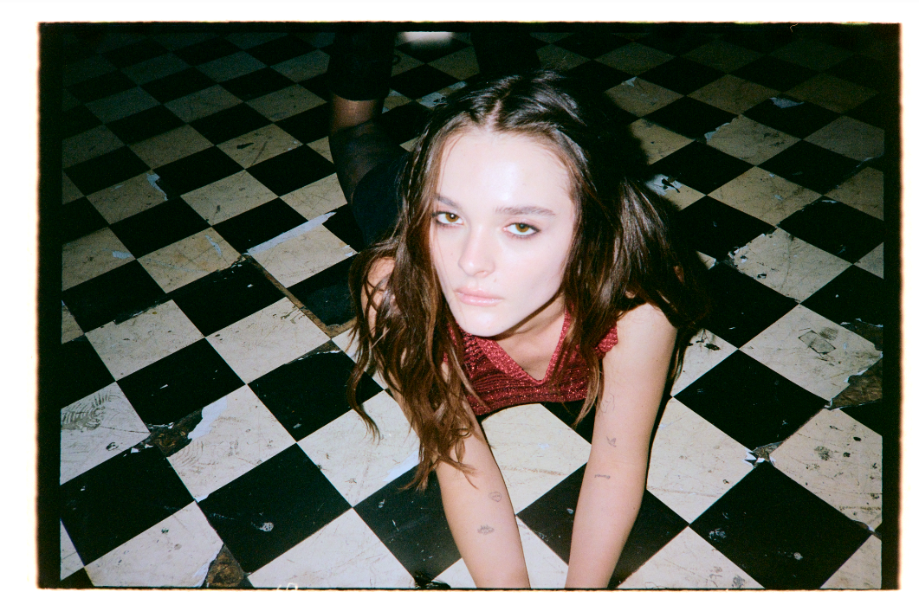
DOWNLOAD PRESS PHOTO
CREDIT: CLARE GILLEN

CONNECT WITH CHARLOTTE LAWRENCE
OFFICIAL | FACEBOOK | INSTAGRAM | TWITTER | YOUTUBE

FOR PRESS INQUIRIES, PLEASE CONTACT:
Kelly McWilliam / Kelly.McWilliam@atlanticrecords.com

