FOR IMMEDIATE RELEASE
JUNE 9, 2023

FAOUZIA UNVEILS “DON’T CALL ME” AND “PLASTIC THERAPY”

INTERNATIONALLY ACCLAIMED ARTIST UNVEILS TWO BRAND NEW SONGS
WITH MORE NEW MUSIC ARRIVING LATER THIS YEAR

LISTEN TO “DON’T CALL ME” | LISTEN TO “PLASTIC THERAPY”

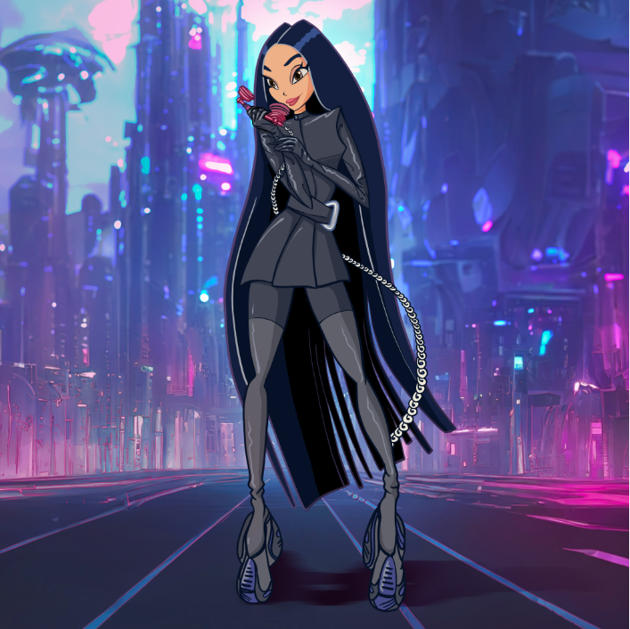
DOWNLOAD ART AND PRESS PHOTO HERE

“One of the most powerful new voices you’ll hear this year.”
– BILLBOARD

“What sets the singer-songwriter apart, though, is a stirring inflection that nods to her Arab roots”
– ENTERTAINMENT WEEKLY

“Faouzia is the Next Big Thing”
– BUSTLE

Internationally acclaimed Moroccan-Canadian singer/songwriter/multi-instrumentalist Faouzia has shared two brand new songs, “Don’t Call Me” and “Plastic Therapy.” Produced by Ryan McMahon (Marina, Addison Rae), both tracks have been teased via Faouzia’s hugely popular TikTok, drawing millions of views and 10K pre-saves thus far.

“Don’t Call Me” and “Plastic Therapy” follow this spring’s latest release, “I’m Blue.” A haunting and ethereal new rendition of Eiffel 65’s worldwide #1 hit, “Blue (Da Ba Dee),” the track was first recorded by Faouzia more than three years ago, earning millions of worldwide streams and over 4.8M video views via YouTube HERE. “I’m Blue” was also featured in the smash Netflix series, Red Rose, rocketing it to Shazam’s “Top 200” in Germany, France, and the UK.

With collaborations with John Legend, Kelly Clarkson, David Guetta, and more, Faouzia has been named one of Variety’s “Artists to Watch for the 2022 Grammys,” Vogue’s “Style Stars Set to Make 2022 Exciting,” PEOPLE’s “Talented Emerging Artists Making Their Mark on the Musical Landscape,” and Entertainment Weekly’s “Artists to Watch in 2022” and has amassed over 1.1B global streams. Boasting a combined social reach of over 11M followers – including over 2.26M YouTube subscribers, 2M Instagram followers and more than 3.4M Tik Tok followers – Faouzia has cemented herself as a surefire artist to watch.

CONNECT WITH FAOUZIA
WEBSITE | FACEBOOK | INSTAGRAM | TIK TOK | TWITTER | YOUTUBE

CONTACT
Jessica Nall // Jessica.Nall@AtlanticRecords.com

