FOR IMMEDIATE RELEASE
JUNE 20, 2023

FRED AGAIN.. ANNOUNCES A HISTORIC RUN OF LIVE SHOWS
IN NEW YORK AND LOS ANGELES

THREE NIGHTS AT NY’S FOREST HILLS STADIUM (OCT. 12-14)
AND EIGHT NIGHTS AT LA’S SHRINE EXPO HALL (OCT. 24-25, 27-29, 31, NOV. 1-2)

PRE-SALE REGISTRATION AVAILABLE NOW AT WWW.FREDAGAIN.COM/TOUR

ARTIST PRESALES BEGIN TUESDAY, JUNE 27 AT 10:00 AM (LOCAL)
GENERAL ON-SALE SET FOR TUESDAY, JUNE 27 AT 2:00 PM (LOCAL)

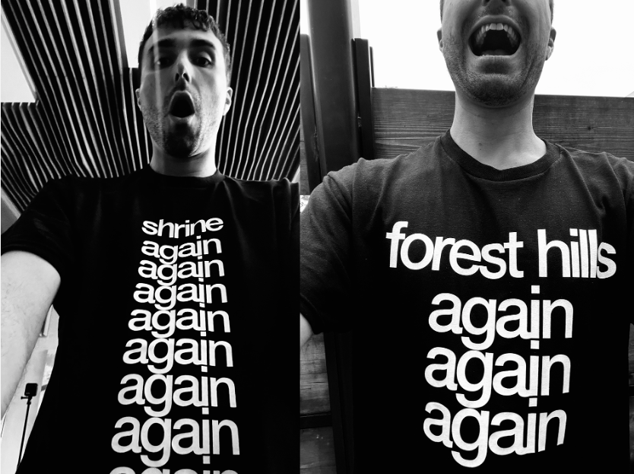
DOWNLOAD IMAGE HERE

Fred again.. has announced an unprecedented run of live shows in New York and Los Angeles with three nights at Forest Hills, NY’s Forest Hills Stadium (October 12-14) and an eight-night residency at Los Angeles, CA’s Shrine Expo Hall (October 24-25, 27-29, 31, November 1-2). Fred will be making history as this will be the first time an artist has ever performed three nights at Forest Hills Stadium. In addition, Fred's eight shows at The Shrine will be the most consecutive shows that any one artist has performed at the venue, breaking the previous record of four. Presale registration is available now through Sunday, June 25, at 11:59 PM (local) at www.fredagain.com/tour. Presale begins Tuesday, June 27 at 10:00 AM (local) and general on sale begins on Tuesday, June 27 at 2:00 PM (local).

The North American dates are part of Fred again..’s just announced tour that will kick off with an eagerly awaited four nights at London, UK’s world-famous Alexandra Palace (September 4-5, 6, 8), followed by shows in Berlin, Amsterdam, Brussels, and Paris. The newly announced dates continue an epic live schedule for Fred again.., highlighted by top-billed festival performances around the world, including the UK’s Glastonbury (June 23), Chicago, IL’s Lollapalooza (August 4), Montreal, QC’s Osheaga Festival Musique et Arts (August 6), and Miami, FL’s Ill Points (October 20). For complete details, please visit www.fredagain.com/tour.

FRED AGAIN.. 2023 TOUR

JUNE
23 – Pilton, UK - Glastonbury Festival †
30 – Beuningen, Netherlands – Down The Rabbit Hole Festival †

JULY
1 – Werchter, Belgium – Rock Werchter †
2 – Marmande, France – Garorock †

AUGUST
4 – Chicago, IL – Lollapalooza †
6 – Montreal, QC – Osheaga Festival Musique et Arts †
25 – Edinburgh, UK – Connect Festival †

SEPTEMBER
1 – Laois, Ireland – Electric Picnic †
4 - London, UK – Alexandra Palace
5 – London, UK – Alexandra Palace
6 – London, UK – Alexandra Palace
8 – London, UK – Alexandra Palace
12 – Berlin, DE – Mercedes-Benz Stadium
14 – Amsterdam, NL – Ziggo Dome
15 – Amsterdam, NL – Ziggo Dome
16 – Brussels, BE – Palais 12
20 – Paris, FR – Zenith
21 – Paris, FR – Zenith

OCTOBER
12 – Forest Hills, NY – Forest Hills Stadium
13 – Forest Hills, NY – Forest Hills Stadium
14 – Forest Hills, NY – Forest Hills Stadium
20 – Miami, FL – Ill Points †
24 – Los Angeles, CA – Shrine Expo Hall
25 – Los Angeles, CA – Shrine Expo Hall
27 – Los Angeles, CA – Shrine Expo Hall
28 – Los Angeles, CA – Shrine Expo Hall
29 – Los Angeles, CA – Shrine Expo Hall
31 – Los Angeles, CA – Shrine Expo Hall

NOVEMBER
1 – Los Angeles, CA – Shrine Expo Hall
2 – Los Angeles, CA – Shrine Expo Hall

† FESTIVAL APPEARANCE

# # #

Fred again.. recently lit up Indio, CA’s Coachella Valley Music & Arts Festival by teaming with fellow icons Four Tet and Skrillex for an electric, weekend-closing headline set that earned worldwide media attention from Rolling Stone, USA Today, Vulture, Dancing Astronaut, Pitchfork, High Snobiety, and Billboard, the latter of which hailed the performance as “the weirdest, hardest, purest and most EDM-antithetical dance music played on the Coachella main stage since the festival’s early days.”

The historic Coachella performance continued what is proving a banner year for the London-based Fred again.. following the recent arrival of “Baby again..,” a collaboration with Skrillex and Four Tet. The trio celebrated “Baby again..” with a series of pop-up events across New York City, including a Valentine’s Day rave at Brooklyn’s Good Room, a packed show at the intimate Le Poisson Rouge, and a live performance on a school bus for The Lot Radio that completely shut down Times Square. To cap off the week, Fred again.., Skrillex, and Four Tet played a historic show at NYC’s world famous Madison Square Garden, a five-hour concert event that sold out within minutes of its announcement three days earlier. Fred dropped “Baby again..” almost halfway through the show, providing a truly iconic moment as the full house lights fell for the first time. A special hour-long looped version of “Baby again..” featuring footage filmed at MSG is streaming now HERE.

Last year saw Fred again.. become one of the year’s most talked about live acts as he transformed his three critically acclaimed Actual Life records into an immersive, communal experience for the first time. Fred continued his upwards trajectory with the unstoppable viral success of his blockbuster Boiler Room session, which has to date surpassed over 20M streams, overtaking the numbers seen by such superstars as Disclosure, Richie Hawtin, Skream, and Fatboy Slim in only a few short weeks. This spring then saw Fred again.. showcase his one-of-a-kind musicality with a truly unique performance on NPR’s Tiny Desk Concerts, streaming now HERE.

# # #

CONNECT WITH FRED AGAIN..
OFFICIAL SITE |INSTAGRAM |TIKTOK | YOUTUBE

FOR MORE INFORMATION ON FRED AGAIN.., PLEASE CONTACT:
Kelly McWilliam / Kelly.McWilliam@atlanticrecords.com

