GAYLE UNVEILS NORTH AMERICAN HEADLINE TOUR

THE SCARED BUT TRYING TOUR GETS UNDERWAY OCTOBER 17 IN TAMPA, FL

LIVE SCHEDULE ALSO INCLUDES EUROPEAN FESTIVAL DATES
AND SPECIAL GUEST APPEARANCES ON P!NK’S SUMMER CARNIVAL 2023
AND TAYLOR SWIFT | THE ERAS TOUR

NEW SONG, “butterflies,” FEATURED ON STAR-STUDDED BARBIE THE ALBUM,
ARRIVING VIA ATLANTIC RECORDS ON FRIDAY, JULY 21

“going on tour with taylor swift and p!nk have been some of the most exciting and terrifying moments of my life. before walking on stage, i would get nauseous and it would be hard for me to control my breathing, but no matter how i felt, i would try and do it anyways. the last couple of years have been a whirlwind, but i’ve continued to do things even though i was afraid.

the thought of going on my own tour is very intimidating to me, but over time, i’ve learned i can do things even though i’m afraid. with this tour, i am scared, but i’m ready to try.”

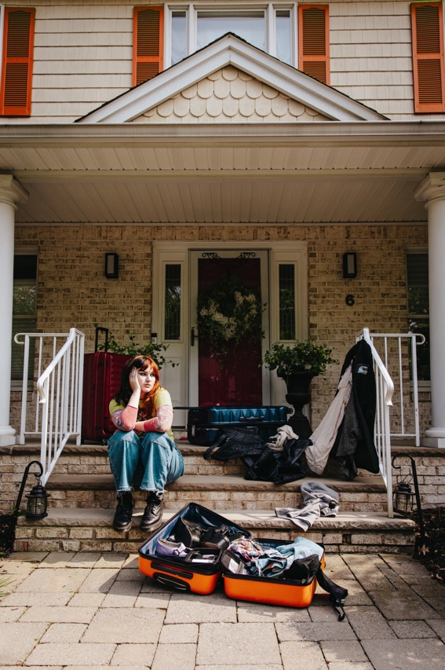
DOWNLOAD HI-RES IMAGES

GRAMMY® Award-nominated, Multi-Platinum-certified, 2.4 billion-streaming artist GAYLE has announced plans for her North American headline tour. The Scared But Trying Tour gets underway at Tampa, FL’s Crowbar on October 17 and then continues through a hometown show at Nashville, TN’s famed Basement East on November 15. Special guests will be announced soon. Artist presales begin Tuesday, June 13 at 10:00 am (local) – Password: TBD. Spotify and local presales begin Wednesday, June 14 at 10:00 am (local). All presales conclude Thursday, June 15 at 10:00 pm (local). General on-sales begin Friday, June 16 at 10:00 am (local). For full details and ticket information, please see www.gayleofficial.com.

The Scared But Trying Tour continues an epic live run from GAYLE, including a series of North American stadium shows as special guest on the blockbuster Taylor Swift | The Eras Tour, set to resume later this summer at Inglewood, CA’s SoFi Stadium on August 5 and 9. In the meantime, GAYLE is currently traveling Europe and the United Kingdom, with top-billed festival appearances and special guest role on Pink’s Summer Carnival 2023 continuing through mid-July.

2023 has proven a landmark year for GAYLE, highlighted by a string of new songs including “butterflies,” featured on BARBIE THE ALBUM, Atlantic Records’ star-studded musical companion to the highly anticipated summer event film, Barbie, starring Margot Robbie and Ryan Gosling as Barbie and Ken and distributed by Warner Bros. Pictures. BARBIE THE ALBUM is available now for pre-order HERE and arrives in stores and at all online retailers on Friday, July 21 in conjunction with the theatrical release of the feature film.

Last month also saw the premiere of GAYLE’s rebellious new song, “don’t call me pretty,” available now at all DSPs and streaming services HERE. First previewed live on Taylor Swift | The Eras Tour, the empowering track is joined by an official visualizer featuring vlog scenes from the road, streaming now via YouTube HERE.

In addition, recent months have seen the 19-year-old songstress share such high-profile collaborations as co-writing Kelly Clarkson’s smash new ballad, “me,” as well as a feature on Lauren Spencer Smith’s “Fantasy (with GAYLE & Em Beihold),” the latter praised by such as Billboard for the trio’s ability to “make room for all of their respective styles, finding cohesion around a lovely piano line and the type of clouds-high chorus that the three artists have previously mastered on their own.”

GAYLE kicked off the year with the release of riff-driven rock song, “everybody hates me.” Released after the artwork was first revealed via her new Discord server, “everybody hates me” marked GAYLE’s first new music since 2022’s a study of the human experience volume two and a half, collecting alternate versions of select tracks from her two acclaimed debut EPs, a study of the human experience volume one and a study of the human experience volume two.

2022 marked a triumphant breakthrough year for GAYLE, with a “Song of the Year” GRAMMY® Award nomination for “abcdefu“ marking the latest in an ever-increasing list of global honors and international accolades. Other achievements include an American Music Awards nomination for “New Artist Of The Year,” a People’s Choice Awards nomination for “The New Artist of 2022,” a Kids’ Choice Awards nomination for “Favorite Breakthrough Artist,” two nominations from the 2022 MTV EMAs (and an electrifying performance of “abcdefu” streaming HERE), two MTV Video Music Awards nominations, being named a Billboard Music Awards finalist, and featured placement on both Billboard’s influential “21 Under 21” list and Variety’s 2022 “Power of Young Hollywood” Impact List.

GAYLE’s monumental year kicked off with the release of her breakthrough debut EP, a study of the human experience volume one. The EP includes the now 3x RIAA platinum-certified hit “abcdefu.” Declared ”the breakout song of 2022” by NYLON and a ”gloriously caustic grunge-pop smash” by the Los Angeles Times, “abcdefu” proved a landmark debut for GAYLE, holding #1 on the Billboard Global 200 for nine consecutive weeks while peaking at #3 on the Billboard ”Hot 100” in the US after three consecutive weeks atop Top 40 radio charts nationwide. “abcdefu” has since been named among the “Best Songs of 2022” by Billboard, Rolling Stone, and UPROXX.

# # #

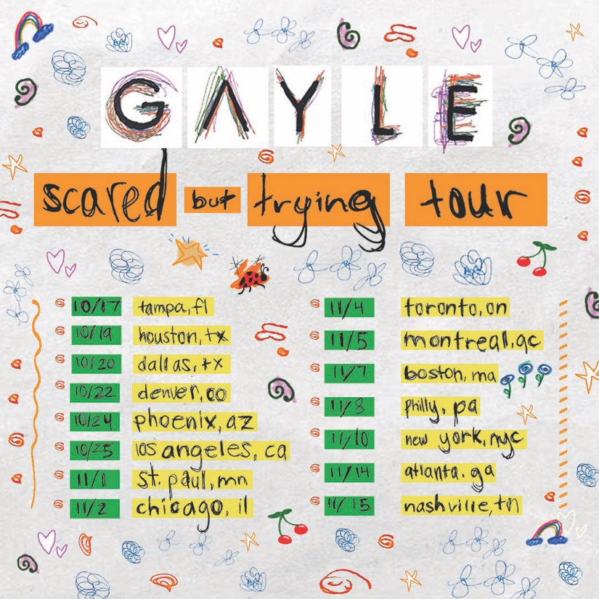
DOWNLOAD HI-RES ADMATS

GAYLE
ON TOUR 2023

JUNE
13 – Birmingham, UK – Villa Park ^
16 – Scheessel, Germany – Hurricane Festival *
17 – Neuhausen ob Eck, Germany – Southside Festival *
18 – Landgraaf, The Netherlands – Pinkpop *
20 – Paris, France – Paris LA Defense Arena ^
21 – Paris, France – Paris LA Defense Arena ^
24 – London, UK – Hyde Park ^
28 – Berlin, Germany – Olympic Stadium ^

JULY
1 – Vienna, Austria – Ernst Happel Stadion ^
2 – Vienna, Austria – Ernst Happel Stadion ^
5 – Munich, Germany – Olympiastadion ^
6 – Munich, Germany – Olympiastadion ^
8 – Cologne, Germany – Rheinenergiestadion ^
9 – Cologne, Germany – Rheinenergiestadion ^
13 – Calgary, Alberta – Calgaray Stampede

AUGUST
5 – Inglewood, CA – SoFi Stadium †
9 – Inglewood, CA – SoFi Stadium †

OCTOBER
17 – Tampa, FL – Crowbar
19 – Houston, TX – The Studio at Warehouse Live
20 – Dallas, TX – The Studio at The Factory
22 – Denver, CO – Bluebird Theater
24 – Phoenix, AZ – Valley Bar
25 – Los Angeles, CA – El Rey Theatre

NOVEMBER
1 – Minneapolis, MN – Amsterdam Bar & Hall
2 – Chicago, IL – Lincoln Hall
4 – Toronto, ON – Velvet Underground
5 – Montreal, QC – Bar Le Ritz PDB
7 – Boston, MA – Brighton Music Hall
8 – Philadelphia, PA – The Foundry
10 – New York, NY – Racket
11 – New Britain, CT – Project: Live 2023/Concert Ideas’ Conference
14 – Atlanta, GA – The Loft
15 – Nashville, TN – Basement East

^ w/ P!NK’S SUMMER CARNIVAL 2023
* FESTIVAL APPEARANCE
† w/ TAYLOR SWIFT | THE ERAS TOUR
# # #

