FOR IMMEDIATE RELEASE
JUNE 23, 2023

KELLY CLARKSON UNVEILS chemistry

TENTH STUDIO ALBUM AVAILABLE NOW VIA ATLANTIC RECORDS

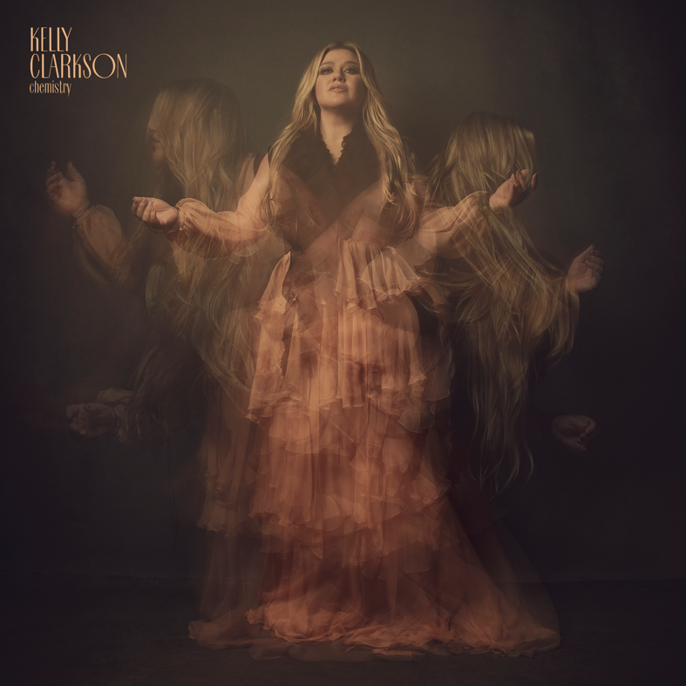
DOWNLOAD HIGH-RES IMAGES + ARTWORK

STREAM chemistry: LINK
WATCH “lighthouse” (live): LINK

GRAMMY-winning global superstar Kelly Clarkson has unveiled her highly anticipated tenth studio album chemistry, available now via Atlantic Records. The 14-track collection features production by long-time collaborators Jesse Shatkin and Jason Halbert, with melodies and lyrics helmed by Clarkson.

chemistry was first announced via double singles “mine” / “me,” which were praised for their “depth of feeling and immaculate, soaring vocals” by The New York Times upon release. Following with upbeat summer-ready single “favorite kind of high,” the Steve Martin-assisted “i hate love,” and attitude-packed “red flag collector,” the variety of tracks have continued to showcase the lyrical complexity featured on the project three years in the making. Clarkson exudes confidence and reclaimed independence on album highlight “Rock Hudson,” while the legendary Sheila E. joins for an island escape on closing track “that’s right” and her candid lyricism is at the forefront of the hauntingly beautiful ballad “lighthouse.”

Opting for live performances to showcase the album’s personal nature, Clarkson has continued to release clips taken from her one-night-only performance of chemistry at Los Angeles’ Belasco Theatre. This week saw the premiere of “lighthouse” (watch here), directed/produced by Weiss Eubanks and Jonny Mars.

chemistry arrives ahead of an exclusive Las Vegas engagement, chemistry…an intimate night with Kelly Clarkson, opening Friday, July 28, 2023 at Bakkt Theater at Planet Hollywood Resort & Casino. Designed exclusively for the Bakkt Theater stage, Clarkson and her longtime band will immerse fans in an intimate music experience that spans her two-decade long catalog of award-winning hits. Clarkson will also perform on September 22nd as part of the TODAY Show’s 2023 Citi Summer Concert Series and on September 23rd at the iHeartRadio Music Festival at the T-Mobile Arena in Las Vegas.

“Having chemistry with someone is an incredible, and overwhelming, feeling. It’s like you have no choice in the matter. You are just drawn to each other. This can be good and bad. This album takes you down every path that chemistry could lead you down.” – KELLY CLARKSON

One of the most popular artists of this era, Kelly Clarkson has sold more than 25 million albums and 40 million singles worldwide. The Texas-born singer-songwriter first came to fame in 2002 as the winner of the inaugural season of American Idol and quickly became one of pop’s top singles artists, in addition to the first artist to top each of Billboard’s pop, adult contemporary, country and dance charts. chemistry marks her tenth studio album and third full-length release with Atlantic Records, following 2017’s Meaning of Life and 2021’s When Christmas Comes Around…. Meanwhile on the small screen, her multi-Emmy Award-winning daytime talk show, The Kelly Clarkson Show, is preparing for a move to New York City for its upcoming 5th season (with the show having already been picked up through 2025).

chemistry track list:
1. skip this part
2. mine
3. high road
4. me
5. down to you
6. chemistry
7. favorite kind of high
8. magic
9. lighthouse
10. rock hudson
11. my mistake
12. red flag collector
13. i hate love (feat. Steve Martin)
14. that’s right (feat. Sheila E.)

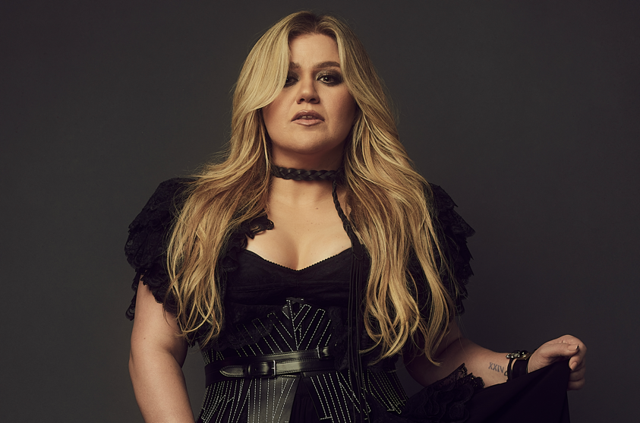
DOWNLOAD HIGH-RES IMAGES + ARTWORK

For more information, please visit:
KellyClarkson.com | Instagram | YouTube | TikTok | Facebook | Twitter | Press Assets

For press inquiries:
Sheila Richman | Sheila.Richman@atlanticrecords.com
Ted Sullivan | Ted.Sullivan@atlanticrecords.com

