FOR IMMEDIATE RELEASE
JUNE 9, 2023

KELLY CLARKSON IS A “red flag collector”

TENTH STUDIO ALBUM chemistry OUT JUNE 23RD VIA ATLANTIC RECORDS

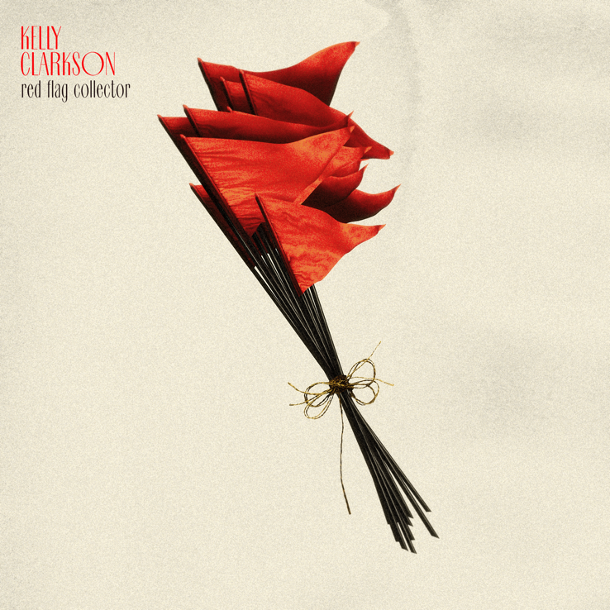
DOWNLOAD HIGH-RES IMAGES + ARTWORK

STREAM “red flag collector”: LINK
WATCH “red flag collector” (live): LINK
PRE-ORDER chemistry: LINK

GRAMMY-winning global superstar Kelly Clarkson has premiered “red flag collector” – the latest off her highly anticipated tenth studio album chemistry, arriving June 23rd and available for pre-order now via Atlantic Records. Produced by long-time collaborator Jason Halbert, the song arrives alongside a special live video taken from Clarkson’s one-night-only performance of chemistry last month at Los Angeles’ Belasco Theatre, directed/produced by Weiss Eubanks and Jonny Mars (watch here).

“red flag collector” marks the fourth release from the 14-track collection, following last week’s Steve Martin-assisted “i hate love” (stream here), upbeat summer-ready single “favorite kind of high” (stream here) and double singles “mine” / “me” (stream here). Released to fan and critical acclaim alike, Clarkson has been praised for the songs’ “depth of feeling and immaculate, soaring vocals” by The New York Times, as the variety of tracks continue to showcase the lyrical complexity featured on the project three years in the making.

“Having chemistry with someone is an incredible, and overwhelming, feeling. It’s like you have no choice in the matter. You are just drawn to each other. This can be good and bad. This album takes you down every path that chemistry could lead you down.” – KELLY CLARKSON

chemistry will arrive ahead of an exclusive Las Vegas engagement, chemistry…an intimate night with Kelly Clarkson, opening Friday, July 28, 2023 at Bakkt Theater at Planet Hollywood Resort & Casino. Designed exclusively for the Bakkt Theater stage, Clarkson and her longtime band will immerse fans in an intimate music experience that spans her two-decade long catalog of award-winning hits. Clarkson will also perform as part of the TODAY Show’s 2023 Citi Summer Concert Series, due to air later this summer on NBC.

One of the most popular artists of this era, Kelly Clarkson has sold more than 25 million albums and 40 million singles worldwide. The Texas-born singer-songwriter first came to fame in 2002 as the winner of the inaugural season of American Idol and quickly became one of pop’s top singles artists, in addition to the first artist to top each of Billboard’s pop, adult contemporary, country and dance charts. chemistry marks her tenth studio album and third full-length release with Atlantic Records, following 2017’s Meaning of Life and 2021’s When Christmas Comes Around…. Meanwhile on the small screen, her multi-Emmy Award-winning daytime talk show, The Kelly Clarkson Show, is preparing for a move to New York City for its upcoming 5th season (with the show having already been picked up through 2025).

chemistry track list:
1. skip this part
2. mine
3. high road
4. me
5. down to you
6. chemistry
7. favorite kind of high
8. magic
9. lighthouse
10. rock hudson
11. my mistake
12. red flag collector
13. i hate love (feat. Steve Martin)
14. that’s right (feat. Sheila E.)

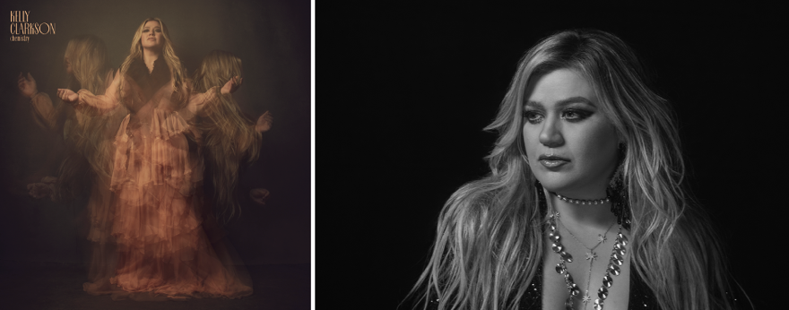
DOWNLOAD HIGH-RES IMAGES + ARTWORK

For more information, please visit:
KellyClarkson.com | Instagram | YouTube | TikTok | Facebook | Twitter | Press Assets

For press inquiries:
Sheila Richman | Sheila.Richman@atlanticrecords.com
Ted Sullivan | Ted.Sullivan@atlanticrecords.com

