MELANIE MARTINEZ RELEASES OFFICIAL MUSIC VIDEO FOR “VOID”
Watch HERE

EAGERLY AWAITED NEW VIDEO PREMIERES TODAY
HOURLY BROADCASTS ON MTV LIVE, MTVU, AND MTV BIGGEST POP,
AND EXCLUSIVE PREMIERE ON THE PARAMOUNT TIMES SQUARE BILLBOARDS
IN NEW YORK CITY’S TIMES SQUARE

SOLD-OUT NORTH AMERICAN HEADLINE RUN CURRENTLY UNDERWAY
INCLUDING NYC’s RADIO CITY MUSIC HALL ON JUNE 28th

NEW INTERNATIONAL DATES SET THROUGH FEBRUARY 2024
IN EUROPE, AUSTRALIA & NEW ZEALAND

LONG AWAITED NEW ALBUM, PORTALS, DEBUTED AT #2 ON BILLBOARD 200
MARTINEZ’S THIRD CONSECUTIVE BILLBOARD 200 TOP 10 ALBUM
AVAILABLE NOW VIA ATLANTIC RECORDS

DOWNLOAD HI-RES ARTWORK

Multi-Platinum alt-pop phenomenon Melanie Martinez has shared the long awaited official music video for her hit single, “VOID,” streaming now at YouTube HERE. Directed, conceived and costume designed by Martinez, “VOID” is airing at the top of every hour throughout the day on MTV Live, MTVU, and MTV Biggest Pop following its exclusive premiere earlier today on the Paramount Times Square billboards in New York City.

“This is the first song I fully produced on my own,” says Melanie Martinez, I remember screaming that chorus while crying, it felt like a weight I needed to get off of me. The weight of my anxiety, the weight of my brain. A void. A dark place where you are left alone with your own thoughts for introspection, in order to find the light within yourself.”

Recently announced as an iHeart Radio “On The Verge” artist of 2023, Martinez’s official music video for “VOID” arrived this morning as the single is currently ascending the Top 40 at CHR/Top 40 radio outlets nationwide. “VOID“ is featured on Martinez’s blockbuster new album, PORTALS, available now in an expanded deluxe digital edition featuring three additional new tracks HERE. The album became Melanie’s highest charting debut on the Billboard 200 upon its release earlier this year, arriving at #2 with 142,000 equivalent album units earned in its first week – Martinez’s third consecutive Billboard 200 Top 10 album debut, and the biggest first week for any solo female artist in 2023 so far.

PORTALS further debuted at #1 on Billboard’s “Current Alternative Albums,” “Current Pop Albums,” “Top Album Sales,” “Current Album Sales,” “Internet Albums,” “Digital Albums,” and “Top Alternative/Rock Albums” charts, along with a #2 debut on the “Top Vinyl Albums” chart. An instant global sensation, the album proved Martinez’s first #1 album debut in Australia, also landing at #1 in New Zealand, #2 in the UK, #3 in Canada and Ireland, and top 10 chart placements in Germany, The Netherlands, Belgium, and Spain.

PORTALS also includes the hit single, “DEATH,” which, along with “VOID,” made history as Martinez’s first original songs to debut on the Billboard “Hot 100.” “DEATH” is joined by a cinematic companion video – directed, conceived, and costume designed by Martinez herself – which trended #1 on YouTube’s Trending “Top Music Videos” chart and now boasts over 23M official views. The song was first teased with a series of eerie clips revealing the rebirth of Martinez’s character “Cry Baby,” quickly sparking a frenzy of theories and garnering over 115M views across all socials. The track and its compelling companion visual earned praise from the likes of Billboard, which raved, “The avant-garde pop auteur creates bold, expansive worlds with each project…While the dramatic five-minute track can be connected to her artistic reawakening, the kinetic drums and electronic elements will also make listeners feel reborn, too.”

Martinez is celebrating the new album with her blockbuster PORTALS Tour. Newly announced European and Australian/New Zealand runs begins October 29 in Stockholm, Sweden, and then makes stops in Oslo, Copenhagen, Prague, Milan, London, Wolverhampton, Manchester, Glasgow, Dublin, Brussels, Amsterdam, Warsaw, Berlin, Dusseldorf, Paris, Madrid, and Lisbon. Martinez will then bring the tour Down Under, beginning January 28, 2024 in Auckland, NZ, followed by shows in Sydney, Brisbane, and Melbourne. Tickets for the European shows go on sale Friday, June 16 at 2:00 pm (LOCAL). AUS/NZ shows go on sale Friday, June 16 at 3:00 pm (LOCAL). For complete details, please visit www.melaniemartinezmusic.com/tour.

The PORTALS Tour – which will see Martinez exclusively performing as the otherworldly new creature rebirth of her alter ego “Cry Baby” – is currently playing to packed houses across North America, with sold-out dates continuing through mid-July. The tour also includes sold out shows in Mexico City and Guadalajara this October, as well as Live Out Festival in Monterrey.

# # #

MELANIE MARTINEZ
THE PORTALS TOUR 2023-2024
NEW DATES - EUROPE, AUSTRALIA, NEW ZEALAND

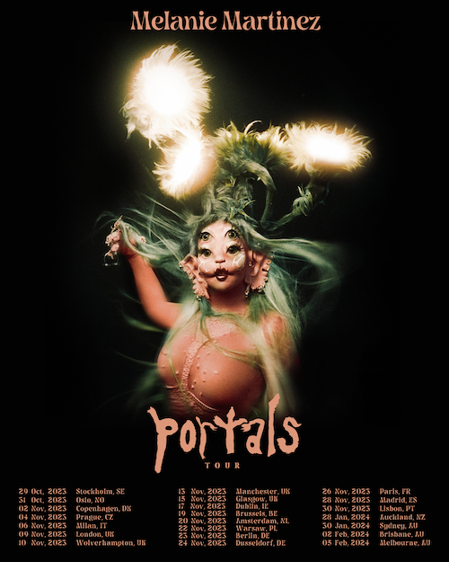
DOWNLOAD HI-RES ARTWORK

JUNE 2023
15 – Irving, TX – The Pavilion at Toyota Music Factory
16 – Houston, TX – 713 Music Hall
17 – Austin, TX – Moody Amphitheater
20 – Tampa, FL – Yuengling Center
21 – Hollywood, FL – Hard Rock Live
23 – Atlanta, GA – Cadence Bank Amphitheatre at Chastain Park
24 – Charlotte, NC – Skyla Credit Union Amphitheatre
27 – Bridgeport, CT – Hartford Healthcare Amphitheater
28 – New York, NY – Radio City Music Hall
30 – Philadelphia, PA – Skyline Stage at The Mann

JULY 2023
1 – Boston, MA – MGM Music Hall at Fenway
2 – Washington DC – The Anthem
5 – Cleveland, OH – Jacobs Pavilion at Nautica
7 – Cincinnati, OH – Andrew J Brady Music Center
8 – Sterling Heights, MI – Michigan Lottery Amphitheatre
10 – St. Louis – Saint Louis Music Park
11 – Chicago, IL – Byline Bank Aragon Ballroom
12 – Minneapolis, MN – The Armory
14 – Toronto, ON – Meridian Hall
15 – Montreal, QC – MTELUS

OCTOBER 2023
16 – Mexico City, Mexico – Pepsi Center WTC
17 - Mexico City, Mexico – Pepsi Center WTC
19 – Guadalajara, Mexico – Auditorio Telmex
21 – Monterrey, Mexico – Heineken Silver Live Out 2023 Parque Fundidora
29 – Stockholm, Sweden – Hovet
31 – Oslo, Norway – Oslo Spektrum

NOVEMBER 2023
2 – Copenhagen, Denmark – K.B. Hallen
4 – Prague, Czech Republic – Fortuna Hall
6 – Milan, Italy – Mediolanum Forum
9 – London, UK – OVO Arena Wembley
10 – Wolverhampton, UK – The Halls Wolverhampton
13 – Manchester, UK – O2 Apollo Manchester
15 – Glasgow, UK – OVO Hydro
17 – Dublin, Ireland – 3Arena
19 – Brussels, Belgium– Forest National
20 – Amsterdam, Netherlands – AFAS Live
22 – Warsaw, Poland – COS Torwar
23 – Berlin, Germany – Verti Music Hall
24 – Dusseldorf, Germany – Mitsubishi Electric Halle
26 – Paris, France – Zenith Paris - La Villette
28 – Madrid, Spain – WiZink Center
30 – Lisbon, Portugal – Sagres Campo Pequeno

JANUARY 2024
28 – Auckland, New Zealand – Spark Arena
30 – Sydney, Australia – Aware Super Theatre

FEBRUARY 2024
2 – Brisbane, Australia - Riverstage
5 - Melbourne, Australia – Margaret Court Arena

For a full list of tour dates, visit melaniemartinezmusic.com

# # #
CONNECT WITH MELANIE MARTINEZ
OFFICIAL | FACEBOOK | INSTAGRAM |TIKTOK | TWITTER | YOUTUBE

