FOR IMMEDIATE RELEASE
JUNE 28, 2023

QUANDO RONDO RETURNS WITH “FEEL THIS WAY” SINGLE RELEASE

FOLLOW-UP TO A FLURRY OF SINGLE RELEASES AND RECOVERY ALBUM

MORE MUSIC COME FROM THE RAP PHENOM SOON

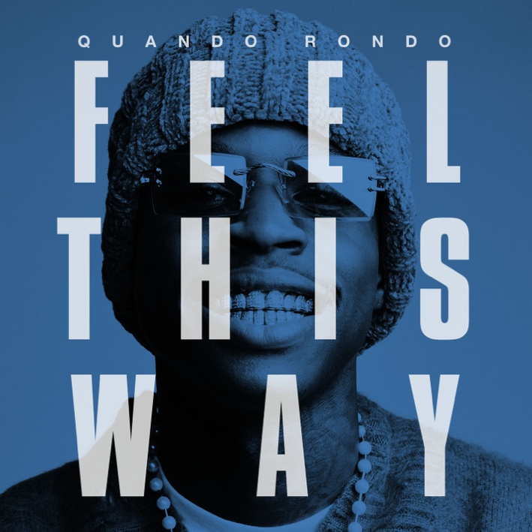
STREAM HERE

Quando Rondo continues his “Recovery” with an emotional new single, “Feel This Way,” where he reflects on his past trauma, shares plans to leave the pain behind him and keep himself in a positive head space moving forward. Quando teased the song on his socials earlier this month and the snippet received over 2M+ views in less than 2 weeks. Fans have been anxiously awaiting the track ever since.

Recovery, released this past March contains 20 tracks and includes a lone feature from YoungBoy Never Broke Again on their track “Give Me A Sign” which Quando released after the untimely passing of his cousin, Pabb. The album was accompanied by the visual release for “Where Would I Be.” Recovery marked Quando’s first solo album in over 2 years. The album title is also a nod to him putting his past behind him and growing as both an artist, but more importantly as a man with a family that looks up to him. A few notable producers on the album include Bankroll Got It, DJ Chose, SephGotTheWaves, & CXBGoCrazy.

QUANDO RONDO

When you know yourself, you can share your story. During a meteoric rise as one of hip-hop’s most enigmatic figures, Quando Rondo discovered himself. The Savannah, GA native went from D.I.Y. upstart to multiplatinum phenomenon, but he also simultaneously transformed from a complicated teen into a thoughtful young man. Along the way, he found fame and fortune, yet he lost friends and loved ones. Never letting his foot off the gas, he built a bulletproof catalog of bangers highlighted by platinum singles—“ABG,” “I Remember” [feat. Lil Baby], and “Imperfect Flower”—as well as a slew of gold singles, namely “Bacc to the Basics,” “Dope Boy Dreams,” “New Ones” [with NoCap], and “Scarred from Love,” to name a few. Meanwhile, his 2020 full-length debut, QPac, crashed the Top 25 of the Billboard 200. Throughout 2022, he assembled what would become “Recovery,” teasing its impending arrival with standouts such as “Long Live Pabb” (dedicated to the late Lul Pabb) and “Me First.” He made a conscious decision to dive deeper into his journey. After earning nearly 2 billion streams, over a dozen RIAA certifications, and widespread acclaim from Pitchfork, Complex, REVOLT, and many others, this sharp street storyteller divulges more than ever before on his 2023 third full-length album, Recovery [Atlantic Records].

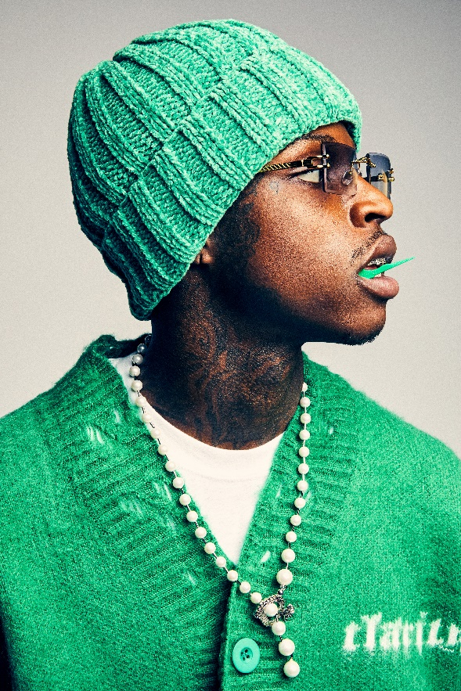
DOWNLOAD HI-RES PHOTOS
CREDIT: JIMMY FONTAINE

CONNECT WITH QUANDO RONDO
OFFICIAL | INSTAGRAM | TWITTER | FACEBOOK | YOUTUBE

FOR ALL PRESS INQUIRIES, PLEASE CONTACT:
ARIANA.WHITE@ATLANTICRECORDS.COM

