RELLYSKI UNVEILS “SEE THROUGH”

ACCLAIMED FLORIDA RAPPER CONTINUES TO BUILD MOMENTUM
WITH ANTHEMIC NEW SINGLE

LISTEN TO “SEE THROUGH” HERE | WATCH HERE

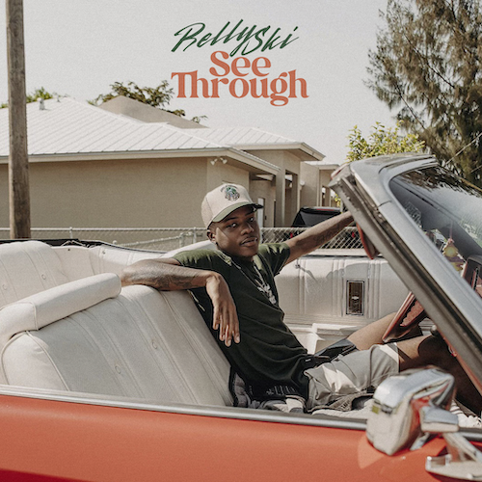
DOWNLOAD ART

Opa-locka, FL-based rapper Rellyski has shared his anthemic new single, “See Through,” available now via Bad Habit/Atlantic Records. Produced by 5K 808Mafia, the optimistic track – which once again sees Rellyski drawing a fine line between gritty hip-hop storytelling and soulful vocal delivery – is joined by an official music video premiering today at YouTube HERE. Stream “See Through” HERE.

“‘See Through’ is about perseverance,” says Rellyski, “no matter where you come from, no matter who’s doubting you, you could still make it.”

“See Through” follows the melodic, “Top of the Morning,” available now via Bad Habit/Atlantic Records. Produced by JC, the mesmerizing track proved a breakthrough for Rellyski, earning first week streams 13x greater than his previous release. “‘Top of the Morning’ is an encouraging anthem mixing smooth vocals and a classic hip-hop feel, inspiring listeners to get their own bag,” declared Glasse Factory. “The bass and trap-heavy beat combines with Rellyski’s impressive flow to create a song perfect for driving down the highway with the windows down.”

Rellyski made his major label debut earlier this year with “Work It Out,” available now at all DSPs and streaming services alongside a Chris Moreno-directed video streaming HERE. The track was met by online applause from such outlets as AllHipHop.com, which raved, “The record carries that nostalgic R&B feeling, mixed with modern day hip hop elements that highlight Rellyski’s smooth and sultry vocals to the fullest – creating a unique, melodic sound.”

ABOUT RELLYSKI:
Having already attracted acclaim from Lyrical Lemonade, Early Rising, and more, Rellyski draws a fine line between gritty hip-hop storytelling and soulful vocal delivery, coating raw reality in magnetic melodies to examine trials, tribulations, triumphs, and everything in between. Raised by a single mother, music surrounded the Opa-locka, FL-based artist from a young age, his voice honed thanks to Grandma by regular visits to church for choir rehearsals. Though he listened to everything from R&B to rap, Rellyski initially gravitated towards football, shining on the field as a receiver and free safety. Recruited by Ohio’s Heidelberg University in Ohio, he channeled his musical interests by recording demos at the school radio station. Unfortunately, financial stress forced Rellyski to return to Florida where he began focusing like a laser on making music. In 2020, he uploaded “FO’REAL” to SoundCloud, catching the attention of the innovative new label Bad Habit, home to such artists as genre-busting trio Fade ‘Em All and GRAMMY® Award-winning global superstar Burna Boy.

Named by Miami New Times as one of “Ten Miami Rappers to Watch in 2022,” Rellyski picked up steam in 2021 with tracks like “Flowers” and “Spalding,” the latter of which generated over 500K worldwide streams and recently scored a sync during the 2023 NBA Eastern Conference Finals between the Miami Heat and Boston Celtics. Now, with “See Through” and more new music to come, Rellyski is sharpening his scorching signature style and “Miami Bounce” sound, refining and defining his vision to create a one-of-a-kind “Hood Lullaby” in the process.

“Authenticity is the biggest thing for me,” Rellyski says. “I want people to see me for me. A lot of people put on a face. Things are either fabricated or exaggerated. I’m just pushing me. I’m not trying to do too much or too little—I’m trying to give you me. I’m just a kid from Opa-locka with a goal. I’m a star who’s just getting his chance to shine. Once you pull back the curtain, you’re going to get blinded.”

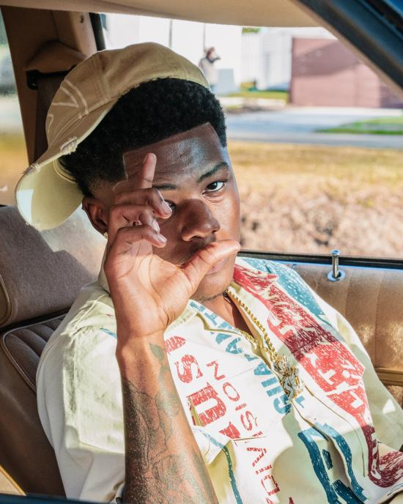
DOWNLOAD HI-RES PRESS PHOTO(S) HERE

# # #

CONNECT WITH RELLYSKI
INSTAGRAM | TWITTER | YOUTUBE

PRESS CONTACT
FAIRLEY MCCASKILL | FAIRLEY.MCCASKILL@ATLANTICRECORDS.COM

