FOR IMMEDIATE RELEASE
JUNE 30, 2023

ROYAL & THE SERPENT CONTINUES HER RAT TRAP SAGA WITH
RAT TRAP 2: THE BURN

SECOND INSTALLMENT IN ALL-NEW SERIES OF TWO-TRACK RELEASES
INCLUDES “JUNKIE” AND THE ENTHUSIASTIC POWER ANTHEM, “SLUG”

SPECIAL GUEST RUN ON FALL OUT BOY’S SO MUCH FOR (TOUR) DUST
CONTINUES THROUGH EARLY AUGUST

SPECIAL IN-STORE PERFORMANCES AND AUTOGRAPH SESSIONS
SET FOR SELECT INDEPENDENT RECORD STORES ACROSS THE COUNTRY

LISTEN TO RAT TRAP 2: THE BURN HERE
WATCH THE “JUNKIE” MUSIC VIDEO | WATCH THE “SLUG” MUSIC VIDEO

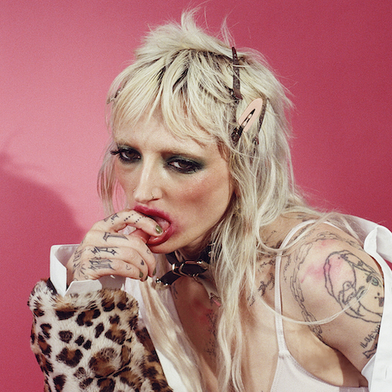
DOWNLOAD HI-RES ARTWORK

RIAA Gold-certified singer-songwriter Royal & the Serpent has shared her latest two-track project, RAT TRAP 2: the burn – Listen HERE. The second installment in an all-new series of double-sided singles arriving each month through the summer, today’s release includes “JUNKIE” and the enthusiastic power anthem, “SLUG.” Watch the official music videos for each track HERE.

“OUCH! what was that?? oh! LOVE! yeah...sometimes it stings,” says Royal. “welcome to trap 2 – the continuation of the RAT TRAP series, where our lead character falls for a boy that can’t help but break her heart (over and over again). I am so excited to share these songs and continue this story – thank you immensely for your time and consideration, these songs are from a deep place in my heart and I cannot wait to keep feeding the plot line.”

Royal kicked off her RAT TRAP saga last month with the premiere of its first chapter, RAT TRAP I: the blueprint, featuring “Astroturf” and the powerfully inspiring LGBTQ+ anthem, “One Nation Underdogs,” both joined by official music videos streaming now HERE.

Royal & the Serpent is currently celebrating the “royalverse” with a special guest run on Fall Out Boy’s just-launched So Much For (Tour) Dust, with dates set through early August. In addition, Royal will visit select independent record stores throughout the tour, including in-store performances and autograph sessions at Salt Lake City, UT’s Graywhale Entertainment (July 7), Atlanta, GA’s Criminal Records (July 26), Brooklyn, NY’s Rough Trade NYC (August 1), and Philadelphia, PA’s Repo Records (August 6). For complete details and ticket information, please visit www.royalandtheserpent.com.

The RAT TRAP series follows last year’s explosive HAPPINESS IS AN INSIDE JOB, an intimately detailed, five-song document of Royal’s journey to self-love. The project includes such searing tracks as “IM FINE,” “No Regrets,” “Happiness 4 Dummies,” “Love Abuser (Save Me),” and “Death of Me,” all accompanied by official visuals streaming now at YouTube.

ABOUT ROYAL & THE SERPENT
Royal & the Serpent is an artist entirely unafraid to bare the deepest and darkest parts of her psyche. After making her Atlantic Records debut with the 2020 EP, get a grip – highlighted by the RIAA Gold-certified single “Overwhelmed,” which captured the chaos of sensory overload and spent 22 weeks on Billboard’s “Alternative Airplay” chart – the L.A.-based singer-songwriter revealed even more of her frenetic inner world in 2022 with IF I DIED WOULD ANYONE CARE and Happiness Is An Inside Job. Her unfiltered songwriting has proved wildly resonant to her ever-growing fanbase – and led to such triumphs as touring with Demi Lovato, grandson, PVRIS, and Fall Out Boy.

Originally from New Jersey, Royal first took up guitar at age 14 with help from the then-six-year-old sister of her friend Donna Missal (a fellow singer-songwriter now signed to Harvest Records), then relocated to L.A. at age 18. While working as a bartender, Royal soon started self-releasing her music, beginning with her spellbinding 2017 single “Temperance.” Thanks to the buzz behind songs like 2019’s “Weddings & Funerals” and “Salvador Dali” – as well as her electrifying live show – she eventually inked a deal with Atlantic and released “Overwhelmed” in the early days of Covid lockdown.

Over the past few years, Royal has built a close-knit community of fans undeniably drawn to her one-of-a-kind balance of intense sensitivity and unruly self-possession. “The main reason I make music is that it’s the best therapy I could ever ask for: the process of taking everything in my brain and putting it on paper and then singing it out loud for people is so helpful and healing for me. The idea that my own expression can affect people in positive ways is such a blessing and a gift; I don’t ever take it lightly. I just want to keep telling my truth and reach as many people as I possibly can, and see where this little journey takes us.”

ROYAL & THE SERPENT
ON TOUR 2023

JUNE
30 – Phoenix, AZ – Talking Stick Resort Amphitheatre

JULY
1 – Chula Vista, CA – North Island Credit Union Amphitheatre
2 – Los Angeles, CA – BMO Stadium
3 – Los Angeles, CA – BMO Stadium
5 – Mountain View, CA – Shoreline Amphitheatre
7 – Salt Lake City, UT – USANA Amphitheatre
9 – Englewood, CO – Fiddler’s Green Amphitheatre
11 – Rogers, AR – Walmart AMP
13 – Somerset, WI – Somerset Amphitheater
15 – Cincinnati, OH – Riverbend Music Center
16 – Noblesville, IN – Ruoff Music Center
18 – Cuyahoga Falls, OH – Blossom Music Center
19 – Bristow, VA – Jiffy Lube Live
21 – Charlotte, NC – PNC Music Pavilion
22 – Virginia Beach, VA – Veterans United Home Loans Amphitheater
24 – West Palm Beach, FL – iTHINK Financial Amphitheatre
25 – Tampa, FL – MIDFLORIDA Credit Union Amphitheatre
26 – Atlanta, GA – Lakewood Amphitheater
29 – Clarkston, MI – Pine Knob Music Theatre
30 – Toronto, ON – Budweiser Stage

AUGUST
1 – Forest Hills, NY – Forest Hills Stadium
2 – Boston, MA Fenway Park
4 – Darien Center, NY – Darien Lake Amphitheater
5 – Holmdel, NJ – PNC Bank Arts Center
6 – Camden, NJ – Freedom Mortgage Pavilion

All Dates W/ Fall Out Boy So Much For (Tour) Dust

# # #

CONNECT WITH ROYAL & THE SERPENT:
OFFICIAL | FACEBOOK | INSTAGRAM | TWITTER | YOUTUBE

Press contacts:
Corey Brewer / Corey.Brewer@atlanticrecords.com
Jessica Nall / Jessica.Nall@atlanticrecords.com
Gabby Reese / Gabrielle.Reese@atlanticrecords.com

